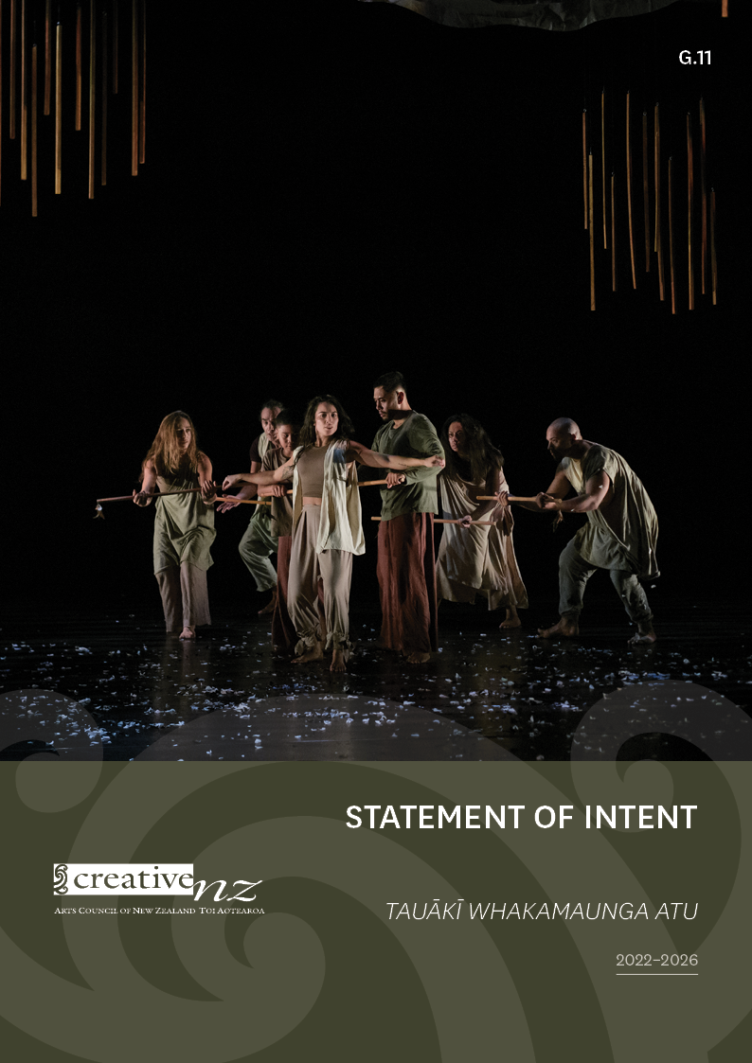
[]

Contact us
Website: www.creativenz.govt.nz
Wellington Office
Level 2, 2–12 Allen Street
PO Box 3806
Wellington 6011
T: 04 473 0880
E: info@creativenz.govt.nz
Auckland Office
First Floor
Southern Cross Building
Cnr High and Victoria Streets
PO Box 1425
Auckland 1140
T: 09 373 3066
E: northern@creativenz.govt.nz
Dunedin Office
Petridish
8 Stafford Street
Dunedin 9016
Christchurch contact
E: southern@creativenz.govt.nz
Crown copyright © This work is licensed under the Creative Commons Attribution 4.0 International licence. In essence, you are free to copy, distribute and adapt the work as long as you attribute the work to the Arts Council of New Zealand Toi Aotearoa (Creative New Zealand) and abide by the other licence terms. To view a copy of this licence, visit: www.creativecommons.org/licences/by/4.0
ISSN XXXX-XXXX (Print)
ISSN XXXX-XXXX (Online)
This Statement of Intent sets out the strategic objectives that the Arts Council of New Zealand Toi Aotearoa (Creative New Zealand) intends to achieve, or contribute to, for the period 1 July 2022 to 30 June 2026.
It is presented in accordance with sections 138 to 149A of the Crown Entities Act 2004.

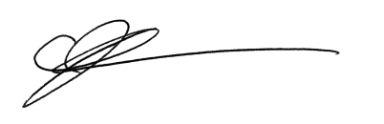

Caren Rangi
Manukura—Chair
29 June 2022

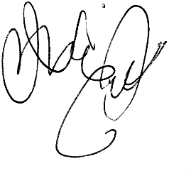

Michael Prentice
Manukura Tuarua—Deputy Chair
29 June 2022

Contents
Ngā ihirangi

Foreword 2
Kupu whakataki
Part One: Our strategic direction for 2019–2029 4
Wāhanga Tuatahi: Te ara ā-rautaki e whāia ana e mātau i ngā tau 2019–2029
How we create value for New Zealanders 7
Te āhua o tā mātau whakaputa hua ki te hunga o Aotearoa
Links to wellbeing frameworks 16
Ngā hononga ki ngā anga whakapiki hauora
Part Two: Our Statement of Intent 2022–2026 19
Wāhanga Tuarua: Tā mātau tauākī whakamaunga atu 2022–2026
Te Kaupapa o Toi Aotearoa – the Creative New Zealand way 20
Our context 22
Te horopaki e hāngai ana ki a mātau
Ministerial expectations 25
Ngā kawatau ā-Minita
Our strategic focus areas 26
Ngā aronga ā-rautaki e arohia ana e mātau
Our progress 30
Te āhua o tā mātau koke
Part Three: Our organisation 32
Wāhanga Tuatoru: Tō mātau whakahaere
About the Arts Council and Creative New Zealand 33
Mō Te Kaunihera Toi me Toi Aotearoa

Foreword
Kupu whakataki
Ahakoa whati te manga, e takoto ana anō te kōhiwi
Although the branch is broken off, the trunk remains – misfortunes will not undermine the group if the foundations are strong
When we established our 10-year strategic direction in mid-2019, little did we know the unprecedented upheaval that lay ahead. The COVID-19 pandemic has changed our lives immeasurably: as people, whānau, communities and as a society, both within Aotearoa New Zealand and globally.
While many areas of our lives have been affected by COVID-19, the arts and ngā toi have been disproportionately affected, time and time again. This is because so much of the value they provide relies on people coming together to develop, present and experience work.
While New Zealand has been better off than many countries, the impacts of COVID-19 have been profound and unevenly felt. They will be with us for years to come.
However, because the arts community has had to plan, re-plan and plan once again, the toll on people’s health and wellbeing – te hauora me te oranga – is apparent. This is particularly true for those who are most vulnerable; artists and arts practitioners who work from ‘gig to gig’ without the security of full-time employment.
The COVID-19 crisis has highlighted significant issues associated with the resilience of the arts community and the sustainability of arts careers. This suggests wider systemic changes need to occur so the arts community can thrive in the years ahead.
During this time, we have also seen New Zealanders and people around the world increasingly turn to the arts and ngā toi as a source of solace: for reflection, for joy, for healing and for escape. This has helped increase awareness of the vital contribution arts, culture and creativity make to the wellbeing of all New Zealanders.
We see this movement in the results of our 2020 research into New Zealanders’ attitudes to, and participation in, the arts. This work found that New Zealanders are more positive than ever about the essential role the arts and ngā toi play in our lives.

Our focus for the journey ahead
We’ve developed this Statement of Intent in the context of the long-term strategic direction we put in place through our Statement of Intent 2019–2029 – Te whakaputa hua ki te hunga o Aotearoa—Creating value for New Zealanders – and the context we set out in Part 1.
While we believe our long-term strategic direction remains relevant, our context means we’ll need to give more attention to particular areas over the next four years.
Part 2 sets out our strategic intentions for 2022 to 2026, which include the following strategic focus areas.
Resilience – developing a resilient and sustainable arts sector, including sustainable arts sector careers
Access, inclusion and equity – ensuring our services and the arts are accessible to, inclusive of and equitable for all New Zealanders
Wellbeing – embedding a recognition of the role of the arts and ngā toi in contributing to the well-being of New Zealanders
As we continue navigating through turbulent waters, it’s critical we keep working together as an arts community and that we seek out others who have similar aims. Given this, we’ve added Partnering for the arts as a new deliverable (our deliverables describe what we do to deliver on our strategic intentions).

We’ve also introduced Te Kaupapa o Toi Aotearoa, a programme aimed at ensuring we have the organisational culture, competencies and practices to enable us to meet our aspirations under Te Tiriti o Waitangi and adopt a multi-lensed approach to how we work.

Ngā mihi maioha
We acknowledge the role of artists and arts practitioners in sharing their creativity in what have been challenging conditions. We also acknowledge the many staff, volunteers and advocates who help make the arts and ngā toi happen in Aotearoa New Zealand¸ and the arts groups, collectives and organisations that support creative people to do what they do so well.
We thank our public funders – the Crown, through Manatū Taonga Ministry for Culture and Heritage, and the New Zealand Lottery Grants Board Te Puna Tahua – for investing in the arts and recognise their immense contribution to the wellbeing of New Zealanders.
Our valued partners, including mana whenua, iwi, local government, community trusts and private givers are also fundamental to building a strong and resilient arts community.
Finally, we acknowledge New Zealanders for continuing to support and participate in the arts and ngā toi in communities across Aotearoa New Zealand, and for embracing new ways of connecting with creativity through challenging times.

Caren Rangi
Manukura—Chair
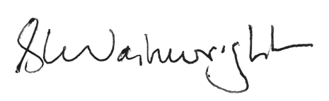

Stephen Wainwright
Tumu Whakarae—Chief Executive

Part One:
Our strategic direction for 2019–2029

Wāhanga Tuatahi:
Te ara ā-rautaki e whāia ana e mātau i ngā tau 2019–2029

How we create value for New Zealanders

Te āhua o tā mātau whakaputa hua ki te hunga o Aotearoa

About Te whakaputa hua ki te hunga o Aotearoa—Creating value for New Zealanders
Our strategic direction to 2029, Te whakaputa hua ki te hunga o Aotearoa—Creating value for New Zealanders, is a public value model that shows how we deliver value to New Zealanders through our support for the arts and ngā toi.
At the heart of Creating value for New Zealanders is Te Kaupapa o Toi Aotearoa – or the Creative New Zealand way – our vision, our purpose, our values and Te Waka Toi Pātaka (our Mātauranga Māori Framework).
As shown in the diagrams on pages 5–6, Te whakaputa hua ki te hunga o Aotearoa describes, through four strategic perspectives and anchored by Te Kaupapa o Toi Aotearoa, the environment we operate in, the relationships between the parts of the system, and how they work together to deliver value.
Creating value for New Zealanders should be read as a ‘virtuous circle’, where strengthening one segment leads to the strengthening of the next, and so on.
The following sections describe Te Kaupapa o Toi Aotearoa and the four strategic perspectives in more detail.

Te Kaupapa o Toi Aotearoa – the Creative New Zealand way
As we’ve grown as an organisation, so has our understanding of what it means to be the national arts development agency of Aotearoa New Zealand.
Central to Te Kaupapa o Toi Aotearoa is that, as an organisation, we’ll create value for New Zealanders by working in a way that enhances the mana and wellbeing of the people and communities we serve, guided by the intellectual traditions, knowledge and tikanga of tangata whenua and tangata Tiriti, alongside conventional government approaches.
We recognise our responsibilities under Te Tiriti o Waitangi and the opportunity Te Tiriti provides for all of us to strengthen our connections with the land, our sense of identity and belonging and to ‘enhance the dignity of everyone who lives here’.
In 2021, we began a programme of work to enhance Te Kaupapa o Toi Aotearoa (see page 20). This mahi recognises that the whakapapa of New Zealand’s support of arts, culture and heritage has privileged certain knowledge, values and systems over others.
Through Te Kaupapa o Toi Aotearoa we are working to find a more equitable, inclusive and balanced approach, and aspire to become a Treaty-honouring organisation.
As we progress on this journey, we expect our developing thinking to further inform how we articulate our strategic intentions into the future, including how we articulate Te whakaputa hua ki te hunga o Aotearoa —Creating value for New Zealanders.
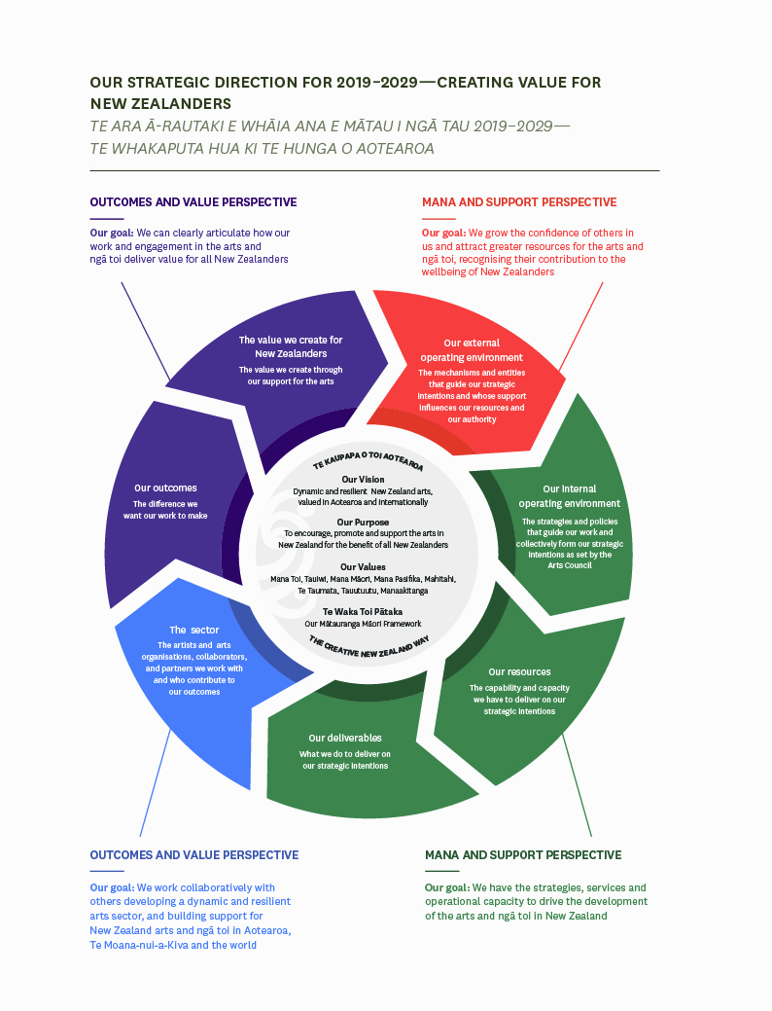

Our vision
Our vision describes our ambition for the arts and what we want to achieve.
Dynamic and resilient New Zealand arts, valued in Aotearoa and internationally
To us, dynamic New Zealand arts are bold, imaginative and not afraid to challenge or provoke their audience. They are created by a diverse group of artists, arts practitioners and arts organisations from around New Zealand, across a spectrum of artforms.
For our arts to be resilient, artists and arts practitioners need to be knowledgeable and skilful in their craft. Arts organisations need to be directed with expertise that ensures they can adapt to challenges and opportunities and respond to the ways Aotearoa New Zealand is changing. For the sector to be resilient, artists and arts practitioners must be able to maintain sustainable careers in the arts.
Arts that are valued improve the lives of New Zealanders, reflect the diversity of who we are and grow our reputation as a creative nation. They are high-quality creative expressions, whose creators are respected for their vision and passion.
One way we measure the progress we’re making towards our vision is through New Zealanders’ views on, and engagement with, the arts and ngā toi. We seek these views every three years through our New Zealanders and the Arts—Ko Aotearoa me ōna Toi and Audience Atlas Aotearoa research.
The results highlighted below are from the 2020 New Zealanders and the arts survey. In 2020, all the measures showed significant improvement on 2017 results.
Dynamic
á 64% agree Overall, New Zealand arts are of high quality
á 80% agree I feel proud when New Zealand artists succeed overseas
Resilient
á 64% agree The arts contribute positively to our economy
á 60% agree The arts should receive public funding
61% agree The arts make an important contribution to community resilience and wellbeing (new in 2020)
Valued
á 67% agree The arts should be part of the education of every New Zealander
á 54% agree My community would be poorer without the arts
á 62% agree The arts help improve New Zealand society
á 64% agree The arts help define who we are as New Zealanders
Source: New Zealanders and the Arts—Ko Aotearoa me ōna Toi 2020. Available at: www.creativenz.govt.nz/development-and-resources/new-zealanders-and-the-arts-2020.

Our purpose
Our purpose is our reason for being, as set out in the Arts Council of New Zealand Toi Aotearoa Act 2014.
To encourage, promote and support the arts in New Zealand for the benefit of all New Zealanders
Encouraging, promoting and supporting the arts effectively align with our five deliverables:
- Investing in the arts
- Developing the arts
- Advocating for the arts
- Leadership in the arts
- Partnering for the arts (new).
We discuss these deliverables in more detail on page 14.

Our values
Our eight values describe the actions and behaviour the arts sector, our partners and the public can expect from us as we work with them. They guide our conduct and decision-making.
Mana Toi – we champion the role of the arts and the contribution artists make to our lives
Tauiwi – we recognise New Zealand’s distinctive cultural and social diversity and work to ensure arts opportunities for all
Mana Māori – we recognise and support the role of Māori as tangata whenua in the arts
Mana Pasifika – we recognise the arts of the Pasifika peoples of New Zealand
Mahitahi – we work together with others so we can achieve more, including exploring the big picture and sharing what we learn
Te Taumata – we set high standards for our work
Tauutuutu – we are open, frank and respectful in our relationships
Manaakitanga – we are welcoming and responsive to all

Te Waka Toi Pātaka
Te Waka Toi Pātaka – our Mātauranga Māori Framework – enables a Māori worldview to guide how we work and make decisions.
Developed in 2018, Te Waka Toi Pātaka anticipates a wider view of wellbeing, incorporating the social, cultural, environmental and economic value of ngā toi Māori, and responds to the aspirations of the ngā toi Māori sector.
Together, the elements of the Pātaka ask us to consider how Creative New Zealand contributes to:
Manahau – resilience
Kawenga – our collective responsibilities to nurture and protect the arts and culture for future generations
Whakarite – balance – the relationship between the past and present and the importance of engagement and connection
Hononga Whenua – connection to Papatūānuku and those things that anchor us together
Whanaketanga – development, including adaption and innovation
Hononga Tīpuna – whakapapa and the ancestral connections that make our artforms distinctive
Maiatanga – potential
Hapori – communities that uphold the integrity of the arts
Āwhina me te Ākinga – the role of the public sector in strengthening and advocating for the arts

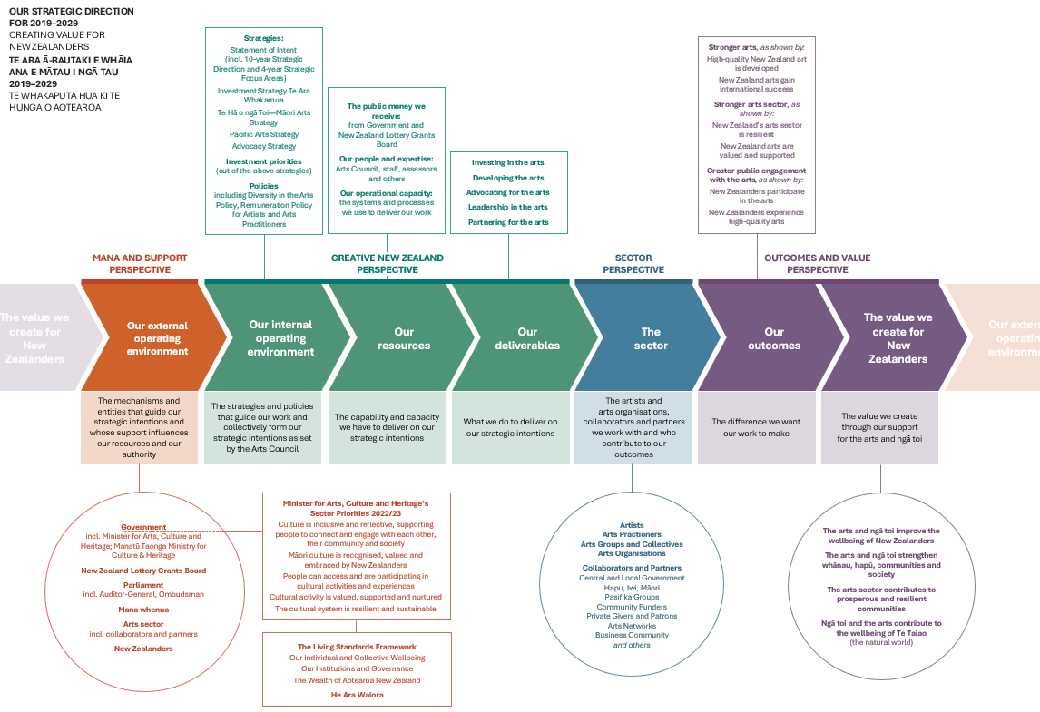

Four strategic perspectives
Creating value for New Zealanders is built on four strategic perspectives, each of which influences how we create value through our support for the arts. The following sections describe these four perspectives in more detail.
For each perspective, we’ve identified a goal that we want to achieve by 2029. By achieving these goals, we aim to strengthen each perspective and, in doing so, increase the value we deliver for New Zealanders.

Mana and support perspective

Our external operating environment
The Mana and support perspective reflects the mechanisms and entities that guide our strategic intentions and whose support influences our resources and authority. We need the legitimacy and licence they confer to be able to undertake our work. This perspective is influenced by the value we create for New Zealanders as well as the confidence others have in our performance.
Mana and support for Creative New Zealand come from:
- the Government (including the Minister for Arts Culture and Heritage and Manatū Taonga Ministry for Culture and Heritage), because we are an autonomous Crown entity
- the New Zealand Lottery Grants Board Te Puna Tahua, as our major funder
- Parliament (including the Auditor-General and the Ombudsman)
- mana whenua (in the areas where our offices are located)
- the arts sector, including our collaborators and partners
- New Zealanders, as the ultimate beneficiaries of the value we create.
Taken collectively, our responsibilities to all of the above help ensure we operate fairly, effectively and efficiently.
These entities also influence our strategic direction. As a Crown entity, the Government has a role in setting the priorities under which we operate, and through our engagement with the sector and the research we undertake, we design fit-for-purpose services and programmes to give effect to our legislative mandate.

Our goal under this perspective
Under this perspective, we’re aiming to achieve the following goal by 2029:
We grow the confidence of others in us, and attract greater resources for the arts and ngā toi, recognising their contribution to the wellbeing of New Zealanders
To achieve this goal, we’ll seek to:
- be recognised as a high-performing, trusted arts development agency
- be proactive in providing advice to government and communities on matters affecting the arts and ngā toi in New Zealand
- make the case for greater support for the arts and ngā toi based on their contribution to New Zealanders’ wellbeing.
By growing the confidence of others in us, we’ll be in a stronger position to advocate for greater resources and support for the arts. We’ll do this by ensuring we’re a high-performing and trusted organisation and, increasingly, by making the case for the arts.
Through our leadership and advocacy roles, we’ll be proactive in championing the arts across government, local government, the private sector and other partners, including through providing trusted advice to government.

Creative New Zealand perspective
The Creative New Zealand perspective is made up of Our internal operating environment, Our resources and Our deliverables.
This perspective shows the strategies and policies that guide our work and the capability and capacity that enable us to deliver on our strategic intentions. This perspective is influenced by our external operating environment and, in turn, influences how we support and engage with the sector.

Our internal operating environment
Our internal operating environment describes the strategies and policies that collectively form our strategic intentions as set by the Arts Council, our governing body. It includes our Statement of Intent alongside the following strategies and policies we have developed in consultation with the sector.
Investment priorities
The following strategies set out our priorities for how we’ll invest in the arts and how, through our work, we’ll recognise in the arts the role of Māori as tangata whenua and advance ngā toi Māori, as well as how we’ll recognise and advance the arts of the Pacific peoples of Aotearoa New Zealand.
- Investment Strategy Te Ara Whakamua: Guides our arts investment to ensure we build an investment portfolio that meets the future needs of the arts in Aotearoa.
- Te Hā o ngā Toi—Māori Arts Strategy: A ‘by Māori, for Aotearoa’ Māori arts strategy that outlines how we’ll work and partner with others to advance ngā toi Māori and ngā toi Māori artists and practitioners for the benefit of all New Zealanders.
- Pacific Arts Strategy: Outlines how we’ll prioritise our investment in the development of Pacific arts for Aotearoa, Te Moana-nui-a-Kiva (the Pacific) and the world.

Other strategies and policies
Along with those above, our other strategies and policies include the following.
- Advocacy Strategy: Sets out our strategy to create, in partnership with the arts sector, a compelling case for the value of the arts to New Zealanders.
- Diversity in the Arts Policy: States our commitment to recognise, promote and celebrate diversity in the arts and ensure our funding and services are fair, equitable, non-discriminatory and keep pace with demographic changes in Aotearoa New Zealand society.
- Remuneration Policy for Artists and Arts Practitioners: States our commitment to supporting and promoting the rights of artists and arts practitioners to fair remuneration for their work, recognising the value of the arts, creative and cultural practice to the social, cultural, economic and environmental wellbeing of Aotearoa New Zealand.

Our resources
Our resources describe the capability and capacity we have as an organisation to deliver on our strategic intentions. This includes the public money we receive, our people and expertise, and our operational capacity.

Our deliverables
Our deliverables are what we’ll do to deliver on our strategic intentions. We have five deliverables:
Investing in the arts – Investing in artists, art practitioners and arts organisations and their projects in a fair, transparent and strategic way
Developing the arts – Developing the arts sector’s capacity to succeed and undertaking initiatives to develop the arts
Advocating for the arts – Promoting the value of the arts and empowering the arts sector to make the case for the arts
Leadership in the arts – Providing leadership to ensure the arts sector is well positioned collectively to respond to change
Partnering for the arts – Developing reciprocal relationships and partnerships that increase the impact of our collective work for the arts (new)
Further details on our deliverables are included in our annual statement of performance expectations. These are available at: www.creativenz.govt.nz/about-creative-new-zealand/corporate-documents.

Our goal under this perspective
Under this perspective, we’re aiming to achieve the following goal by 2029:
We have the strategies, services and operational capacity to drive development of the arts and ngā toi in New Zealand
To achieve this goal, we’ll seek to:
- use our Investment Strategy Te Ara Whakamua, and Te Hā o ngā Toi—Māori Arts Strategy and the Pacific Arts Strategy, to guide investment decisions
- increase our focus on delivery to under-served communities and building the resilience of the arts sector
- improve our service delivery and be recognised for having processes that are fair and transparent.
To achieve our vision and outcomes, and enhance the confidence of others in us, we must provide high-quality, relevant and accessible services to the arts sector.
We’ll continue to improve our services and ensure our decisions are fair and transparent. We’ll also work to ensure we have the skills and capacity to deliver the strategies we have designed to advance ngā toi Māori and Pacific arts.
A specific focus will be on gaining a better understanding of what we can do to build the resilience of the arts sector, and how we can best deliver to those communities across Aotearoa New Zealand that currently benefit less from our investment.
Increasingly, alongside our focus on supporting the development and delivery of high-quality arts experiences, we’ll be considering who is accessing our services, who is benefiting and who isn’t. We’ll also be looking carefully at what demographic changes will mean for how we deliver our services.

Sector perspective
The Sector perspective describes who we work with and the players who help us achieve our outcomes and, ultimately, deliver value for New Zealanders.
When we talk about ‘the sector’, we mean the clients, collaborators and partners we work with. Our clients are the artists, arts practitioners and arts organisations that receive our funding and create artworks, deliver activities and provide services.
Also included in this perspective are the investors and partners who support the sector. This includes central government agencies, local government, community and philanthropic trusts, iwi and Māori, Pasifika groups, patrons, the private sector, volunteers and the wider creative sector.

Our goal under this perspective
Under this perspective, we’re aiming to achieve the following goal by 2029:
We work collaboratively with others developing a dynamic and resilient arts sector, and building support for New Zealand arts and ngā toi in Aotearoa, Te Moana-nui-a-Kiva and the world
To achieve this goal, we’ll seek to:
- develop our role as a leader, convenor and enabler in the arts, helping to ensure the arts sector is well positioned to adapt to present and future challenges
- work proactively with others to build a resilient arts sector, including developing sustainable careers for artists and arts practitioners
- strengthen our relationships and grow partnerships across the arts sector, government, local government, iwi and Māori communities, Pasifika communities, other investors and international partners, to build support for the arts.
To achieve our vision and outcomes, including that the arts are valued and supported, we’ll need to broaden and deepen the relationships and partnerships we have with others, both in New Zealand and overseas.
Building partnerships is an important focus through Te Hā o ngā Toi—Māori Arts Strategy and our Pacific Arts Strategy (this is why we use the Pasifika term, Te Moana-nui-a-Kiva, under this goal, which is understood as the ocean homeland of Pasifika peoples).
Increasingly, we are also looking to develop relationships with mana whenua, starting in the rohe where Toi Aotearoa is based (Tāmaki Makaurau, Te Whanganui-a-Tara and Ōtepoti).
As a national body, we see a role for ourselves in providing leadership in the arts, by tracking trends and developments across the sector, identifying and responding to issues, and bringing the sector together to address challenges or respond to opportunities.
A particular focus will be working with the sector to identify ways to build resilience for artists and arts practitioners, arts organisations and the sector as a whole (see page 26). This includes looking at the sustainability of careers in the arts.

Outcomes and value perspective
The Outcomes and value perspective is made up of Our outcomes and The value we create for New Zealanders. This perspective shows the difference the arts are making for New Zealanders every day across Aotearoa New Zealand.

Our outcomes
Our outcomes describe the difference we want our work to make. As an arts development agency, we achieve our outcomes by working with others. We do this through investing in artists, arts practitioners and arts organisations that deliver arts experiences and services to New Zealanders, and our work in developing, advocating for and providing leadership in the arts, as well as partnering with others for greater impact.
We measure our success towards achieving these outcomes in our annual reports, available at: www.creativenz.govt.nz/about-creative-new-zealand/corporate-documents.
Stronger arts, as shown by:
- High-quality New Zealand art is developed
- New Zealand arts gain international success
Strong arts come from artists, arts practitioners and arts organisations that have the ability and opportunity to generate high-quality work, reflecting who we are as a nation and engaging audiences in New Zealand and internationally.
We work to ensure high-quality New Zealand arts are developed by enabling artists, arts practitioners and arts organisations to:
- develop their artforms, the quality of their work, and their artistic skills and capabilities
- be innovative in their arts practice
- create work that excites, challenges, inspires and resonates with audiences.
International engagement contributes to strong arts by strengthening New Zealand arts practice and broadening the reach of our arts. We work to ensure New Zealand artists, arts practitioners and arts organisations can:
- develop their practice in relation to the international arts environment, including through cultural and artistic exchange
- develop international markets and audiences to expand their reach onto the world stage and improve their financial sustainability
- promote New Zealand and its arts to international audiences.
Stronger arts sector, as shown by:
- New Zealand’s arts sector is resilient
- New Zealand arts are valued and supported
A strong arts sector is the foundation from which artists, arts practitioners and arts organisations can produce high-quality arts and provide opportunities for public engagement with the arts.
We’ll work collaboratively to build the resilience of the arts sector so it can adapt to challenges and embrace opportunities, while recognising the ways in which our country and the needs of its people are changing.
The value New Zealanders place on the arts is critical to building the resilience of the sector. We’ll champion the arts and the value they create for New Zealanders, to attract greater support for, and investment into, the arts.
Greater public engagement with the arts, as shown by:
- New Zealanders participate in the arts
- New Zealanders experience high-quality arts
We want to see increased public engagement with the arts, recognising their powerful ability to improve our personal wellbeing and that of whānau, communities and society. The arts inspire, delight and provoke us; they help people understand, interpret and adapt to the world; they let us express our identities; and they help build social cohesion.
We’ll work to ensure New Zealanders have as many opportunities as possible to participate in the arts, including to:
- express themselves artistically
- celebrate, practise, transmit and develop their diverse artistic traditions and cultural heritage
- develop links between communities.
We’ll also work to broaden the opportunities for all New Zealanders to experience high-quality arts, including by:
- ensuring access to a diverse range of arts experiences
- investing to engage under-served communities.

The value we create for New Zealanders
Through our support for the arts and ngā toi, we aim to achieve our outcomes. The question then becomes, to what end? What impact does realising these outcomes have on individuals, whānau, communities and society? How do we create value for New Zealanders through our support for the arts?
We describe the ways the arts create value and contribute to the wellbeing of New Zealanders under four headings.
- The arts and Ngā toi improve the wellbeing of New Zealanders
- The arts and ngā toi strengthen whānau, hapū, communities and society
- The arts sector contributes to prosperous and resilient communities
- Ngā toi and the arts contribute to the wellbeing of Te Taiao (the natural world)
A number of value statements sit under each of these headings – these are set out in the table on page 19.
We’re only one player in the arts ecosystem so we can’t control whether these wellbeing impacts are achieved. We are, however, interested in tracking the extent to which these benefits are realised through engaging with the arts.
To help with this, we’ve aligned the value statements with the wellbeing domains and wealth areas in the Treasury’s Living Standards Framework and He Ara Waiora – a framework for understanding Māori wellbeing (see page 19).

Our goal under this perspective
Under this perspective, we’re aiming to achieve the following goal by 2029:
We can clearly articulate how our work and engagement in the arts and ngā toi deliver value for all New Zealanders
To achieve this goal, we’ll seek to:
- build an evidence base for how the arts and ngā toi contribute value to New Zealanders
- promote the value the arts and ngā toi contribute to New Zealanders’ individual and collective wellbeing
- be recognised as a powerful advocate for the arts and ngā toi.
As the national arts development agency, we’re uniquely placed to advocate for the value of the arts and ngā toi and to build recognition of the contribution they can make to the wellbeing of New Zealanders.
Successfully building this recognition will promote stronger investment into, and support for, the arts sector in New Zealand.
Internationally, the evidence is growing on the contribution of the arts to a broad range of wellbeing outcomes. Our challenge is to build an evidence base to support these outcomes within a New Zealand context, including from a te ao Māori worldview.
This work will let us demonstrate the sector’s contribution to the Living Standards Framework and the He Ara Waiora framework (see page 19).

Links to wellbeing frameworks
Ngā hononga ki ngā anga whakapiki hauora
Wellbeing frameworks help us understand how the value we create for New Zealanders links to more holistic understandings of wellbeing.

Living Standards Framework
The Treasury has adopted the Living Standards Framework as a high-level way to measure and analyse intergenerational wellbeing. The framework was refreshed in 2021, with the aim of better reflecting culture and children’s wellbeing, including being more compatible with te ao Māori and Pacific cultures.
The framework identifies:
- 12 domains of wellbeing – aspects of our lives that are important for our individual and collective wellbeing (such as health, knowledge, cultural capability and belonging)
- six types of institutions – political, economic, social and cultural – that play a role in facilitating the wellbeing of individuals and collectives, as well as safeguarding and building our national wealth
- four areas of wealth – these identify how wealthy we are as a country and support current and future wellbeing, including our natural environment, social cohesion, human capability, and financial and physical capital.
Culture has been identified as an underpinning element of the framework. It emphasises that all aspects of our wealth, institutions and wellbeing are cultural, and that culture is in every part of the framework.
The framework aims to provide a ‘macro’ view across social, environmental and economic conditions in New Zealand. The intention is that, by applying a broad set of considerations to policy making and budget setting, the wellbeing and living standards of all New Zealanders will be lifted over time.
More about the Living Standards Framework is available at: www.treasury.govt.nz/information-and-services/nz-economy/living-standards/our-living-standards-framework

He Ara Waiora
He Ara Waiora is a framework adopted by the Treasury to help understand waiora, often translated as a Māori lens on wellbeing.
The term ‘waiora’ speaks to a broad conception of human wellbeing, grounded in wai (water) as the source of ora (life).
He Ara Waiora presents a holistic, intergenerational approach to wellbeing. While its principles are derived from mātauranga Māori, many of its elements are relevant to lifting the intergenerational wellbeing of all New Zealanders.
He Ara Waiora sets out both the ends, or what are important elements in Māori perceptions of wellbeing, and the means, or the tikanga values or principles that help achieve the ends.
More about He Ara Waiora is available at: www.treasury.govt.nz/information-and-services/nz-economy/higher-living-standards/he-ara-waiora

How we contribute
The table on page 18 shows how we’ve aligned the value we create for New Zealanders (through our support for the arts and ngā toi) to the wellbeing domains and areas of wealth under the Living Standards Framework, and to the ‘ends’ identified in He Ara Waiora.
For example, the arts contribute to social inclusion by connecting people and communities and this, in turn, will contribute to the wellbeing domain of Family and friends. By strengthening social connections, the wealth of social cohesion will grow.
Under He Ara Waiora, people (tangata) and collectives (kainga) thrive when they participate and connect within their communities (mana tauutuutu). Engaging with or participating in the arts is an important way through which people can connect and so it supports their wairua (spirit).
As we help develop the evidence base for how the arts create value for New Zealanders, we’ll be able to better demonstrate the sector’s contribution to the elements of the Living Standards Framework and to He Ara Waiora.
Aligning our value of the arts statements to the Living Standards Framework and He Ara Waiora
Creative New Zealand  value of the arts statements | Link to Living Standards Framework domains of wellbeing | Link to Living Standards Framework areas of wealth | Link to He Ara Wairoa concepts and ends
The arts and ngā toi improve the wellbeing of New Zealanders |  | Human capability | Te Ira Tangata (the human domain encapsulates human activities and relationships)
The arts contribute to personal wellbeing | Subjective wellbeing;  Leisure and play |  | Mana whanake: having the power to grow sustainable, intergenerational prosperity
The arts contribute to healthier people | Health
The arts contribute to education, skills development and creating a highly skilled workforce | Knowledge and skills |  | Mana āheinga: people and collectives having the capability to decide on and realise aspirations within their context and unique circumstances
The arts develop creative people who provide new approaches to solving problems
The arts and ngā toi strengthen whānau, hapū, communities and society |  | Social cohesion | Te Ira Tangata
The arts contribute to social inclusion and cohesion by connecting people and communities | Family and friends;  Work, care and volunteering |  | Mana tauutuutu: participating and connecting within communities, including fulfilling community rights and obligations
The arts contribute to our identity as individuals, whānau, hapū, communities and as a nation | Cultural capability and belonging |  | Mana tuku iho: having a strong sense of identity and belonging
The arts support a strong democracy | Engagement and voice |  | Mana āheinga
The arts sector contributes to prosperous and resilient communities |  | Financial and physical capital | Te Ira Tangata
The arts sector provides jobs and careers for artists and practitioners | Work, care and volunteering |  | Mana whanake
The arts play a role in rejuvenating and making cities and communities great places to live | Leisure and play;  Environmental amenity;  Safety
The arts contribute to New Zealand’s economy | Income, consumption and wealth
Ngā toi and the arts contribute to the wellbeing of Te Taiao (the natural world) |  | Natural environment | Te Taiao
Ngā toi and the arts can play a role in the culture change required to address environmental challenges such as climate change | Environmental amenity |  | The wellbeing of Te Taiao is vital and inextricable from human wellbeing, responsibilities and obligations are in place to sustain and maintain the wellbeing of Te Taiao

Part Two:
Our Statement of Intent 2022–2026

Wāhanga Tuarua:
Tā mātau tauākī whakamaunga atu 2022–2026

Te Kaupapa o Toi Aotearoa – the Creative New Zealand way
Our Statement of Intent lays out what we want to achieve to create long-term value for New Zealanders. Te Kaupapa o Toi Aotearoa – the Creative New Zealand way will help guide how and why we do this, considering the people and communities we serve; the vision, purpose, values and Te Waka Toi Pātaka (our Mātauranga Māori Framework) that are at the heart of our strategic direction; and the social context of our work within Aotearoa New Zealand.
Through Te Kaupapa o Toi Aotearoa we want to work in a way that enhances the mana of people and communities, guided by the intellectual traditions, knowledge and tikanga of tangata whenua – alongside tangata Tiriti and conventional government approaches – acknowledging our obligations under Te Tiriti o Waitangi.
Ngā toi Māori and mātauranga Māori are distinctive to Aotearoa New Zealand and central to our unique national identity. They can also help us think about the way we relate to one another. We’re developing our organisational culture and capability to work well in te ao Māori, be more responsive to other worldviews and perspectives, and to support the wellbeing of artists, arts practitioners, communities and the arts sector.
Te Kaupapa o Toi Aotearoa is part of our approach to ensuring our work is accessible, inclusive and equitable as we fulfil our purpose to ‘encourage, promote, and support the arts in New Zealand for the benefit of all New Zealanders’.
We are privileged to work with mana whenua partners, and many tohunga and mātanga around the motu have generously shared their mātauranga to support us as we rechart our course for the future.

Kaupapa Waka wayfinding approaches
Kaupapa Waka values, waka hourua navigation traditions and wayfinding have inspired us to think about how we best recognise and respond to situations in the environment as they unfold, using our organisational purpose of working for the benefit of all New Zealanders as an ‘orienting star’.
Waka hourua are a potent visual representation of how we wish to work. Waka evoke a clear sense of our place in Aotearoa New Zealand and within Te Moana-nui-a-Kiva. They connect us to our whakapapa as a country and as an organisation. They help us to think about the values and processes we use, where these have come from and how we might work differently in the future to consider a broader range of knowledge and perspectives.
Waka connect us to our environment and to considerations of how we care for the moana and whenua and our relationships across Te Moana-nui-a-Kiva and globally.
The components of the waka also help us think about the type of leadership required to navigate effectively. The dual hulls reflect the bringing together of different values, world views, systems and approaches, with the kīato crossbeams of the waka representing the importance of communication and building relationships based on integrity, reciprocity and respect.

Te Waka Toi Pātaka – our Mātauranga Māori Framework
Te Waka Toi Pātaka, Creative New Zealand’s Mātauranga Māori Framework, informs and challenges our thinking, elevating a Māori worldview to guide our decision-making and demonstrate a new way of engaging in the arts for Aotearoa New Zealand (see page 9).

Our context
Te horopaki e hāngai ana ki a mātau
Since 2019, our operating context has significantly changed – the COVID-19 pandemic has affected the arts and wider society in profound ways. In addition, significant and rapid shifts have occurred in societal norms, and our own financial context has also changed. This context will influence how we operate over the coming years.

Our strategic context
Our strategic context and long-term strategic direction are set out in Part 1 of this document.

Our operating context
The COVID-19 pandemic, and its impact on the arts, remains a dominant factor in the external environment. COVID-19 has disrupted:
- the lives and livelihoods of artists and arts practitioners
- the sustainability and resilience of arts organisations, collectives and groups
- the ability of artists to develop artistic works, which is often undertaken in collaborative environments
- the ability of artists to present their work and engage audiences and communities
- the ways in which artists engage with their communities and audiences, with online delivery bringing both challenges and opportunities to reach those with access issues and those currently underserved
- the international market for arts workers and artworks through touring and overseas presentation
- the ability for communities to come together and draw strength from sharing collective experiences.
Recent research undertaken by UNESCO points to the impacts of the COVID-19 pandemic on the creative sector globally, noting: ‘What was already a precarious situation for many artists has become unsustainable, threatening creative diversity’. The report highlights the disparities between labour protection for artists and arts practitioners compared with the general workforce, along with the effect of widespread digitisation of cultural products on artists’ incomes.
The highlighting of these issues, many of which pre-date the pandemic, is prompting calls for broader systemic change that recognises the perilous nature of creative careers and the significant contribution the arts and ngā toi make to the wellbeing of all New Zealanders.
A need also exists to, over time, gain a better understanding of the longer-term impacts of COVID-19 on how the sector operates, including its effects on the industry and on arts development.
Domestically as well as internationally, the concerns are that one of the long-term impacts of COVID-19 will be a permanent loss of practitioners from the sector. Concerns have also been expressed about the ability of the sector, and funders alike, to adapt to the new environment and new ways of working.
Coupled with the ongoing effects of the pandemic is an increasingly pressured economy. Cost of living increases are significant, and inflation has begun to rise after a long period of relatively low rates.
Economic pressures challenge our ability to create more value for New Zealanders: the cost for artists to create art goes up and creative output may decline; members of the public find it more difficult to financially support the arts; and public funders face more pressure in their financial decision-making.
We’re also seeing rapid societal shifts across a range of areas. Some of these movements have been initiated overseas but their effects are being felt here, while others are more about our context in Aotearoa New Zealand.
These shifts include:
- a reconsideration of the role of Te Tiriti o Waitangi in how the Government operates and its relationships with Māori
- increased understanding and recognition of the value of te reo, tikanga and mātauranga Māori to New Zealand society
- increased awareness, prompted by international movements, of issues around systemic racism, unconscious bias and calls internationally and domestically to decolonise institutions
- increased awareness of issues around gender equity, which are coming to the fore in many industries, including the arts
- increased awareness of diversity and inclusivity more broadly as individual communities seek greater recognition and autonomy, for example, Deaf and disability, LGBTQIA+ or rainbow, and ethnic communities
- international and domestic calls for governments and societies to address the climate crisis and build more sustainable models for how we live
- ongoing advances in digital technologies and the vital role they play in enabling access to the arts through the pandemic.

Our financial context
In 2019, Creative New Zealand was a significant funder of the arts in New Zealand (alongside the Government’s direct investment in national organisations such as Te Matatini, the New Zealand Symphony Orchestra and the Royal New Zealand Ballet).
With significant additional investment through the Government’s 2020 Arts and Culture COVID Recovery Programme (and subsequent responses to the Delta and Omicron outbreaks) led by Manatū Taonga Ministry for Culture and Heritage, the funding landscape has changed considerably.
Over the next four years, we’ll need to consider what effect this new investment has on the sector and how this might influence the way in which we support the sector into the future.
Creative New Zealand relies on Lotto New Zealand profits for around 70 percent of revenue and so, before COVID-19, we maintained a level of reserves that enabled us to make longer-term commitments to arts organisations despite this variable revenue.
Because of the significant investment we made in our initial 2020 COVID-19 emergency response, our reserves are largely spent. As a result, we’ll have limited financial flexibility over the next four years.
This comes at a time when we expect intense pressure on our resources as a result of:
- high demand for our funding, due in part to increased expectations following the significant one-off funding injections over the past two years
- expectations of significantly higher inflation than we have experienced for some time, with consequent effects across all sectors, including the arts
- high levels of risk facing the sector due to uncertain audience and participant demand, higher costs as a result of COVID-19 regulatory requirements and reduced revenue (including through local authorities, philanthropy and sponsorship)
- uncertainty about the future of Manatū Taonga Ministry for Culture and Heritage-led COVID-19 funding, which has filled gaps in the arts infrastructure, many of which pre-dated the COVID-19 pandemic.
We’ll therefore need to adopt a prudent approach to financial planning over the four years of this Statement of Intent. See also page 31: What might hamper our progress.
Due to our funding variability, more information about our financial planning context and approach is included in each year’s statement of performance expectations.

Ministerial expectations
Ngā kawatau ā-Minita
Alongside our understanding of the arts sector and the context we’re operating in, we’ve developed our Statement of Intent with consideration of government priorities and Ministers’ expectations of us.

Enduring expectations
The Minister for Arts, Culture and Heritage has affirmed the following enduring expectations of Crown entities, including Creative New Zealand:
- supporting future-focused Māori Crown relations, including supporting the Maihi Karauna (the Government’s Strategy for Māori Language Revitalisation) and pursuing further opportunities for partnership with Māori entities and businesses
- ensuring entity workplaces and leadership teams are diverse and inclusive
- taking active steps to reduce greenhouse gas emissions, improve energy efficiency and reduce waste outputs.

Minister’s priorities for the arts, culture and heritage sector
The Minister has asked sector agencies to ensure their strategies reflect the following.
- Culture is inclusive and reflective, supporting people to connect and engage with each other, their community and society.
- Māori culture is recognised, valued and embraced by New Zealanders.
- People can access and are participating in cultural activities and experiences.
- Cultural activity is valued, supported and nurtured.
- The cultural system is resilient and sustainable.
The Minister has also asked sector agencies, including Creative New Zealand, to:
- have a Māori language plan as one of the ways they are supporting Maihi Karauna
- support the implementation of the Government’s action plan to reduce gender, Māori, Pacific and ethnic pay gaps and create a fairer workplace.

Expectations of Creative New Zealand
The Minister’s specific expectations of Creative New Zealand for each performance year are set out in our statement of performance expectations (our annual plan). These are available at: www.creativenz.govt.nz/about-creative-new-zealand/corporate-documents.

How we contribute
Strong alignment exists between the Minister’s priorities for the portfolio and our outcomes, as well as with our strategic focus areas for 2022–2026 (see page 26).

Our strategic focus areas
Ngā aronga ā-rautaki e arohia ana e mātau
In the context of our strategic direction for 2019–2029 and Ministerial expectations, and in response to our current operating environment, we’ve identified three strategic focus areas for the next four years.
We believe that focusing on these areas, alongside our existing investment priorities, will contribute to lifting the sector out of the challenges associated with the COVID-19 pandemic, contribute to the goals established in our long-term strategic direction and, ultimately, help us achieve our vision of Dynamic and resilient arts, valued in Aotearoa and internationally.
These focus areas reflect a continued emphasis on our Stronger arts sector outcome, by which we’re seeking to build the resilience of the arts sector and the value New Zealanders place on the arts.
More information on the actions and activities we’ll pursue each year to support these focus areas is included in our statements of performance expectations (our annual plans), available at: www.creativenz.govt.nz/about-creative-new-zealand/corporate-documents.

Our strategic focus areas
Creative New Zealand’s strategic focus areas for 2022–2026 are:
Resilience – developing a resilient and sustainable arts sector, including sustainable arts sector careers
Access, inclusion and equity – ensuring our services and the arts are accessible to, inclusive of and equitable for all New Zealanders
Wellbeing – embedding a recognition of the role of the arts and ngā toi in contributing to the wellbeing of New Zealanders
These areas are broad, but this speaks to the wide reach each has for the sector, New Zealanders, for us and those who support us to do our work (including government).
Along with these three strategic focus areas, we’ll advance our Te Kaupapa o Toi Aotearoa programme (see page 20).
By adding Partnering for the arts as a new deliverable (ie, the things we do to deliver on our strategic intentions), we’ll be more intentional about working across the arts ecosystem with those who have shared aims so that, collectively, we can have greater impact on the issues that matter.

Resilience
Under the Sector perspective of Creating value for New Zealanders, we have the following goal.
We work collaboratively with others in developing a dynamic and resilient arts sector, and building support for New Zealand arts in Aotearoa, Te Moana-nui-a-Kiva and the world.
Under this goal, in 2019, we said we’d:
- develop our role as a leader and enabler in the arts, helping to ensure the arts sector is well positioned to adapt to present and future challenges
- work proactively with others to build a resilient arts sector, including developing sustainable careers for artists and arts practitioners
- strengthen our relationships and grow partnerships across the arts sector, government, local government, iwi and Māori, Pasifika groups, other investors and international partners, to build support for the arts.
The COVID-19 pandemic has highlighted issues of sector resilience, sustainability and the lack of viable arts sector careers. It may, however, prove to be a catalyst for us to look for new models.
The potential exists for new models to focus on building resilience within the sector; to engage larger audiences, including through digital channels; to change how we value and support those in the arts ecosystem who are most vulnerable, our artists and arts practitioners; and to think about how we build public support for the arts and ngā toi, including how Creative New Zealand supports the sector.
Over the next four years under this focus area, we plan to:
- advance our sustainable careers work programme and monitor the sustainability of arts sector careers
- develop a work programme aimed at improving the resilience of the arts sector, by which we mean the sector’s ability to respond and adapt to challenges, and to embrace opportunities
- work with others to consider the need for longer-term systemic change to the way in which the arts sector is supported, including considering how we support independent artists and arts practitioners as the most vulnerable workers in the sector
- develop new partnerships across the public and private sectors aimed at co-investment and improving sector sustainability.
This work aligns with the concepts of Whanaketanga (development, including adaption and innovation), Hapori (community), Hononga Tīpuna (the ancestral connections that make our artforms distinctive) and Āwhina me te Ākina (the role of the public sector in providing support and advocacy) in Te Waka Toi Pātaka, our Mātauranga Māori Framework.

Access, inclusion and equity
Underpinning our strategic direction for 2019–2029 is our purpose: To encourage, promote and support the arts in New Zealand for the benefit of all New Zealanders.
Under the Creative New Zealand perspective of Creating value for New Zealanders, we have the following goal.
We have the strategies, services and operational capacity to drive development of the arts in New Zealand.
Here, we talk about providing high-quality, relevant and accessible services to the arts sector.
Increasingly, we’re being asked whether what we do is accessible to, and reflective of, the diverse communities of Aotearoa New Zealand. These include the deaf and disability community, LGBTQIA+ or rainbow communities, Asian New Zealanders and those representing younger New Zealanders.
We know from reporting on key elements of our Diversity in the Arts Policy that we have more work to do to improve the accessibility of our services, and the extent to which the work we support reflects New Zealand’s diverse communities.
We also need to gain a better understanding of what equity in the arts means and how can we achieve equitable outcomes for all New Zealanders through our support for the arts and ngā toi for Māori, Pasifika and New Zealand’s diverse communities.
Our discussion about equity needs to recognise the different places we start from and historic patterns of investment in the arts by the Government and us. These discussions must begin with consideration of Te Tiriti o Waitangi and our aspirations for how we’ll work in this context.
In response to these questions, over the next four years under this focus area, we plan to:
- implement a programme of work aimed at ensuring our services are accessible to and reflective of different communities, as identified through our diversity reporting (against our Diversity in the Arts Policy)
- advance Te Kaupapa o Toi Aotearoa, aimed at ensuring we have the organisational culture, competencies and practices to enable us to meet our aspirations under Te Tiriti o Waitangi and adopt a multi-lensed approach to how we work
- review our Diversity in the Arts Policy to reflect a focus on equity.
This work links to concepts of Kawenga (responsibility), Maiatanga (potential) and Manahau (resilience) in Te Waka Toi Pātaka, our Mātauranga Māori Framework.

Wellbeing
Under the Outcomes and value perspective of Creating value for New Zealanders, we have the following goal.
We can clearly articulate how our work and engagement in the arts deliver value for all New Zealanders.
Under this goal, in 2019, we said we’ll:
- build an evidence base for how the arts contribute value to New Zealanders
- promote the value the arts contribute to New Zealanders’ wellbeing
- be recognised as a powerful advocate for the arts.
The COVID-19 pandemic has shown us the value of the arts and ngā toi in challenging times, with more people turning to the arts because of their power to inspire, delight and provoke us; their ability to help people understand, interpret and adapt to the world; the way they enable us to express our identities; and the way they help build social cohesion.
In turbulent times, the arts have a crucial role; we face a less certain future and need to re-examine our assumptions about how we live, work and interact with each other. Prolonged times of crisis also have the potential to fracture our communities.
The arts themselves have been hard hit, and this makes it more important than ever to embed a stronger recognition of their value to New Zealanders. This will help ensure that the arts, with artists at the centre, can flourish and play a vital role in our individual and collective wellbeing into the future.
Over the next four years under this focus area, we plan to:
- develop new frameworks for measuring the impact of the arts and ngā toi on New Zealanders
- embed a widespread recognition of the role of the arts and ngā toi in contributing to the wellbeing of New Zealanders
- explore the potential for the arts and ngā toi to deliver to objectives across government, including in physical and mental health, education, justice, corrections, tourism and in our relationships with other countries.
Te Waka Toi Pātaka, our Mātauranga Māori Framework, anticipates a wider view of wellbeing, incorporating the social, cultural, environmental and economic value of ngā toi Māori. It links to the concepts of Hononga Whenua (connection to Papatūānuku), Hapori (community) and Whakarite (balance) within the framework.

Changes we want to see
Looking ahead, by focusing on these strategic focus areas, we want to see change in:
- how we deliver our services
- how the arts sector operates
- how society values and supports the arts and ngā toi.
The table below outlines the changes we are seeking across the four years of this Statement of Intent and looking out to 2029, the period of our current long-term strategic direction.

Changes we are seeking across our strategic focus areas
 | By 2026 | By 2029
Resilience | Creative New Zealand’s Remuneration Policy for Artists and Arts Partitioners is recognised as an ‘industry standard’ and widely adopted by the arts sector and those engaging artists and arts practitioners.  Working with others, Creative New Zealand has developed a roadmap for improving the sustainability of arts sector careers.  Creative New Zealand and the arts sector are developing and trialling new models (operating, funding and monetisation) aimed at improving the resilience and sustainability of the sector. | Remuneration practices in the arts sector reflect good practice, and remuneration levels achieve parity with all New Zealanders.  Clear pathways exist for those seeking a career in the arts sector, from the education system through to maintaining a sustainable career across the lifetime of an artist or arts practitioner.  New operating models mean the arts sector is equipped and empowered to withstand shocks, adapt to changing contexts and pursue new opportunities.
Access, inclusion and equity | New Zealand artists and arts practitioners from diverse communities can access Creative New Zealand’s services, and our services are enabling.  Through our diversity reporting, we can accurately identify who is and who isn’t benefiting from our services and implement initiatives that seek to address gaps.  Our policies reflect our aspirations under Te Tiriti o Waitangi, address equity alongside access and inclusion, and are widely reflected in the practices of those in whom we invest.  Te Kaupapa o Toi Aotearoa is embedded across our organisational processes, policies and structures, and Creative New Zealand has the capability and capacity to operate effectively in te ao Māori and take a ‘multi-lensed’ approach to its work. | Creative New Zealand will be recognised as a leader in the delivery of services that are fair, transparent, inclusive and equitable.  Those who use and benefit from our services and investment broadly reflect New Zealand’s population.  Creative New Zealand is recognised as a Te Tiriti o Waitangi-honouring organisation.
Wellbeing | Working with others, we’ll have developed a strong evidence base for the value the arts and ngā toi contribute to New Zealanders and our society.  Creative New Zealand and the arts sector will be powerful advocates for the value of the arts and ngā toi.  Increasingly, partnerships exist across a range of sectors that provide investment into the arts and increase the recognition of the value they deliver. | New Zealanders place a high level of value on the arts and ngā toi, recognising the vital contribution they make to the cultural, social and economic wellbeing of New Zealanders and New Zealand communities and society.  Support and investment into the arts and ngā toi comes from various sources – public and private – reflecting the value they deliver.  The arts and ngā toi are drawn on across a variety of sectors for the value they can provide in education, health, rehabilitation and tourism, and as a means of addressing the challenges we face.

Our progress
Te āhua o tā mātau koke
Measuring and reporting on progress made in achieving our medium- and long-term aspirations is important. An open and transparent approach allows our stakeholders to see what we’re doing to create value for New Zealanders and how we’ve done it. This will help us to refine our strategies in response to the dynamic context we’re operating in.
Each year, we develop a statement of performance expectations, in effect, our annual plan. The first of these plans against this Statement of Intent is for the 2022/23 performance year, and is available at: www.creativenz.govt.nz/about-creative-new-zealand/corporate-documents.

What gets measured
The performance framework in each statement of performance expectations outlines what we’ll be measuring and reporting on that year. This will be a mix of measures that, when taken together, provide a balanced picture of our performance. We report against these measures each year in our annual report, available at: www.creativenz.govt.nz/about-creative-new-zealand/corporate-documents.
Our measures will be a combination of:
- annual priorities – through these, we’ll focus on activities that link to the four perspectives of our strategic direction and to the strategic focus areas, as well as our Te Kaupapa o Toi Aotearoa work programme
- core activities – these are more ‘business as usual’ activities, such as running investment programmes, delivering capacity-building initiatives or carrying out advocacy or leadership activities.
We’ll track our progress and report against our annual priorities and core activities, as well as discuss how these are helping us reach our goals and moving us towards the change we’re seeking. Reporting on annual priorities is against milestones identified for each priority. Reporting on core activities focuses on measures like dollars, numbers and percentages.
We’ll also be including indicators, which are measures relating to significant areas of interest that can be used to show change over time. For example, under the Sector perspective of Creating value for New Zealanders, we’ll be developing indicators to track the health of the sector. These indicators will include areas that are not necessarily within Creative New Zealand’s control but where movement within them may prompt us to take action.
We’ll also measure the broader results of our work under our outcomes. For example, the Greater public engagement with the arts outcome will be shown by:
- New Zealanders participating in the arts (ie, reported participant numbers across our major funding programmes)
- New Zealanders experiencing high-quality arts (ie, audience numbers from activity funded through our major funding programmes).
We aim to improve the quality of our measures over time. During 2022/23, we’ll review the adequacy of our performance framework in helping us to understand our progress, including under each of the three strategic focus areas and towards achieving the goals in our longer-term strategic direction. We expect this to result in changes to our performance framework from 2023/24.
The review of our performance framework will include how we can better track and report progress against our other strategies, including the Investment Strategy Te Ara Whakamua, Te Hā o ngā Toi—Māori Arts Strategy and the Pacific Arts Strategy.
In our reporting, we’ll also talk about how our day-to-day work links to our vision, to Ministerial priorities and to how they contribute to the creation of public value through under Creating value for New Zealanders.

What might hamper our progress
Like any organisation, we need to understand what might prevent us from achieving our aims and seek to mitigate these risks. The Arts Council, through its Audit and Risk Committee, has responsibility for governance oversight of risk management and compliance.
As we prepare this Statement of Intent in 2022, COVID-19 continues to loom large, and this affects our view on the near-term risks.
As the pandemic recedes, we’ll continue to reassess the risks and challenges facing the arts sector and ourselves.
These risks include the following.
- COVID-19 has resulted in profound changes to the way we live, work and engage with arts, culture and creativity, and ongoing uncertainty remains about the trajectory of the pandemic and its continued implications for the arts sector.
- COVID-19 has highlighted systemic challenges facing the arts sector that it is incumbent on us, and others, to start to address. These challenges include improving the sustainability of the sector and of artists’ and arts practitioners’ careers so the arts can be a viable career option.
- In the absence of additional Crown baseline funding, we will have little financial flexibility as a result of spending down our reserves in response to the initial COVID-19 crisis in 2020, and ongoing funding instability because of our reliance on Lotto New Zealand profits for around 70 percent of revenue, and the end of one-off COVID-response funding over 2020/21 and 2021/22.
- Uncertainty also exists about the future of the significant multi-year investment made by the Government through the Arts and Culture COVID Recovery Programme.
- Demand for our services and funding has significantly increased in recent years, in part as a result of the significant one-off investment in our response to COVID-19 since 2020.
- Challenging economic times will increasingly affect our ability to create value for New Zealanders. The cost of living is increasing, as are inflation rates. As outlined under Our operational context earlier (page 22), these erode the value that’s created for New Zealanders from our investment in the sector.

Part Three:
Our organisation

Wāhanga Tuatoru:
Tō mātau whakahaere

About the Arts Council and Creative New Zealand
Mō Te Kaunihera Toi me Toi Aotearoa
Governed by the Arts Council, Creative New Zealand is an autonomous Crown entity operating under the Arts Council of New Zealand Toi Aotearoa Act 2014.
We have a commitment to continually improving the capability of our organisation. This includes having a robust governance structure, appropriate operational policies, effective and efficient internal processes, and capable and engaged staff.

What we do
Our work is structured around eight investment categories, which represent the major programmes we run. These categories represent our five deliverable areas of Investing in the arts, Developing the arts, Advocating for the arts, Leadership in the arts and Partnering for the arts, and include:
- Toi Tōtara Haemata Investment Programme
- Toi Uru Kahikatea Investment Programme
- Grants, including Special Opportunities
- Creative Communities Scheme
- International Programme
- Capability Building Programme
- Advocacy
- Initiatives and Pilots.
We invest in arts activity by New Zealand artists, arts practitioners and arts organisations, both within New Zealand and internationally. This is where most of the money we get is spent.
We invest across a variety of artforms: craft/object, dance, inter-arts, literature, multi-disciplinary, music, ngā toi Māori (all forms of heritage and contemporary arts practice), Pacific arts (all forms, heritage and contemporary), theatre and visual arts.
Within our Grants, Toi Tōtara Haemata and Toi Uru Kahikatea investment categories, we allocate funding across three streams: General, Māori and Pacific. Proposals are assessed on their appropriateness to the artform and programme criteria.
Applications to the Māori and Pacific streams are also assessed on whether mātauranga Māori or kaupapa Pasifika is evident in the practice and the results of the proposal. Applicants can select whether they would like their application assessed in the General arts, ngā toi Māori or Pacific arts funding pools. Applicants must be tangata whenua Māori or part of a Māori-led organisation to apply to the ngā toi Māori pool.
From time to time, special arts development opportunities are available that are open to all artists and practitioners. Others, such as internships and cultural exchanges, are specific to artforms (eg, the Prime Minister’s Awards for Literary Achievement), Māori or Pacific artists and practitioners, or other criteria.
More information on our funding programmes is available at: www.creativenz.govt.nz/en/getting-funded.
We also support the development of the arts, by building the capability of artists, arts practitioners and arts organisations across a range of needs, as well as developing initiatives to address gaps.
To complement our funding and development work, we also advocate for the value of the arts and provide leadership in the arts (eg, by making submissions on matters affecting the arts or convening the sector to address challenges or opportunities). We also partner with others to increase the impact we can have by working with those with similar aims.
In accordance with our legislation, in carrying out our work, we recognise:
- in the arts the role of Māori as tangata whenua
- the arts of the Pacific peoples of New Zealand
- the cultural diversity of the people of New Zealand.
We also recognise and uphold the principles of participation, access, excellence and innovation, professionalism and advocacy in our work.

Our relationships
We work with many stakeholders, including the Minister for Arts, Culture and Heritage and Associate Ministers; Manatū Taonga Ministry for Culture and Heritage; the New Zealand Lottery Grants Board Te Puna Tahua; mana whenua, iwi and Māori; Pasifika groups; local government; individual artists and arts practitioners; arts collectives, groups and organisations; and, more broadly, the diverse communities of Aotearoa New Zealand. We consult with stakeholder groups when developing strategies and reviewing policies that affect the arts sector.
We also have links to international arts councils, and we’re an active member of the International Federation of Arts Councils and Culture Agencies.

The Arts Council
Under the Act, the Arts Council, our governing board, has responsibility for:
- setting the strategic direction of Creative New Zealand and monitoring its performance
- setting guidelines for the allocation of funding and the implementation of initiatives
- establishing assessment processes for the allocation of funding
- maintaining relationships with other agencies and organisations.
Under its Governance Charter, the Council is guided by the following three pou (pillars), which broadly describe the Council’s different roles.
- Determining future focus and direction – ‘As a board, we are focused on the future, guided by the mahi and legacy of those who’ve come before us. Together, we develop, endorse and support Creative New Zealand’s strategic direction as the national arts development agency of Aotearoa. This helps guide our kaupapa, our waka and our mahi to future success.’
- Building culture – ‘As a board, we strive to set an effective and future-oriented governance culture for Creative New Zealand; one which upholds Te Kaupapa o Toi Aotearoa. This contributes to our roles of Determining future focus and direction and Holding to account.’
- Holding to account – ‘As a board, we oversee Creative New Zealand’s activities and progress made towards meeting the organisation’s goals. This helps give confidence to those who fund and support us that we’re responsible guardians of public money and that we work in the public interest.’
The Council is made up of 13 members who, between them, have a wide range of skills and experience.
The Council has a minimum of four members with knowledge of ngā toi Māori (Māori arts), te ao Māori (a Māori worldview) and tikanga Māori (Māori protocol and culture). These members are appointed in consultation with the Minister for Māori Development. Under our Act, they form a committee – Te Komiti Māori – to advise the Council on matters relevant to the Council’s functions in relation to Māori, and any other functions the Council delegates to the committee.
Two Council members are appointed with knowledge of the arts and traditions, or cultures, of the Pacific peoples of New Zealand, in consultation with the Minister for Pacific Peoples.
We work to ensure that:
- Council members have appropriate and timely information to make decisions
- Council members are knowledgeable about and engaged with Creative New Zealand’s work
- decisions are made at the appropriate organisational level, reflecting their importance, risk and the need for timeliness
- management and staff provide appropriate support to the Council.

Policies and processes
We undertake regular reviews of internal policies, covering areas like finance, human resources, conflicts of interest and delegations. In each review, we consider the appropriateness of existing policy, best practice examples from similar organisations and compliance with legislation.
We also have a strong focus on improving the services we deliver, particularly around investment decision-making and reporting processes.
The goal under our strategic direction’s Creative New Zealand perspective is that: We have the strategies, services and the operational capacity to drive development of the arts in New Zealand.
To deliver to this, we’re interested not just in the efficiency and effectiveness of our processes but the extent to which they are fair, equitable and accessible to all New Zealanders.
We regularly assess, with the arts sector, whether we’re performing to the standards we’ve set ourselves. Each year, we survey users of our services on their experience engaging with Creative New Zealand, and use this valuable feedback to inform service improvements.
We also have a formal complaints management system, and we monitor informal feedback from applicants and clients through social media and interactions with staff, which also help provide ongoing feedback.
We regularly report on the diversity of those who access or benefit from our services and the diversity of our organisation and those who contribute to decision-making. This reporting, in line with our Diversity in the Arts Policy, aims to increase our understanding of issues around equity and access in the arts.

Environmental impact

Creative New Zealand does not currently have specific measures in place to measure its environmental impact, including around greenhouse gas emissions. Further work in this area will be undertaken over the period of this Statement of Intent.

Our staff
We rely on having a skilled and engaged staff to achieve our strategic intentions. As of the end of June 2022, we have 78 staff (76.6 full-time equivalent staff), based in Auckland, Wellington, Christchurch, Dunedin and across other centres (because remote working has become increasingly feasible). We have dedicated office spaces in Auckland, Wellington and Dunedin.
Our staff work across five groups: Arts Development Services, Business Services, Māori Strategy and Partnerships, Pacific Arts and Strategy and Engagement.
The Creative New Zealand whānau have a range of professional experience across artforms, international market development and cultural exchange, audience development, project management and corporate and business services.
All staff are offered training and development in a variety of areas, aligned with their individual needs and those of the organisation (including under our Te Kaupapa o Toi Aotearoa work programme). A Māori language plan is also under development.
We show our commitment to our ‘good employer’ obligations by maintaining and reporting against a personnel policy that includes reference to the seven key good employer elements, those being:
- leadership, accountability and culture
- recruitment, selection and induction
- employee development, promotion and exit
- flexibility and work design
- remuneration, recognition and conditions
- harassment and bullying prevention
- safe and healthy environment.
We also include, in our personnel policy and reporting, specific commitments to the aims, aspirations and employment requirements of Māori, ethnic or minority groups, women and people with disabilities. We also support, within Creative New Zealand, implementation of the Government’s action plan to reduce gender, Māori, Pacific and ethnic pay gaps and create a fairer workplace.

More information
Further details about the Arts Council and Creative New Zealand are available at: www.creativenz.govt.nz/about-creative-new-zealand.

Toi (noun) art, knowledge. Source: Te Aka Māori Dictionary https://maoridictionary.co.nz. Note: Creative New Zealand is working with the ngā toi Māori sector to provide a definition of ngā toi that explains its broader meaning and significance.
Jackson, M. Where to next? Decolonisation and the stories in the land. In Imagining Decolonisation. Wellington: Bridget William Books Ltd: 2020.
Te Waka Toi Pātaka is described in more detail in Te Hā o ngā Toi—Māori Arts Strategy. Available at: www.creativenz.govt.nz/about-creative-new-zealand/corporate-documents/te-ha-o-nga-toi-maori-arts-strategy-2019-2024.
Spiller, C, Barclay-Kerr, H and Panoho, J. Wayfinding Leadership: Ground-breaking wisdom for developing leaders. Wellington: Huia Publishers, 2015.
By artists, we include: arts practitioners, arts organisations, collectives and groups.
UNESCO. 2022. Re|Shaping policies for creativity: addressing culture as a global public good. Retrieved from https://www.unesco.org/reports/reshaping-creativity/2022/en (13 May 2022).
A ‘sustainable career’ is a pathway of paid work over the course of an individual’s working life that enables them to earn a viable living to support themselves and their family.

