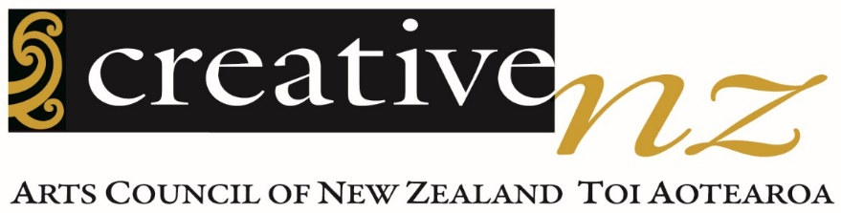

Diversity Report 2019 to 2020
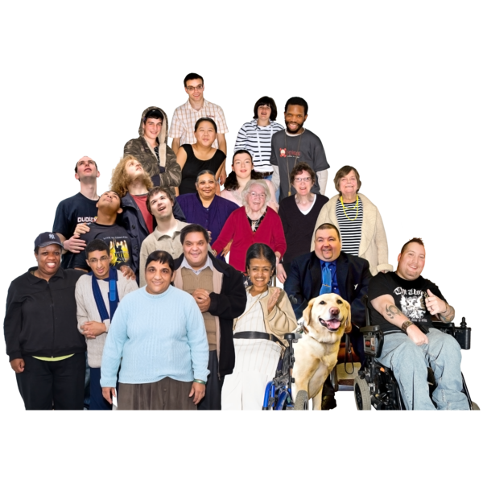
Te Pūrongo Rerenga Kētanga

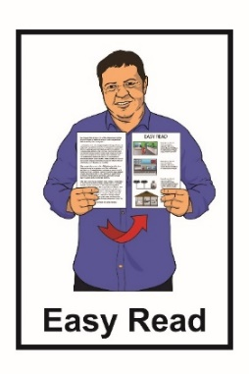

October 2021

Before you start

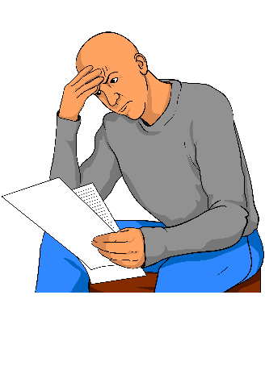
This is a long document.

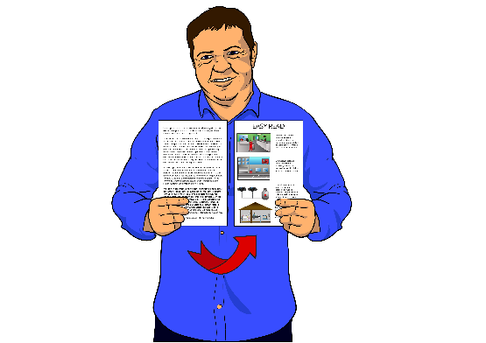
While it is written in Easy Read it can be hard for some people to read a document this long.

Some things you can do to make it easier are:
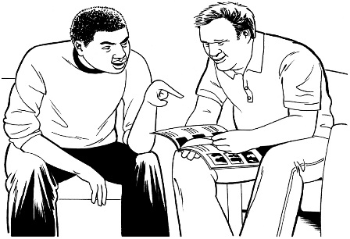
- read it a few pages at a time

- have someone help you to understand it.

What is in this report

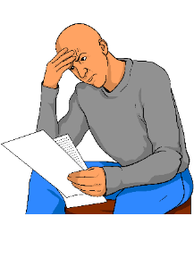
Page number:

Before you start………………………1

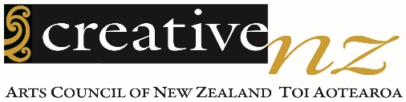
About Creative New Zealand……….6
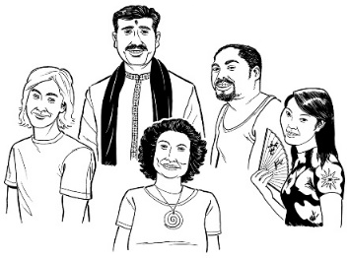

What we mean by diversity…………9
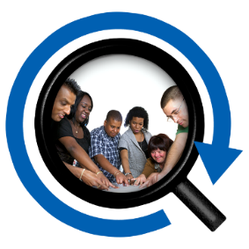

About this report……………………12

Our diversity policy…………………14

Māori arts……………………………16

Page number:
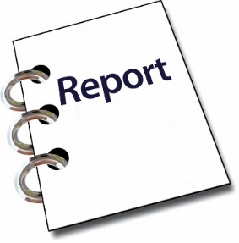

What the diversity report says…….18

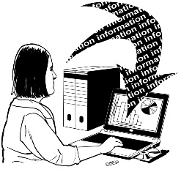
Collecting information……………...20

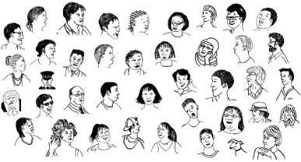
Groups we do not reach…………...21

Who we are…………………………22
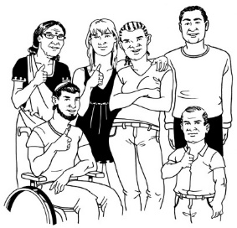

What we know about people who ask for funding………………………23
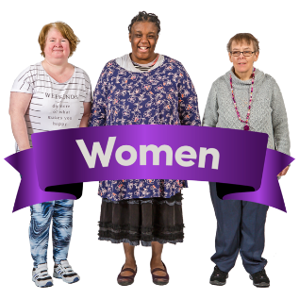

Gender………………………………24

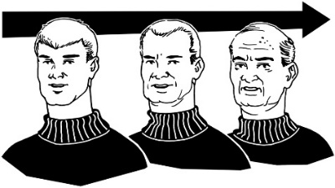
Age…………………………………..26

Page number:

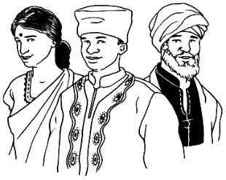
People from different
ethnic groups………………………..27

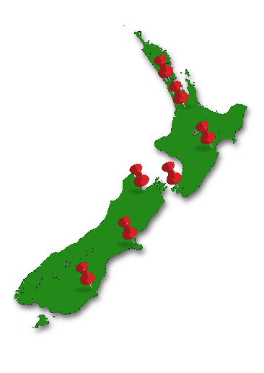
Where the organisations
are from……………………………...28

How long people have been
working in the arts………………….30

Attendance at the arts……………..31

Participation in the arts…………….32

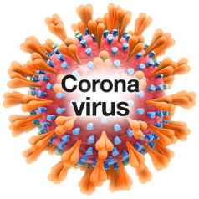
COVID-19 emergency response….33

Page number:

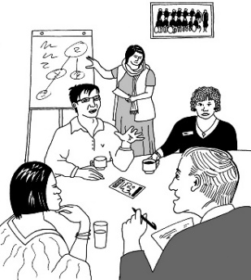
The people who give us
advice on funding…………………..35

Our staff……………………………..38

Arts Council members……………..40

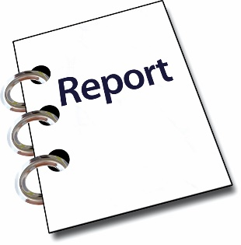
For more information………………42

About Creative New Zealand

Creative New Zealand works to support the arts.

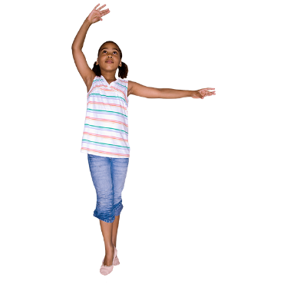
The arts means things like:
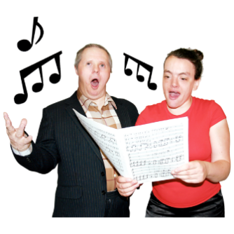
- dancing
- music / singing
- acting

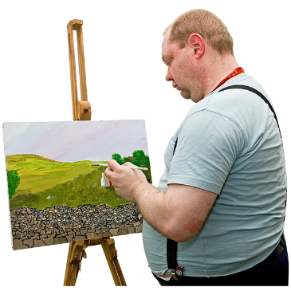
- things in museums / galleries

- paintings
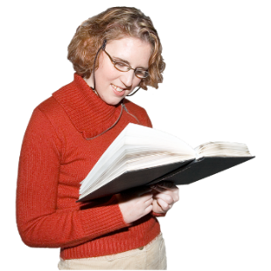
- writing
  - poems
  - stories.
The arts also means:

- Māori arts like
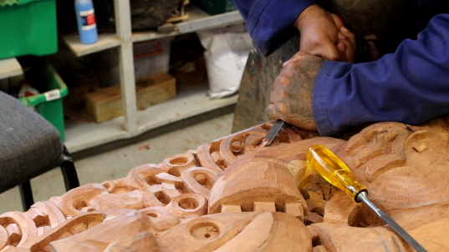
  - carving

  - weaving

  - kapa haka

- Pacific arts like:
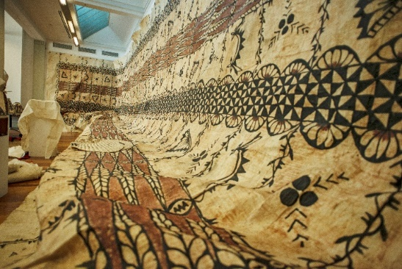
  - making tapa cloth

  - making tivaevae / quilts

  - festivals.

Creative New Zealand helps the arts in New Zealand with:
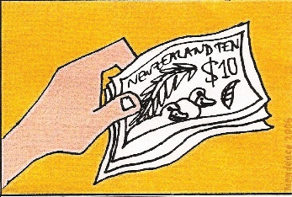
- money

- training
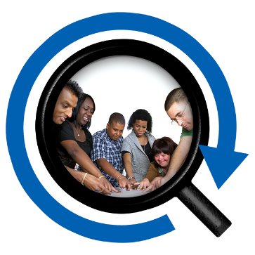
- research

- showing the work of New Zealand artists overseas
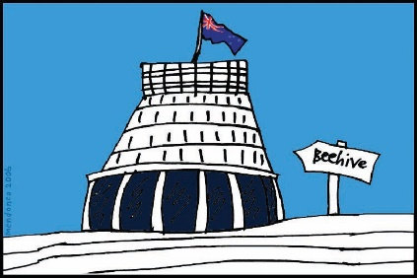
- giving advice to the government about how to support the arts.

What we mean by diversity

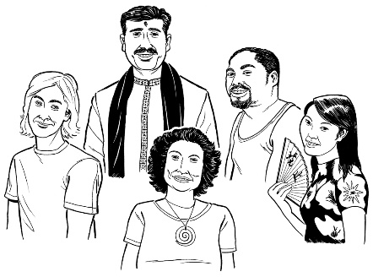
This report is about diversity in the arts.

Diversity means including people from different backgrounds.

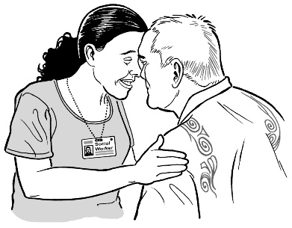
Aotearoa New Zealand is home to many people of different:

- ethnicities

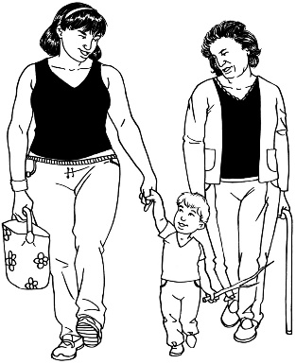
- religions

- ages

- whānau / family ways of life.

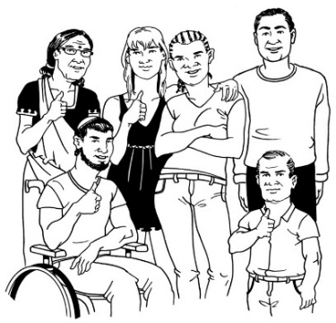
Aotearoa New Zealand is also home to:

- people who live in different places
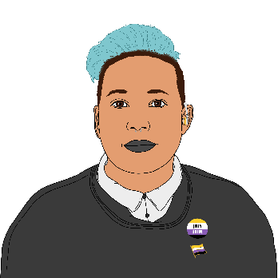
- disabled people

- LGBTTIQ+ people.

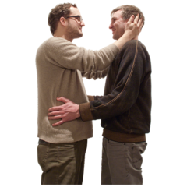
LGBTTIQ+ stands for people who are:

- lesbian

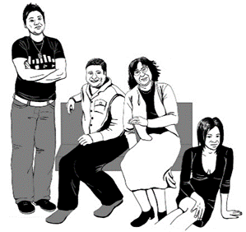
- gay

- bisexual

- transgender

- takatāpui
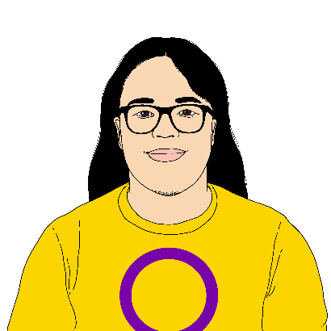
- intersex

- queer

- and others.

About this report

This is the first report about diversity.

We will write these reports every 2 years.

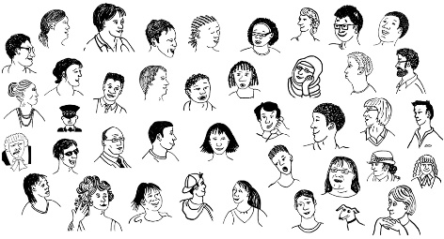
In this report we wanted to know about the people from different backgrounds who:
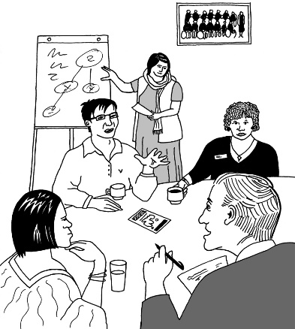
- use our services

- work for us

- give advice about arts funding.

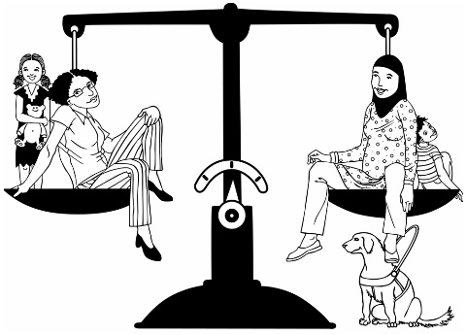
We want this report to help us:

- understand how fair the arts are to different groups of people

- make things better in the future.

Our diversity policy

Creative New Zealand has a policy called Diversity in the Arts that was written in 2015.

The policy says what we will do to make sure different communities can be involved in the arts.

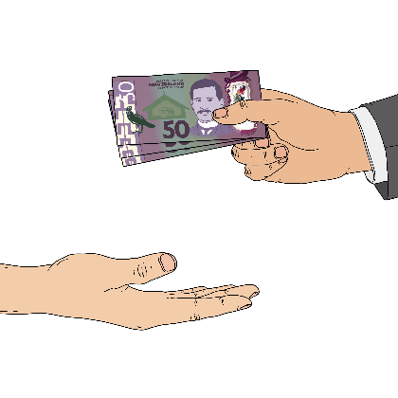
One aim of the policy is to make sure that the way we give money / funding:

- is fair to everyone
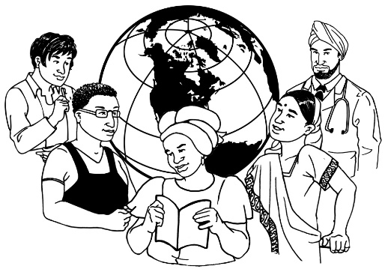
- keeps up with changes in the population like people who move to Aotearoa New Zealand from different countries.

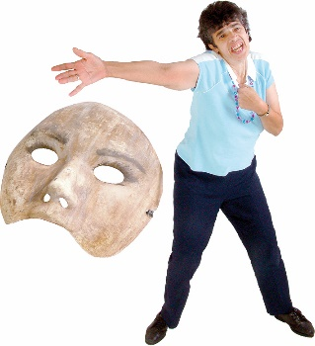
We want to make sure that all New Zealanders can enjoy the arts that we support.

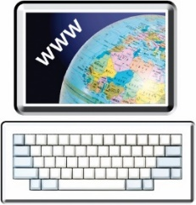
You can read more about our diversity policy on our website:

creativenz.govt.nz/diversity-in-the-arts-policy-2015

Māori arts

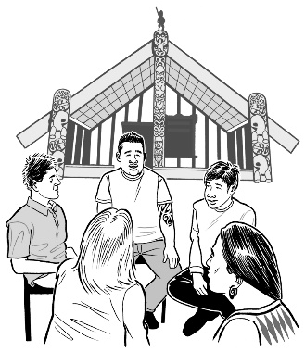
Creative New Zealand knows that Māori have a special place in Aotearoa New Zealand as tāngata whenua

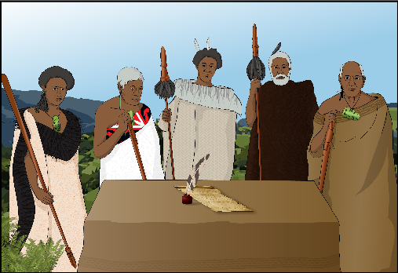
Tāngata whenua are the first people of the land / Aotearoa New Zealand.

We understand that:
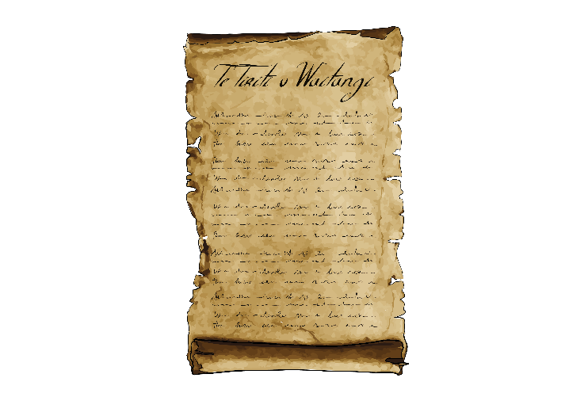
- Aotearoa New Zealand was built on an important agreement between Māori and the British Crown

- this agreement is called Te Tiriti o Waitangi.
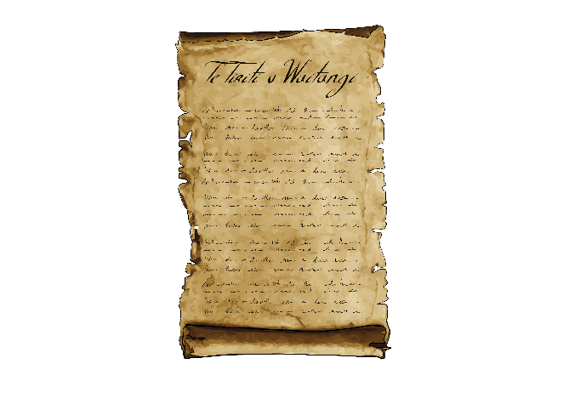
We are learning more about what Te Tiriti o Waitangi means for our work.

As we learn more about it we expect that we will need to change our policy on diversity.
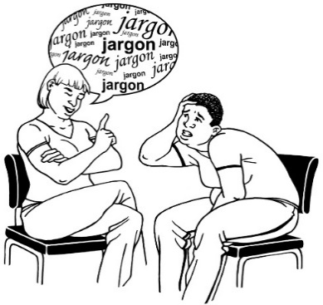

We know that some people do not like the word diversity.

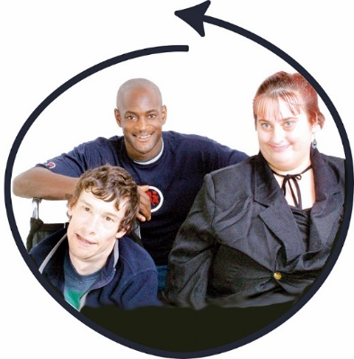
In the future we expect to put more work into:

- being fair

- including everyone.

What the diversity report says

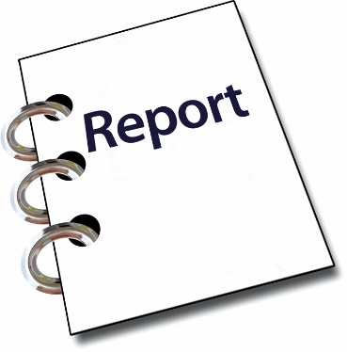
In this report we find out more about:

- the groups who ask us for money

- the kinds of people who come to the arts activities that we support

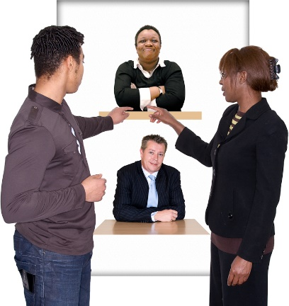
- the people who give advice on how we give out money

- staff who work for us

- members of the Arts Council which is the group that governs Creative New Zealand.
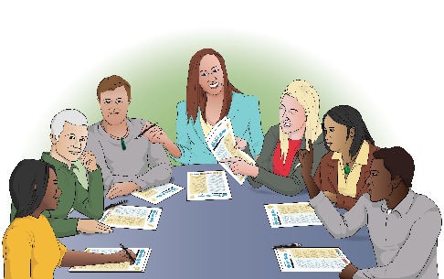

Governs means making decisions about what Creative New Zealand should do.

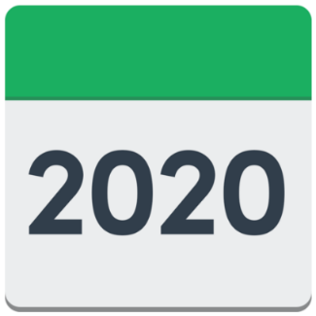
In the report we also find out who got money from the first COVID Emergency Response between March to June 2020.

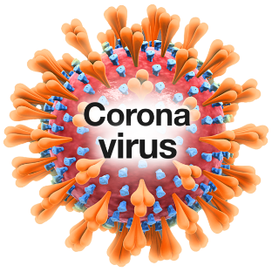
The COVID Emergency Response was a fund that was set up during the COVID lockdowns in 2020.

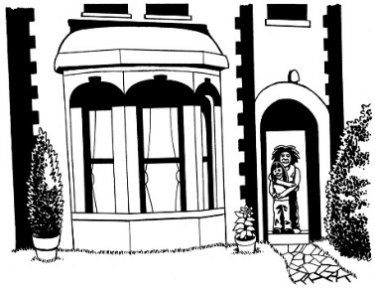
In 2020 we had lockdowns when people had to stay at home to help stop the spread of COVID-19.

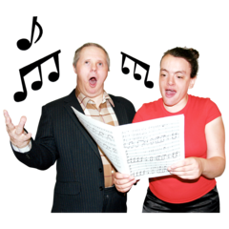
This meant that lots of live arts could not happen in 2020.

Collecting information

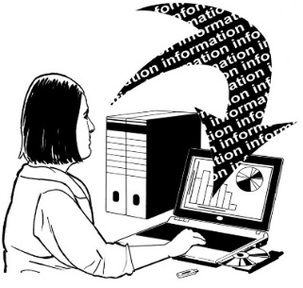
We found out that we need to keep better information about the groups that access our services like:
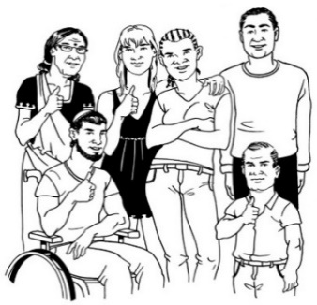
- disabled people

- LGBTTIQ+ communities.

Groups we do not reach

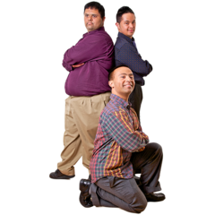
The groups that did not apply for our programmes as much as other groups are:

- people from Asian backgrounds

- young people aged from 20 to 29.

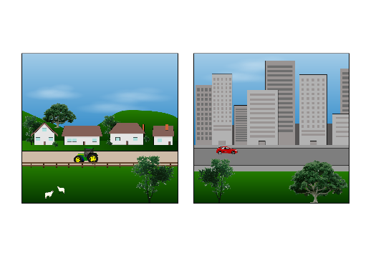
We do not give the same amount of funding to groups in big cities compared to groups in other areas.

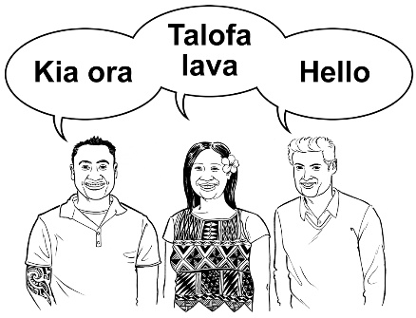
Some funding areas do not have enough groups that are led by:

- Māori

- Pacific peoples.

Who we are

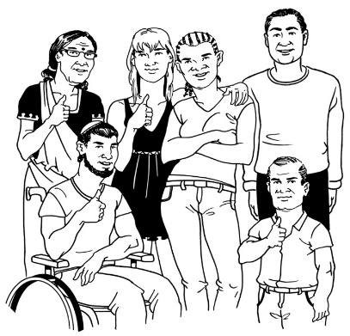
We need to do more to have diversity in:

- the people who work for us

- the people who give us advice in our decisions about funding.

What we know about people who

ask for funding

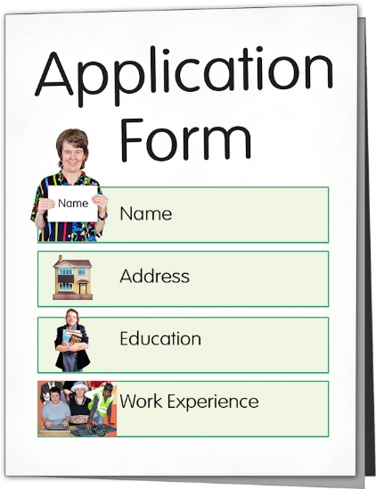
People who have received money before are the ones that tell us more about themselves.

Organisations are more likely to get money because:

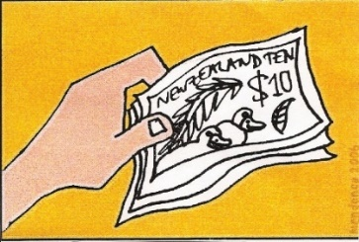
- they can write better applications

- they usually have bigger projects that involve more people as:

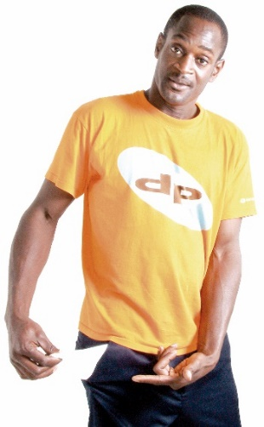
  - performers

  - audiences.

This means that people who ask for money as individuals are less likely to get it.

Gender

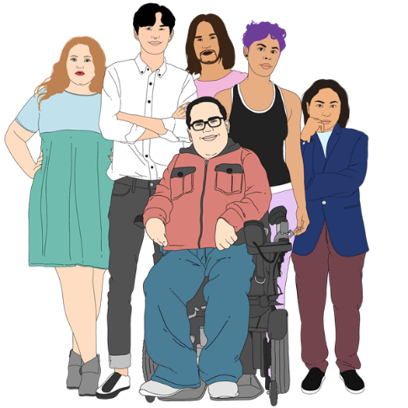
Gender is if you are:

- a man

- a woman

- another gender like non-binary or genderqueer.

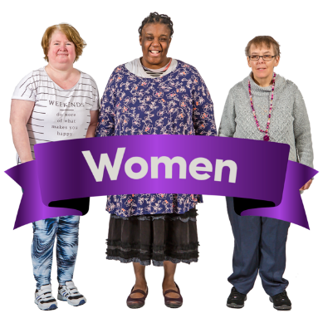
More women than men ask for funding.

Men and women are given around the same amount of funding.

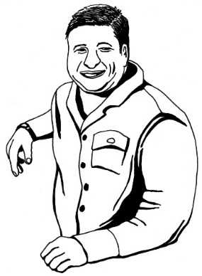
We do not collect much information about other kinds of gender diversity like if people are transgender.

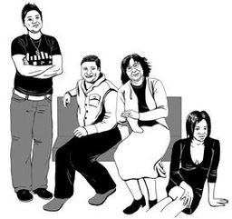
Transgender people have a different gender to what people thought their gender was when they were born.

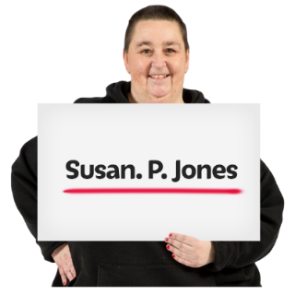
Many transgender people change things to be a better fit for their gender like:
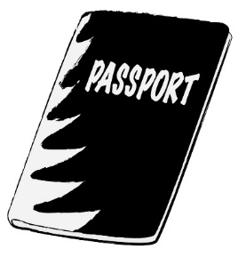
- changing their name
- changing what their passport or birth certificate says their gender is
- taking medicine to change their body.

Age

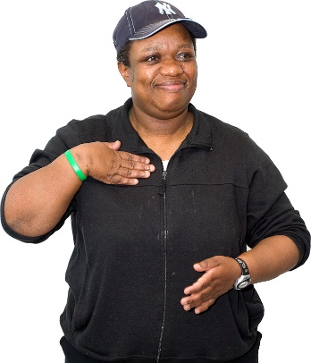
People aged from 30 to 39 are the group most likely to get funding.

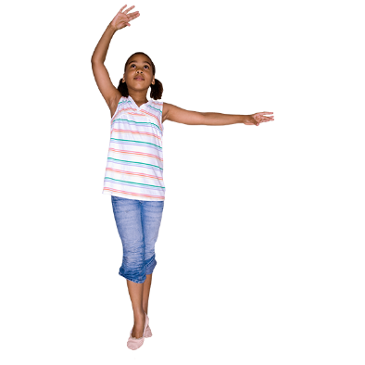
This fits in with the numbers of people involved in the arts as their job.

The people least likely to get funding are young people under 20 years old.

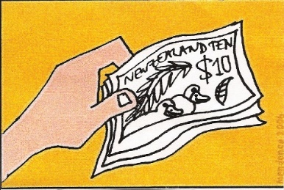
Only a very small number of their projects got funding.

People from different ethnic groups

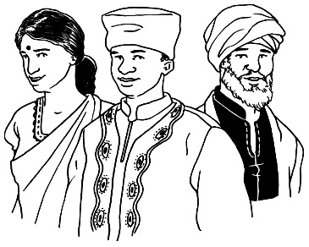
People from most ethnic groups applied for funding.

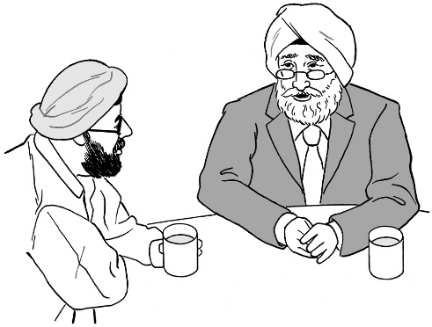
Asian people were less likely to apply.

When Asian people did apply they often got the funding they asked for.

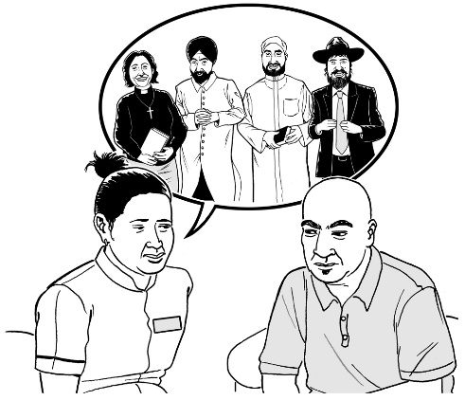
Most groups that applied did not say anything about ethnicity.

We will ask more groups about ethnicity so we can learn more about who is applying for funding.

Where the artists and organisations are from

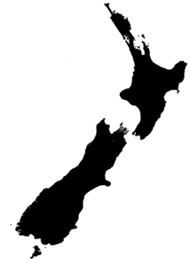
Most of the artists and organisatsions applying for funding lived in:

- Auckland

- Wellington.

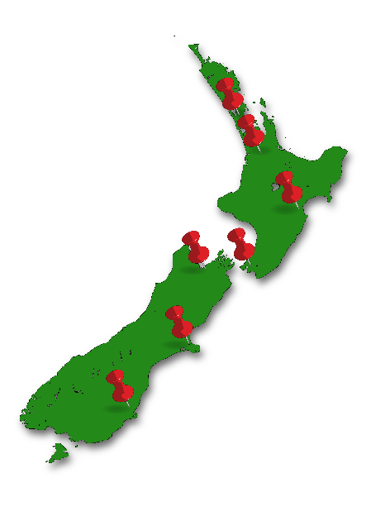

Lots of artists might be based in those two cities but perform in different places in Aotearoa New Zealand.

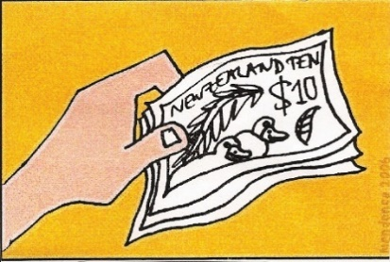
We also have funds to support arts outside of the main cities.

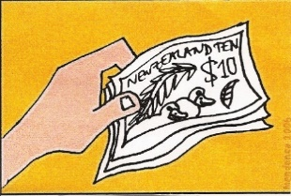
The funds used to support arts outside of the main cities are called:

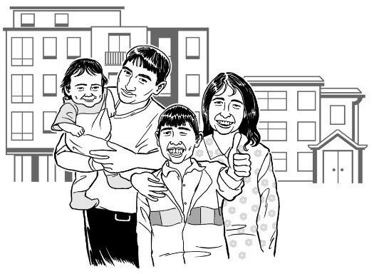
- the Creative Communities Scheme

- Ngā Toi ā Rohe – Arts in the Regions.

How long people have been working

in the arts

We do not have much information about how long people have been working in the arts.

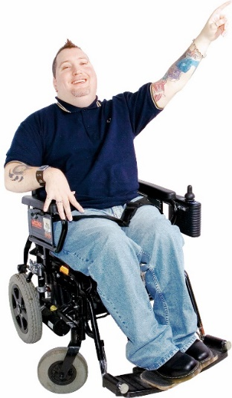
From the information we have it seems that people who have been working in the arts for longer are more likely to:

- ask for funding

- get funding.

Attendance at the arts

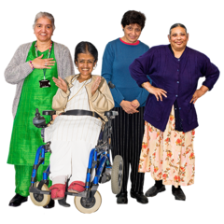
Attendance means if people go to different arts events.

More people attend the arts in:

- Wellington

- Nelson - Marlborough.

Not as many people attend the arts in:

- Northland

- Auckland

- Waikato

- Bay of Plenty

- Manawatū - Whanganui.

Participation in the arts

Participation means people doing art.

More people participate in the arts in:

- Wellington

- Canterbury

- Southland.

Not as many people participate in the arts in:

- Northland

- Auckland

- Bay of Plenty

- Waikato.

COVID-19 emergency response

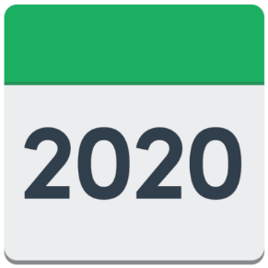
In 2020 we had to change some of the things we did because of COVID-19.

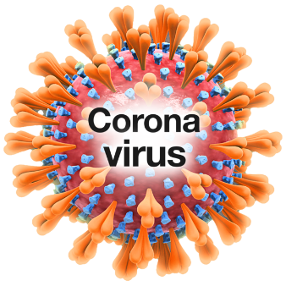
COVID-19 is a virus that can make people very sick.

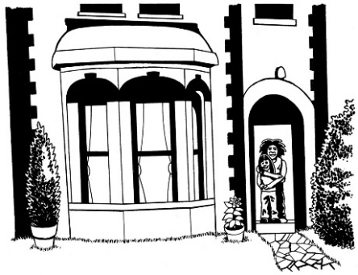
In 2020 we had COVID-19 lockdowns when people had to stay at home.

This meant that lots of live arts could not happen in 2020.

We made some new kinds of funding to support artists during COVID-19.

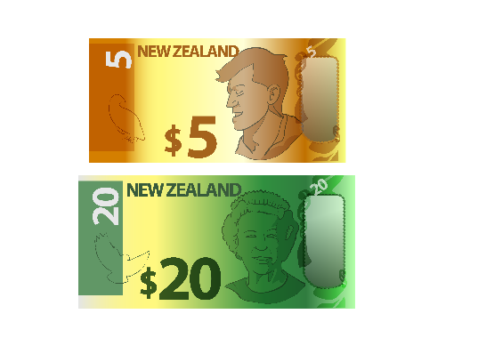
During COVID-19 lockdown when people had to stay at home
lots of new artists asked us for funding.

More money went to the places with the most artists:

- Auckland

- Wellington.

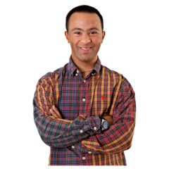
More money went to artists between 20 and 29 years old than usual.

The people who give us advice on funding

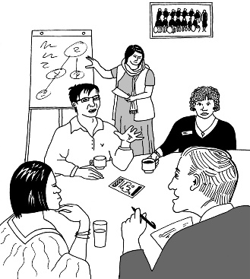
We get advice on our funding decisions from peer assessors.

Peer assessors are people who:
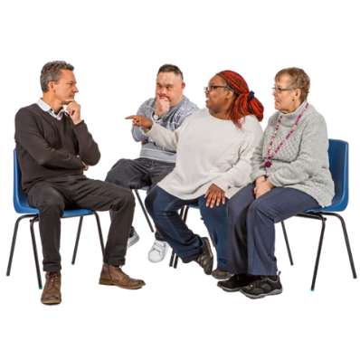
- know about the arts

and

- have worked in the arts.

Peer assessors come from all across Aotearoa New Zealand.

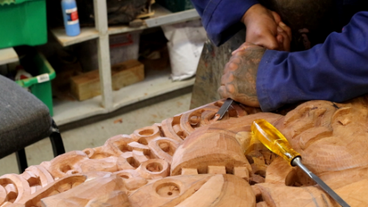
Peer assessors are involved in all different kinds of arts like:

- Māori arts

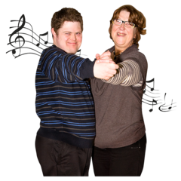
- dance

- visual arts

- music.
There is good diversity in our group of peer assessors:

- almost 1 in 2 are New Zealand European
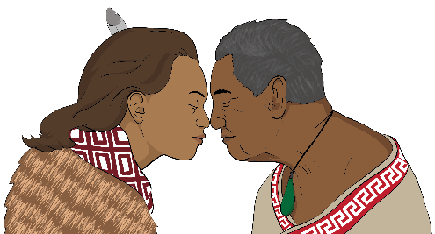
- more than 1 in 4 are Māori

- nearly 1 in 5 are Pasifika

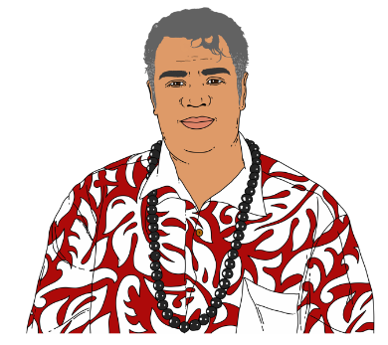
- just over 1 in 20 are Asian

- 1 in 20 are other European

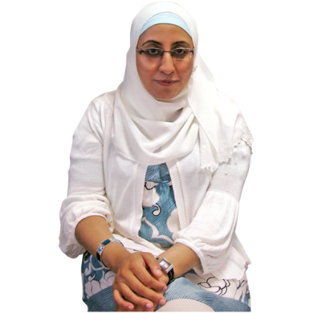
- 1 in 100 peer assessors are from a group of places called:

- the Middle East

- Latin America

- Africa.

Almost 1 in 3 peer assessors are from 40 to 49 years old.

One area we saw a gap in our diversity was for people aged from 20 to 29.

Our staff

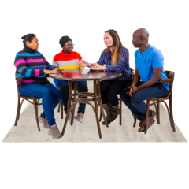
The diversity of Creative New Zealand staff is good.

The diversity could be better.

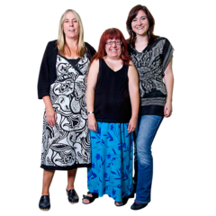
In the year 2019 to 2020:

- 7 out of every 10 staff were women

- 4 out of every 10 senior leaders were women.
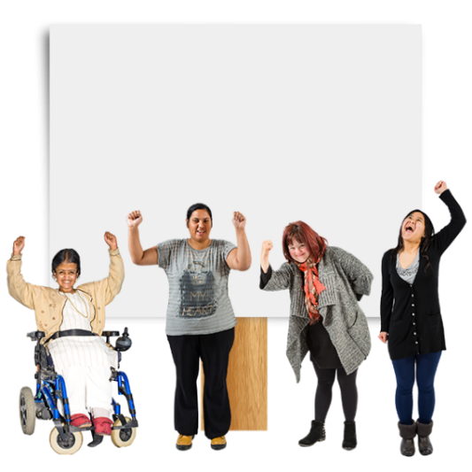

Since then more women have become leaders.

Now half of our leaders are women.

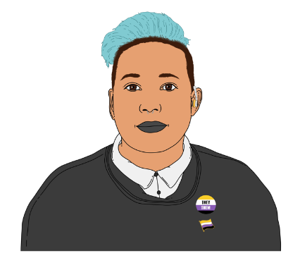
2 in every 100 of our staff say they are non-binary.

Non-binary people are people who:

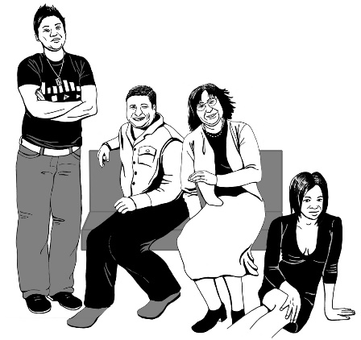
- have a gender that is not a man or a woman

- have more than 1 gender

- do not have a gender at all.

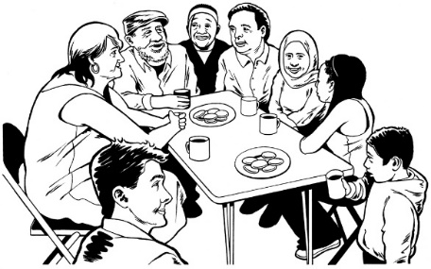
Our staff come from lots of different:

- ethnic groups

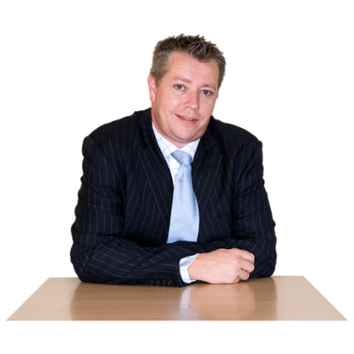
- age groups.

Our managers are not as diverse as the rest of our staff.

Arts Council members

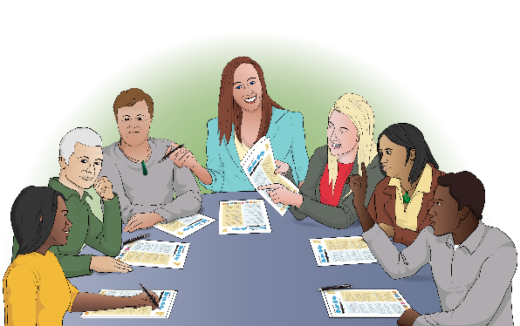
The Arts Council is the group that governs Creative New Zealand.

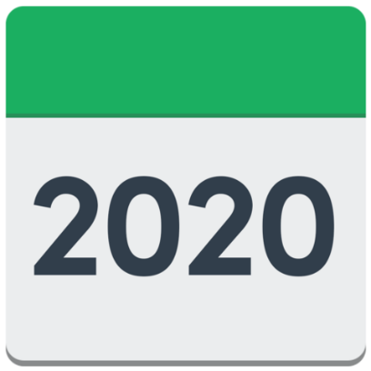
Governs means making decisions about what Creative New Zealand should do.

These figures are from June 2020.

The members of the Arts Council included:

- 7 women
- 6 men.

Most of the members of the Arts Council are between 50 and 59 years old.

Most members of the Arts Council live in Wellington.

The law that says who should be in the Arts Council tells us the number of people who should be:

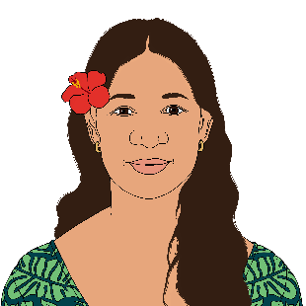
- Māori

- Pasifika.

The Arts Council has:

- 1 member who is Asian
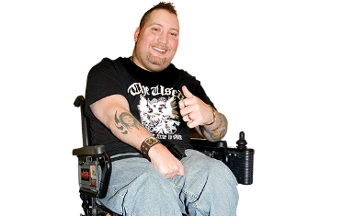
- 1 member who is a disabled person.

For more information

You can find more information about the arts in the full report.

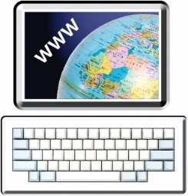
You can find the full report on the Creative New Zealand website at:

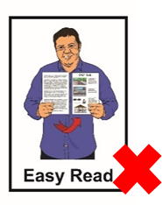
www.creativenz.govt.nz/research

The full report is not in Easy Read.

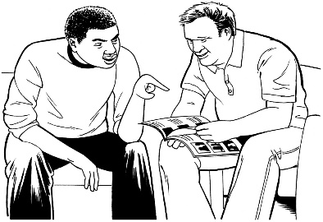
You can ask someone to read it through with you.

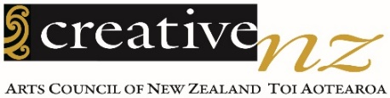
This information has been written by Creative New Zealand.
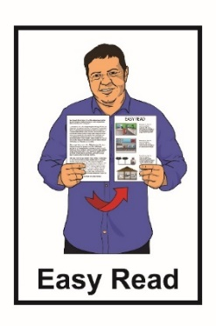
It has been translated into Easy Read by the Make It Easy service of People First New Zealand Inc. Ngā Tāngata Tuatahi.
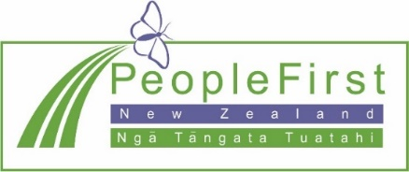
The ideas in this document are not the ideas of People First New Zealand Ngā Tāngata Tuatahi.
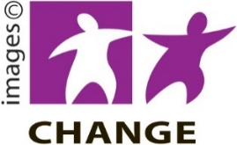
Make It Easy used images from:
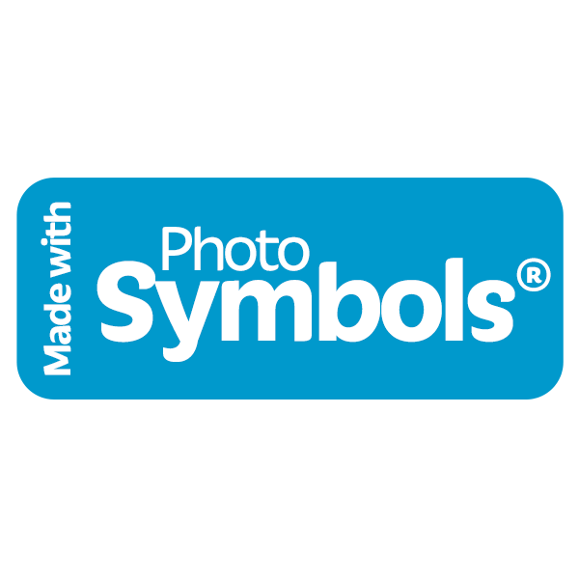
- Changepeople.org

- Photosymbols.com

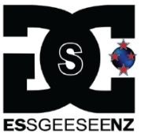
- Sam Corliss

- Huriana Kopeke-Te Aho

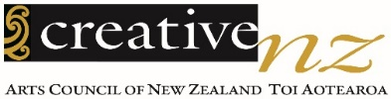
- Creative New Zealand

- Raymond Sagapolutele.
All images used in this Easy Read document are subject to copyright rules and cannot be used without permission.

