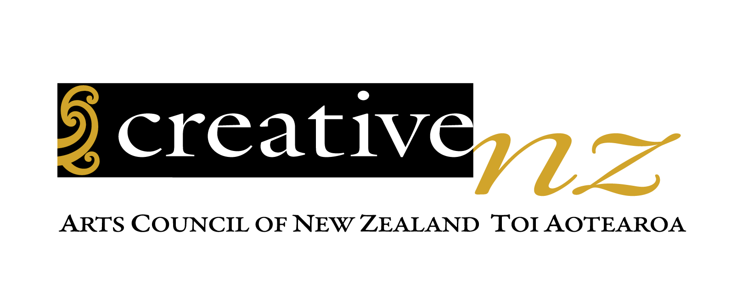
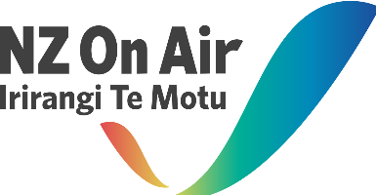
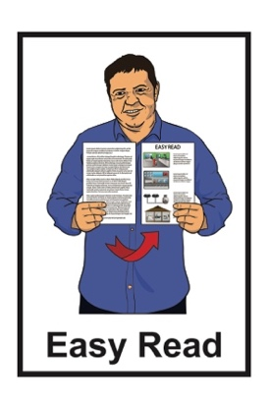
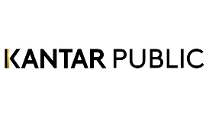

Research summary:
The working life of
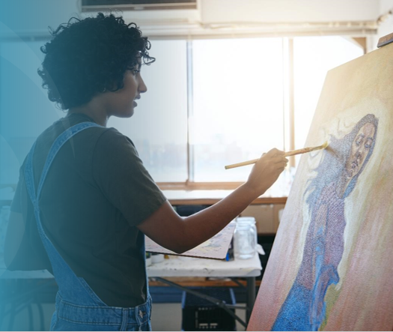
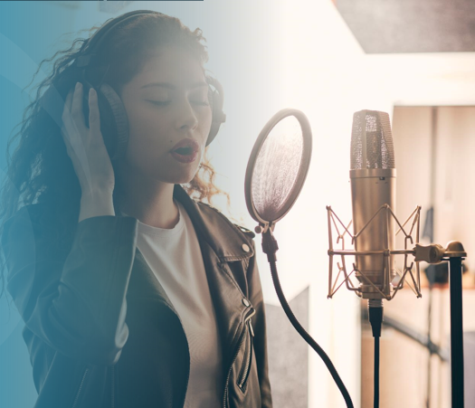
creative professionals in 2022

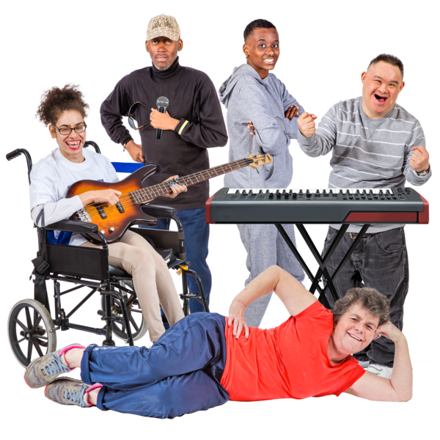

Published: May 2023

Before you start

This is a long document.

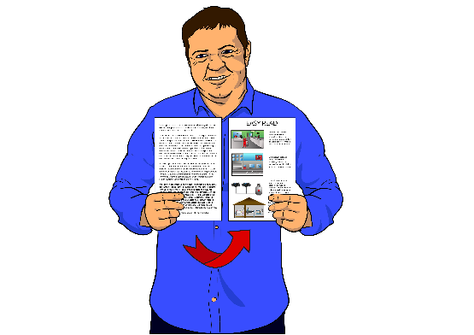
While it is written in Easy Read it can be hard to read a document this long.

Some things you can do to make it easier are:
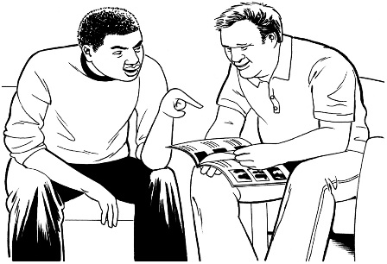
read it a few pages at a time
ask someone to support you to understand it.

What you will find in this document

Page number:

What this document is about 3
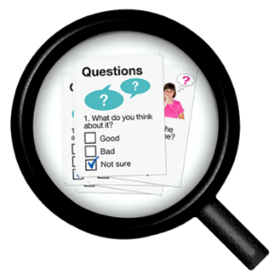

What the research was about 7

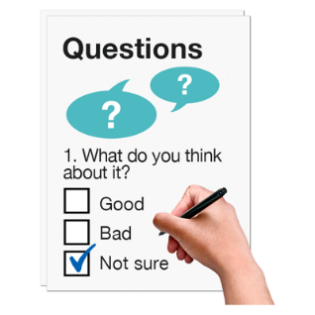
How the research was done 9

Who took part in the survey? 12
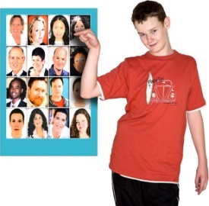

What the survey showed 15

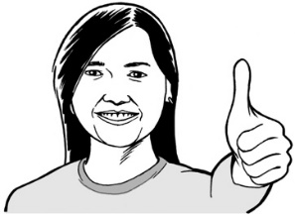
Saying thank you 38

Where to find more information 40

What this document is about

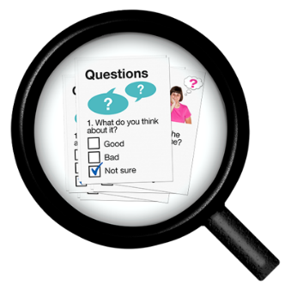
In 2022 Creative New Zealand and NZ On Air asked Kantar Public to do some research.

Creative New Zealand is the government office that supports the arts.

NZ On Air works with creative professionals to share stories and songs made in New Zealand.

Kantar Public is a business that works with other businesses / the government to do things like research.

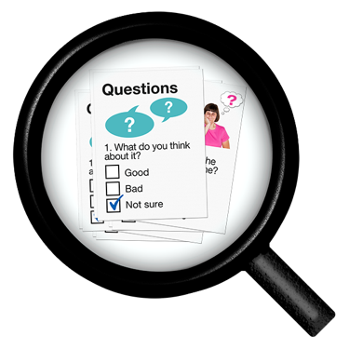
Research is when we:
look at what things have happened
try to find out ways to do things better.

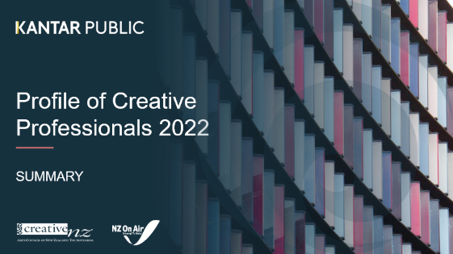
This document is an Easy Read summary of the research report called:

Profile of Creative Professionals 2022

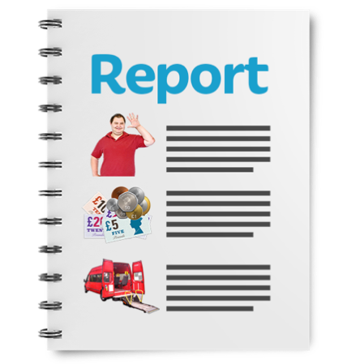
A summary:
is shorter than a full report
tells you the main ideas.

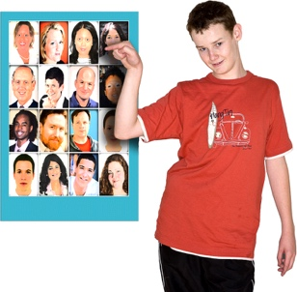
A profile is a way of saying what something / someone is like.

Creative professionals are people who earn money from doing creative work.

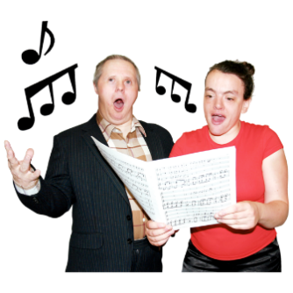
Creative work can be things like:
dancing
playing a musical instrument
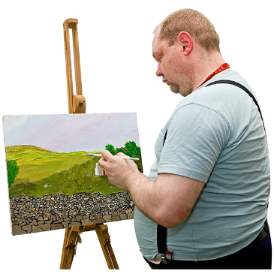
singing
acting
painting.

Creative work can also be:
writing books
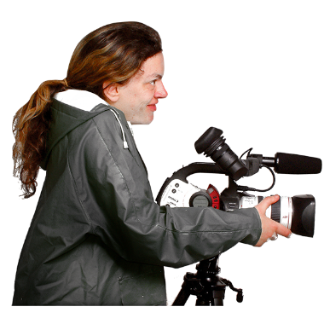
writing poems
making films
working with musicians
making online games like computer games.

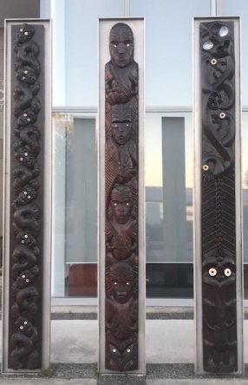
Creative work includes ngā toi Māori / Māori arts like:
carving
weaving.

What the research was about

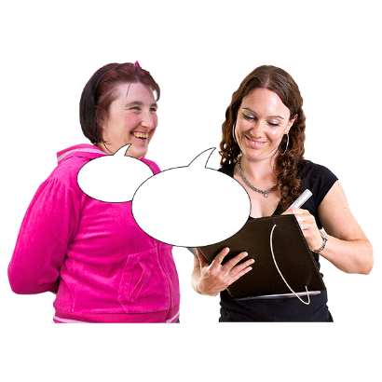
The research asked people who do creative work about their work:
from April 2021
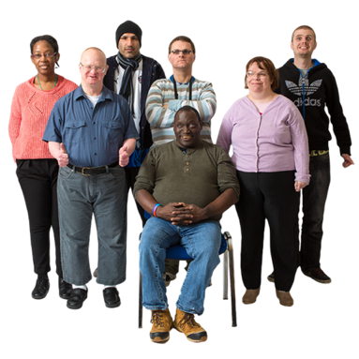
to March 2022.

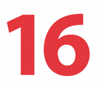
The research was only for people over 16 years old.

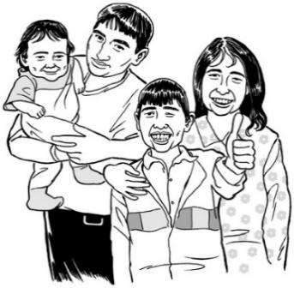
Creative New Zealand used the research to find out if:
- people who do creative work earn enough money to live a good life
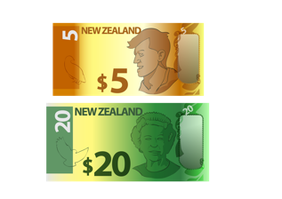
- there are better ways to support people who do creative work.

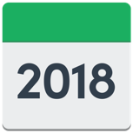
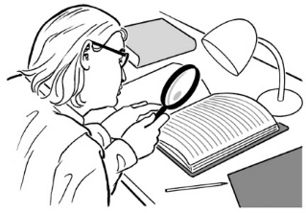
The last time Creative New Zealand did research like this was in 2018.

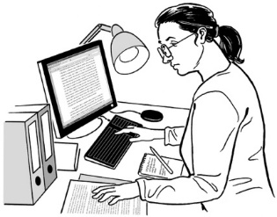
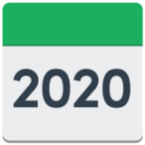
The 2022 research lets people see if anything has changed for people who do creative work since 2018.

How the research was done

Kantar Public made a survey for people to do.
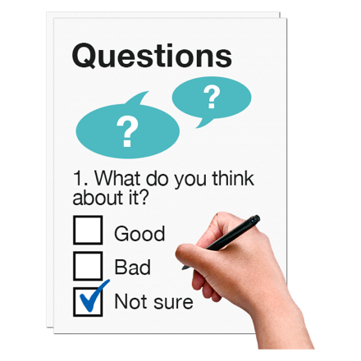

A survey is when people are asked questions about something to find out what they think.

People could do the survey:
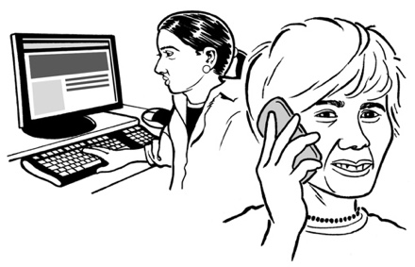
- online using a computer / smartphone
- by making a phone call.
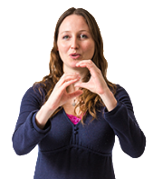

People could also make a video call with a New Zealand Sign Language interpreter.

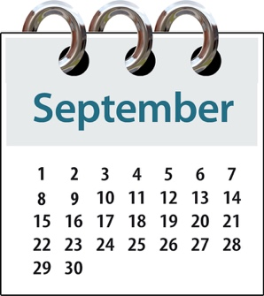
People took part in the survey:
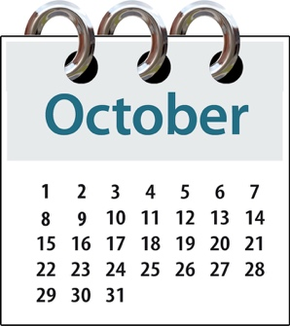
from 15 September 2022
to 10 October 2022.

In the survey Kantar Public asked people who do creative work questions about:
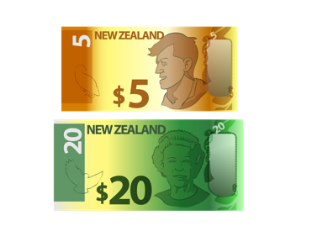
their wellbeing
how much money they earned
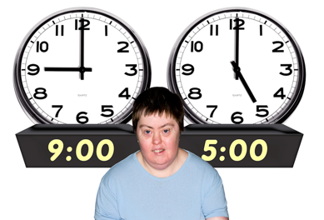
how many hours they worked.

Wellbeing means how people feel about their lives.

Some of the things that are important to wellbeing are having:
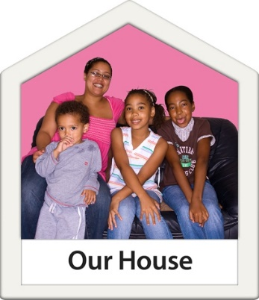
good health
enough money to live a good life
a safe place to live.

Who took part in the survey?

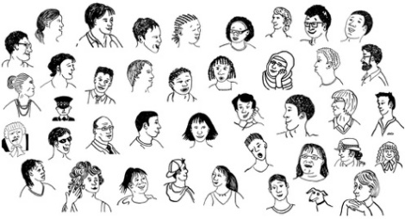
603 people who do creative work took part in the survey.

About half of the people who took part were men.

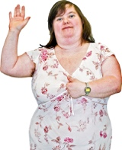
About half the people who took part were women.

18 people who took part were
non-binary.

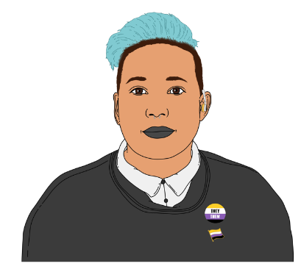
Some people are not a man or a woman.

They may call themselves non-binary.

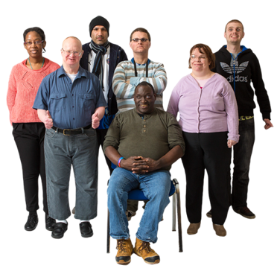
63 people who took part said they were Deaf / disabled.

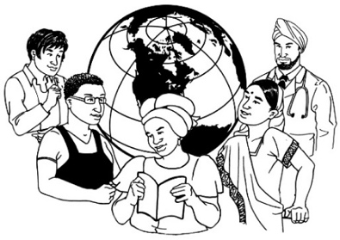
The people who took part in the survey cam from lots of different backgrounds / cultures.

Culture is a way of:
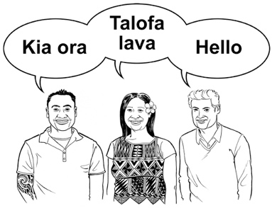
thinking that people share
doing things as a group.

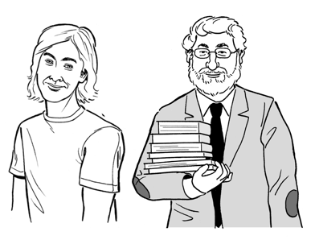
People who took part in the survey included:
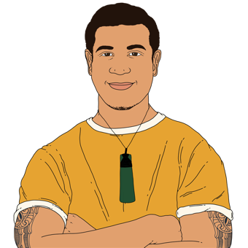
almost 5 hundred people who were New Zealand European
more than 1 hundred people who were Māori.

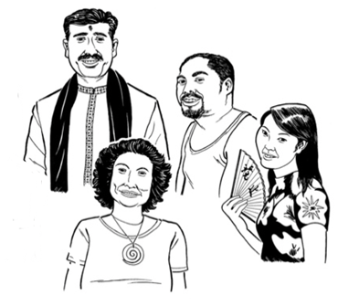
A small number of people who took part in the survey were:
Asian New Zealanders
Pacific peoples.
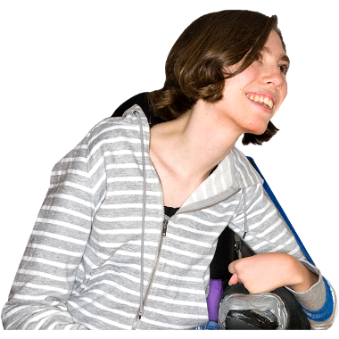

The people who took part in the survey were from many different age groups.

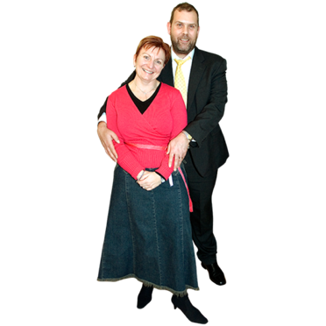
The smallest group of people were under 30 years old.

Half of the people were over 30 but under 50 years old.
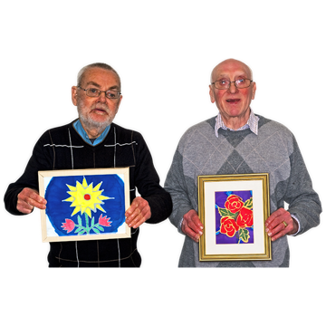

More than a third of the people were over 50 years old.

What the survey showed

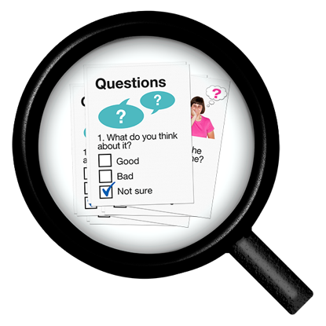
The next few pages are about:
the kinds of questions that were asked in the survey
what Kantar Public found out from the survey.

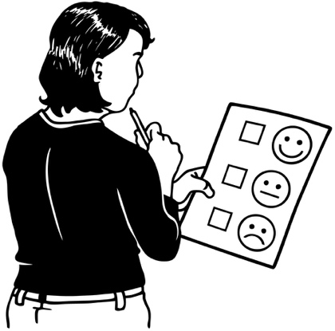
In this Easy Read document we have put the questions that were asked in the survey:
in bold writing
at the top of the page.

Did people doing creative work earn the same amount of money as other people in 2021 / 2022?

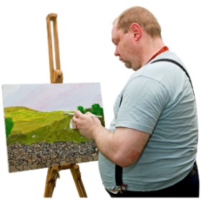
We found out people doing creative work mostly earned about
37 thousand dollars in a year.

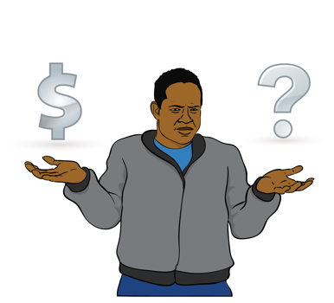
This amount was:
about the same as other people in New Zealand who were self-employed
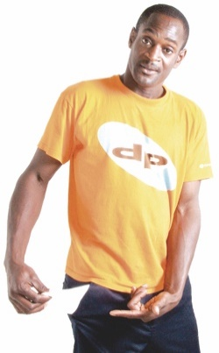
a lot less money than people in New Zealand who earned money called wages for the jobs they do.

Self-employed means working for yourself.

Did people doing creative work earn different amounts in 2021 / 2022 because of who they were?

Men who did creative work earned the most money.

They earned around 44 thousand dollars in the year.

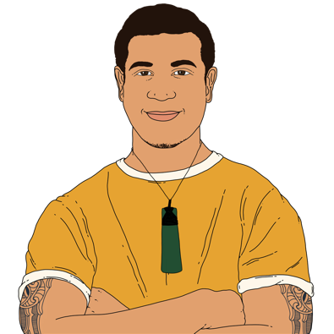
People who did creative work who were Māori also earned quite well.

They earned around 42 thousand dollars in the year.

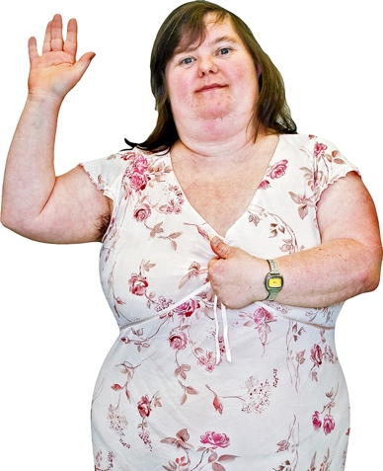
Women who did creative work did not earn so well.

They mostly earned around thirty thousand dollars in the year.

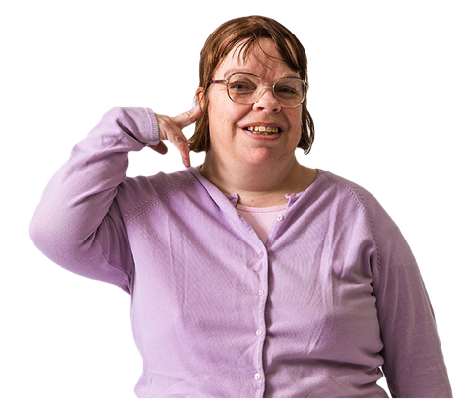
Deaf / disabled people who did creative work earned the least.

They mostly earned around 28 thousand dollars in the year.

Did people doing creative work earn more money or less money after COVID-19 was found in New Zealand?

COVID-19 is an illness that can make some people very sick.

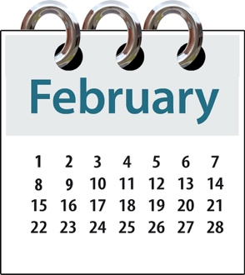
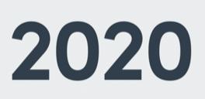
COVID-19 was first found in New Zealand in February 2020.

The research found that:
about 4 in 10 people who did creative work earned more after February 2020
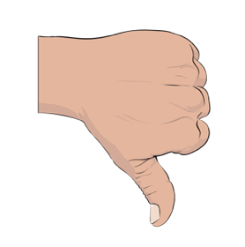
about 4 in 10 people who did creative work earned less after February 2020.

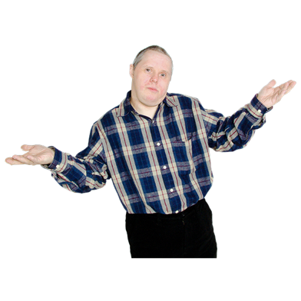
Some people who did creative work earned about the same amount of money as before February 2020.

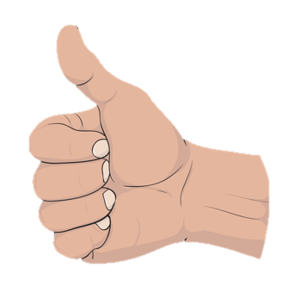
Some people who did creative work earned a lot more money after February 2020.

For example a lot of video game developers said they earned more after February 2020.

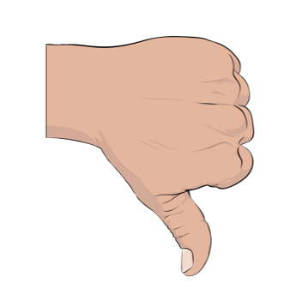
Some people who did creative work earned a lot less money after February 2020.

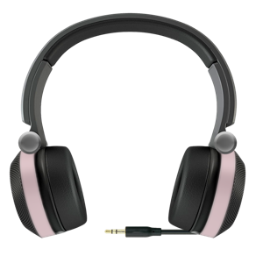
For example about half of music and sound artists said they earned less after February 2020.

Sound artists are people who use computers to make music sound good.

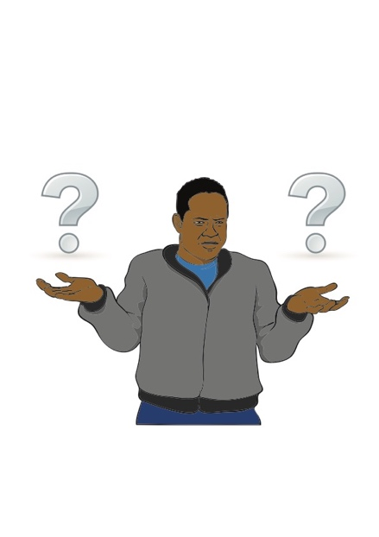
Were the 2022 research results different from the 2018 results?

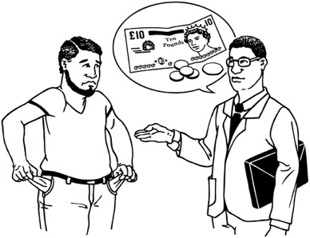
The research shows that most people who did creative work still did not earn very much money.

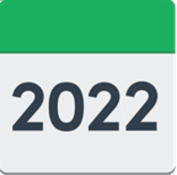
People who did creative work generally earned a bit more money from their creative work in 2021 / 2022 than in 2018.

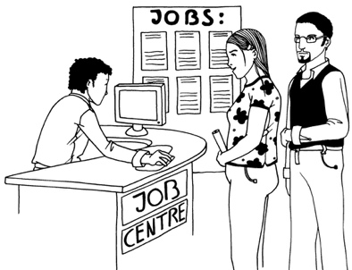
Many people who did creative work also got money from other work that was not creative.

People who did creative work and other work generally earned a bit more money from all their jobs in 2021 / 2022 than in 2018.
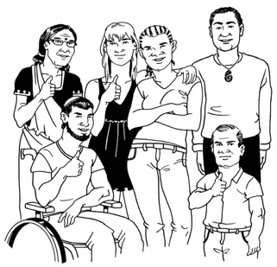
The people who took part in the 2022 survey were different from the people who took part in the 2018 survey.

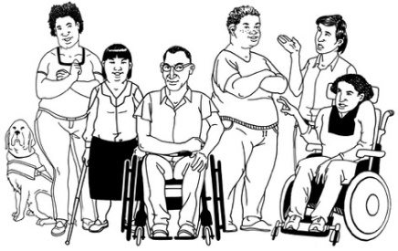
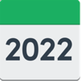
The people who took part in the 2022 survey included more people doing creative work who:
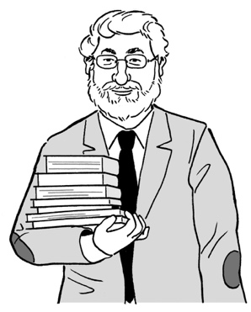
- were men
- were older
had been working in creative jobs for a long time
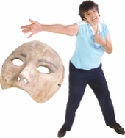
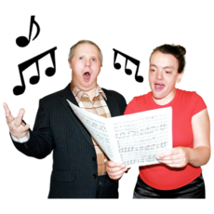
did different sorts of art / creative jobs from people in the 2018 survey.

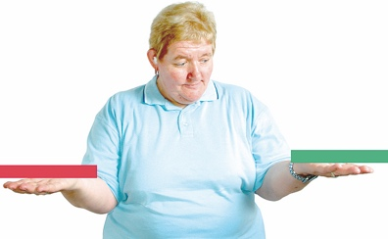
These differences may be a reason why the research showed people earned more in 2022 than in 2018.

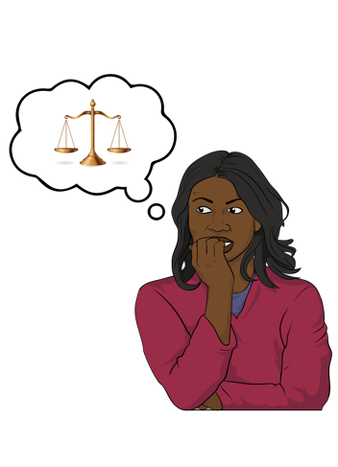
Did people doing creative work earn a fair amount of money for the time they worked in 2022?

Fair means the money was enough for the work done.

Only 2 out of 10 people who did creative work thought the money they earned was fair.

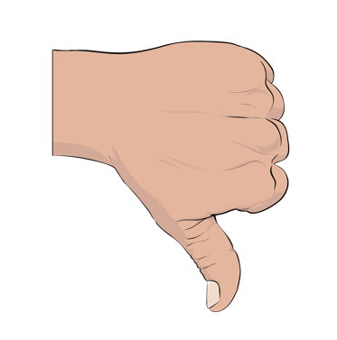
About 7 out of 10 people who did creative work thought the money they earned was not fair.

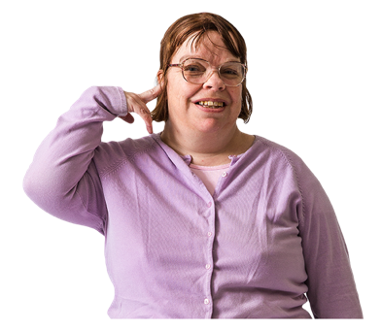
The people who were most likely to think the money from their creative work was not fair were:
- Deaf / disabled
- writers / people working with books
- people working in theatre / music / dance
- women
- people who work in the gig economy.
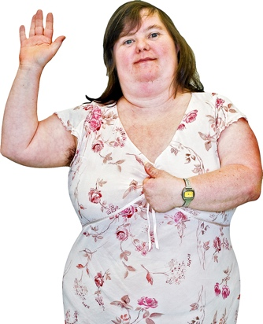

The gig economy is a way of working where people do lots of short jobs 1 after the other.

Did people doing creative work do other work as well as creative work in 2022?

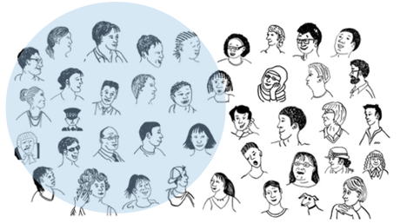
About half the group only did creative work.

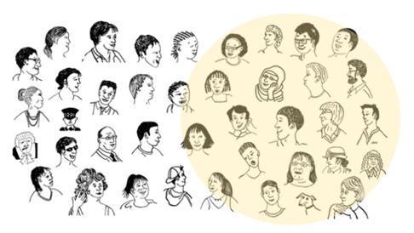
About half the group did other work as well as creative work.

The people in the group who were most likely to do other work as well as creative work were:
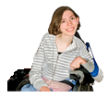
- music / sound artists
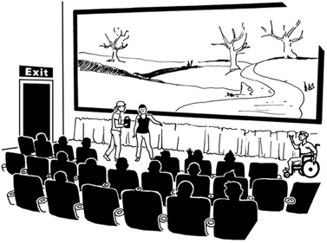
- just starting out doing creative work / young
- working in theatre / music / dance
- working in the gig economy.

Did households where people live who do creative work earn as much as other households in 2022?

A household is a place where a group of people live together.

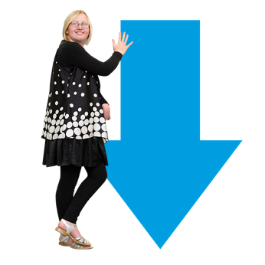
Most households where people who do creative work lived had a lower household income than other New Zealand households.

Household income means the money everyone in a household earns added together.

Households where people who did creative work lived earned about 17 thousand dollars less than other households in 2022.

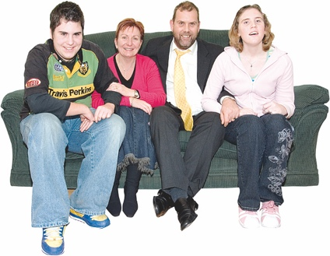
Did people doing creative work think they got enough money to live a good life in 2022?
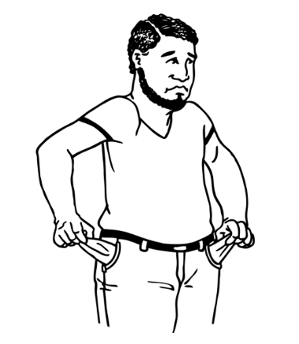

1 out of 10 people who had a household income of about
39 thousand dollars in 2022 said it was very difficult to live a good life.
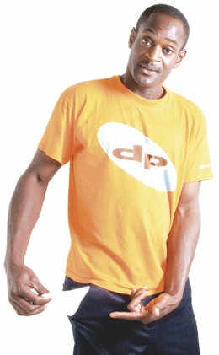
About 2 out of 10 people who had a household income of about
67 thousand dollars in 2022 said it was difficult to live a good life.
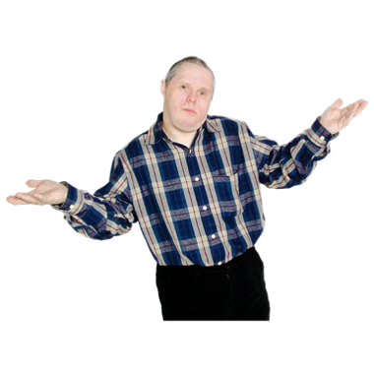
4 out of 10 people said they were getting by on a household income of about 95 thousand dollars in 2022.

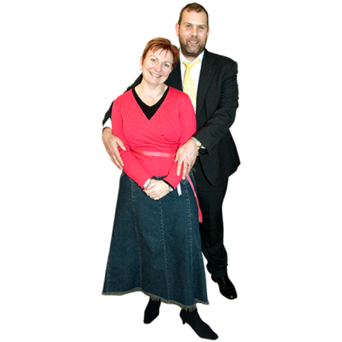
About 2 out of 10 people said they lived comfortably on a household income of about
140 thousand dollars in 2022.

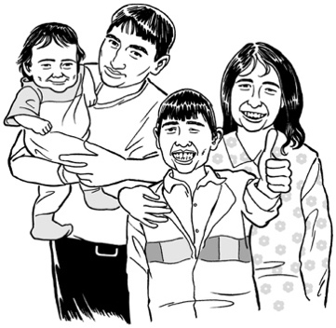
Did people doing creative work have a happy working life in 2022?

People who feel happy with their working life usually feel happy with their whole life.

1 out of 10 people said they were not happy with their working life.

5 out of 10 people said they were happy with their working life.

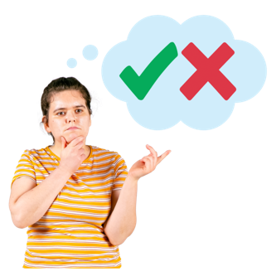
4 out of 10 people said they were neither:
happy with their working life

or
unhappy with their working life.
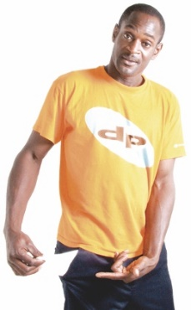
The people doing creative work who were not happy with their working life included people who were:
- finding it hard to live a good life as they did not have enough money
- Asian New Zealanders
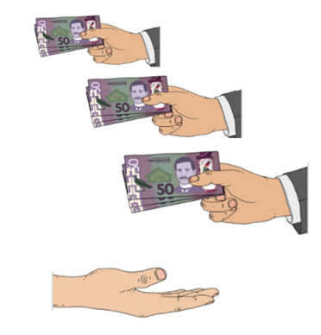
- just starting in a creative job
- doing other jobs as well as creative work
- working in the gig economy.

Did people doing creative work get burnout because of their working life in 2022?

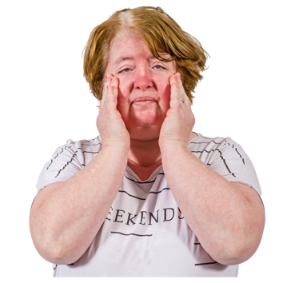
Burnout is a type of stress that makes you too tired to do anything because of your job.

Stress is the way your body feels when you must deal with something difficult.

Stress can make you feel:
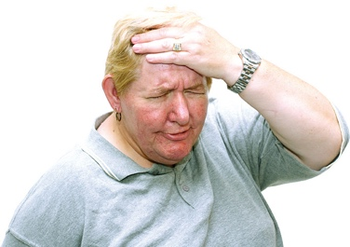
like you cannot think clearly
like you cannot cope with things.

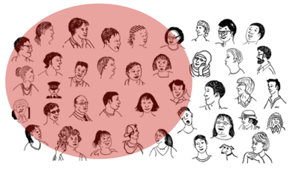
More than half of the people said they had felt burnout.

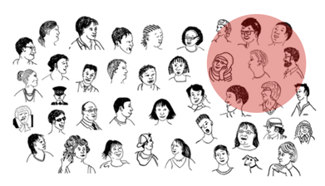
Just over a quarter of the people said they had felt close to having burnout.

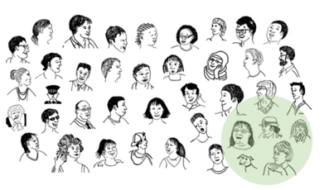
Less than a quarter of the people said they had not felt burnout.

A very small number of people said they did not know if they had felt burnout.

The people doing creative work most likely to say they had felt burnout were:
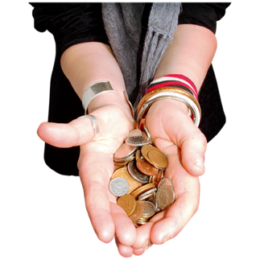
- Deaf / disabled
- finding it hard to live a good life with not enough money
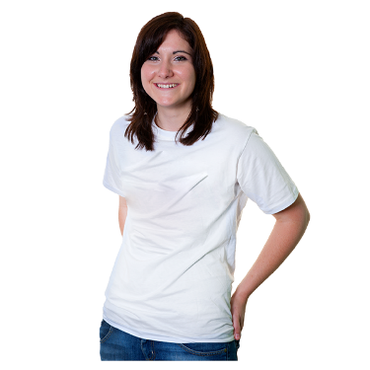
- under 40 years old
- just starting working in a creative job
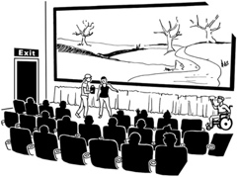
- working in more than 1 creative way
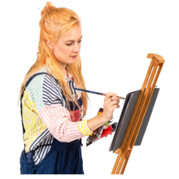
- doing another job as well as a creative job.

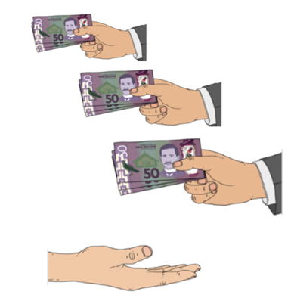
Working in the gig economy

7 out of 10 people doing creative work did jobs in the gig economy in 2021 / 2022.
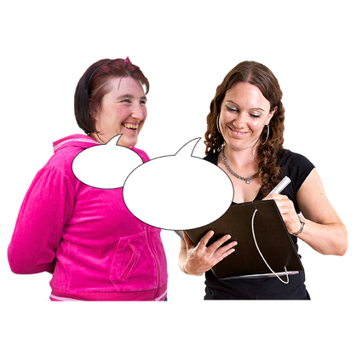

We asked them if it was hard to work in the gig economy.

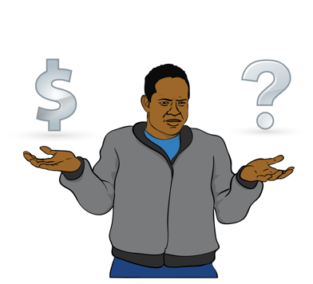
They told us working in the gig economy made it hard to:
- get a loan
- know how much money they would earn in a year.

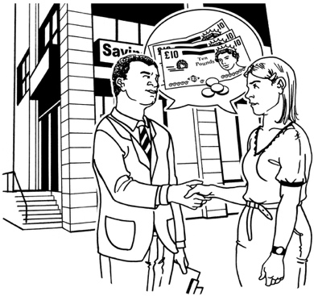
A loan is money you get from your bank.

You must pay this money back at a later time.

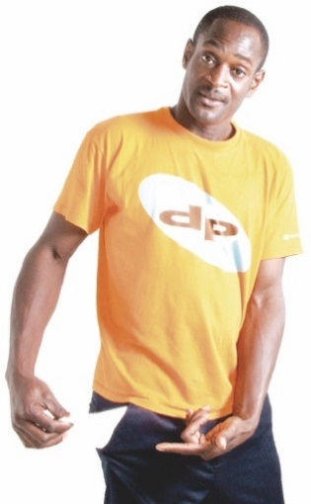
The people doing creative work also told us doing jobs in the gig economy was hard because they did not get:
holiday pay
- sick pay.

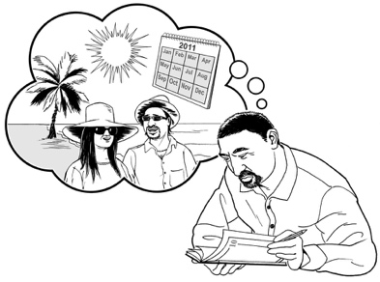
Holiday pay is money you get from your job when you are on holiday and not working.

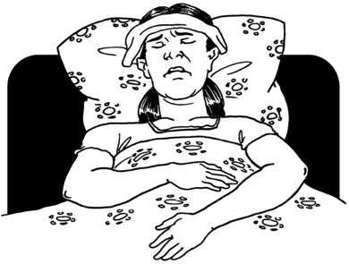
Sick pay is money you get from your job when you are sick and cannot work.

Half of the people doing creative work said tax forms were hard to do.

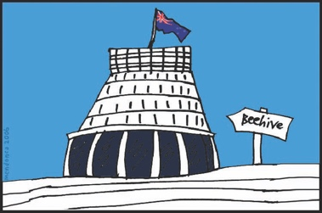
A tax form is a form you fill in to tell the government how much money you earned in a year.

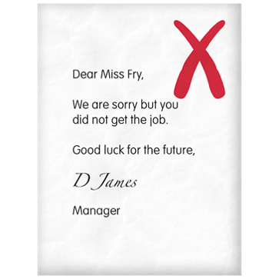
6 out of 10 people said it was hard to:
- get new work
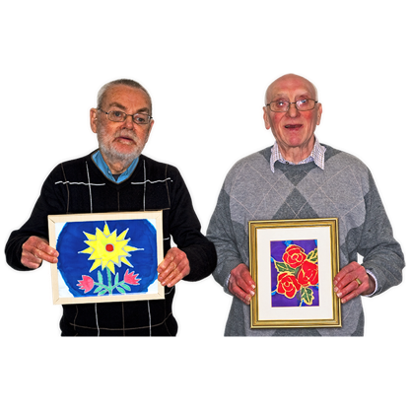
- sell their work
- stop people copying their work without paying for it.

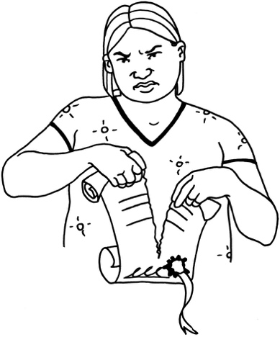
3 out of 10 people said contracts were hard to understand.

A contract is a document that says what a seller and a buyer agree on.

Saying thank you

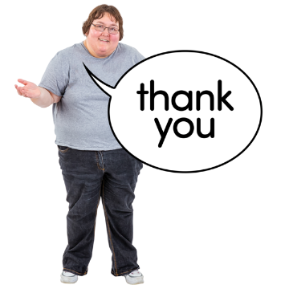
The following pages include all the people / groups we would like to thank for supporting our research.
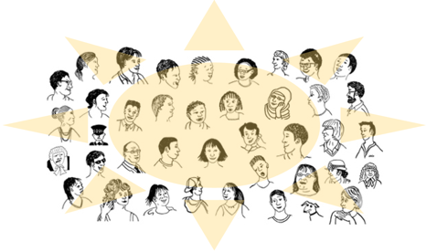

Thank you to all the creative professionals who did the survey.

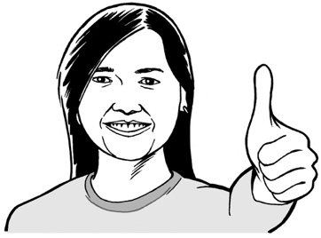
Thank you for supporting the research:
- Arts Access Aotearoa
- Te Matatini
- Te Māngai Pāho
- Te Taumata Toi-a-Iwi.

Thank you also to members of the G8 for supporting the research including:
- Te Tairāwhiti Arts Festival
- Taki Rua
- Kia Mau Festival
- Te Pou.

Where to find more information

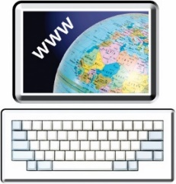
You can read more about the Profile of Creative Professionals report on our website:

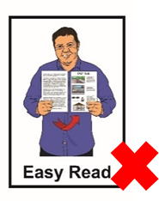
www.creativenz.govt.nz

The website is not in Easy Read.

You can ask someone to read it with you.

You can talk to someone at
Creative New Zealand about the research by:
email at:

research@creativenz.govt.nz
phone on:

0800 273 284
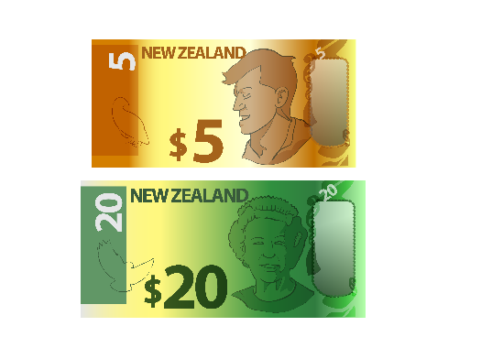

It will not cost you any money to call this number.

This information has been written by Creative New Zealand.

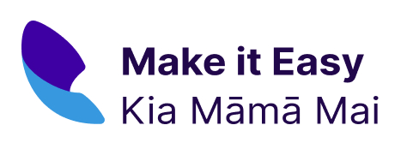
It has been translated into Easy Read by the Make it Easy Kia Māmā Mai service of People First New Zealand Ngā Tāngata Tuatahi.

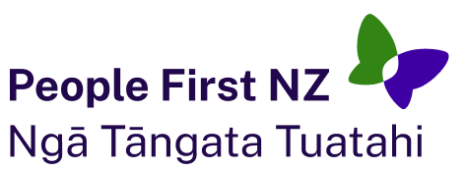
The ideas in this document are not the ideas of People First New Zealand Ngā Tāngata Tuatahi.
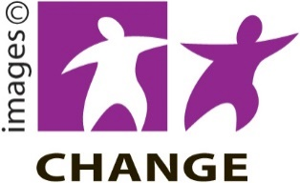
Make it Easy uses images from:

- Changepeople.org

- Photosymbols.com

- SGC Image Works

- Huriana Kopeke-Te Aho.

Some images have been provided by Creative New Zealand.
All images used in this Easy Read document are subject to copyright rules and cannot be used without permission.

