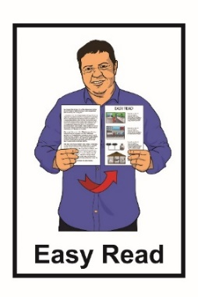
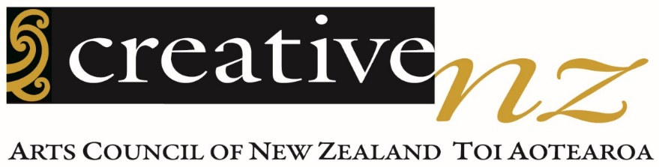

Diversity in the Arts Policy
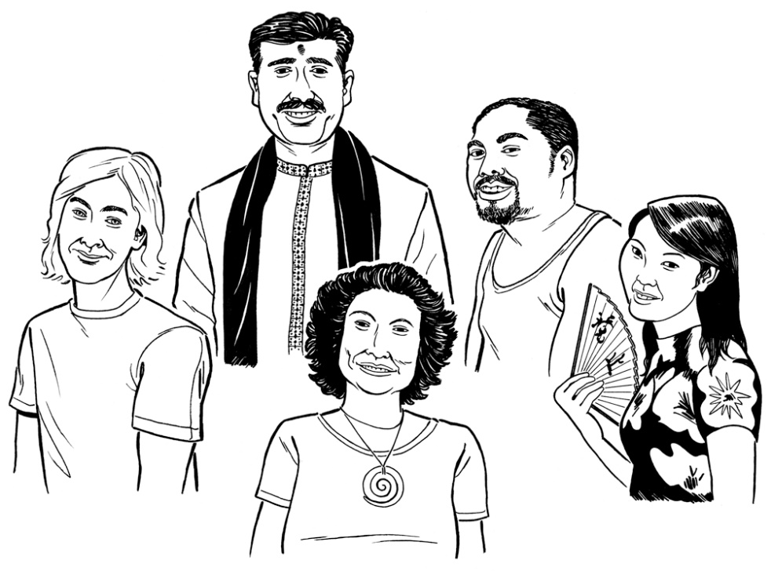

Diversity in the Arts Policy written: October 2015

Summary of the Policy translated into Easy Read: January 2023

Before you start

This is a long document.

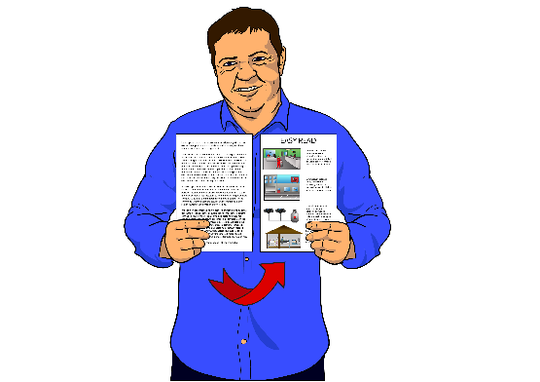
While it is written in Easy Read it can be hard for some people to read a document this long.

Some things you can do to make it easier are:
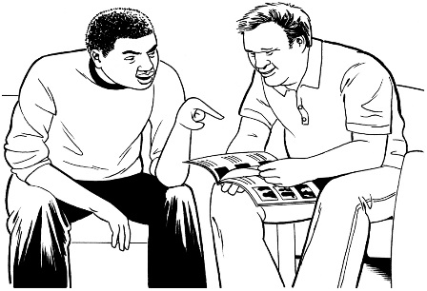
- read it a few pages at a time

- have someone support you to understand it.

What is in this document

Page number:

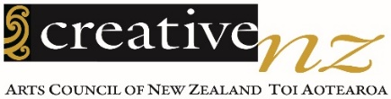
About Creative New Zealand 4
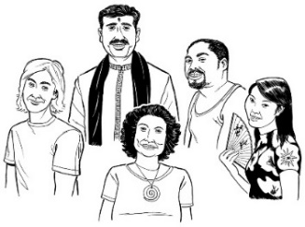

What we mean by diversity 8

About our diversity policy 11

Why we have a diversity policy 14

What we promise to do 17
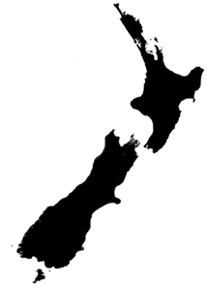

How our diversity policy supports arts in Aotearoa New Zealand 22

Page number:
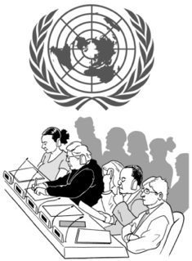

What other things affect our diversity policy 25

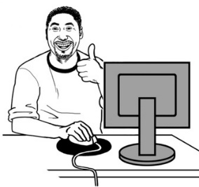
For more information 30

About Creative New Zealand

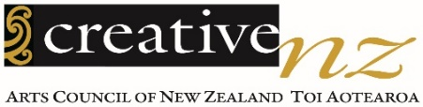
Creative New Zealand works to support the arts.
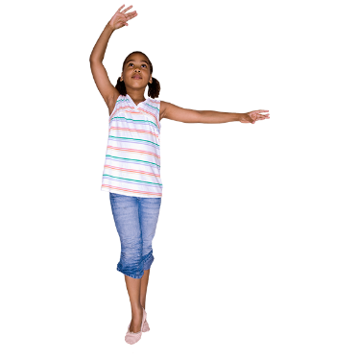

The arts are things like:
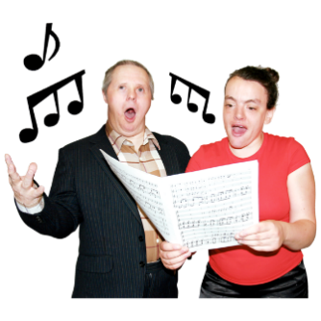
- dancing
- music / singing
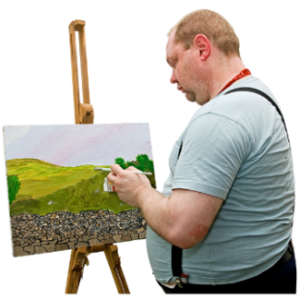
- acting

- paintings
- writing
  - poems
  - stories.
The arts are also:
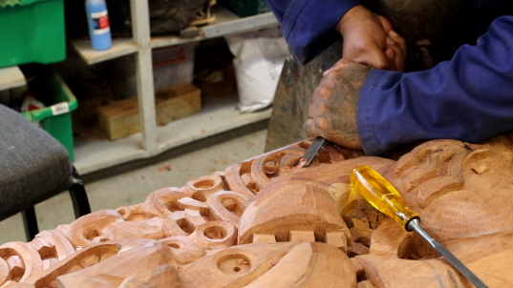
- Ngā toi Māori / Māori arts like:

  - whakairo / carving

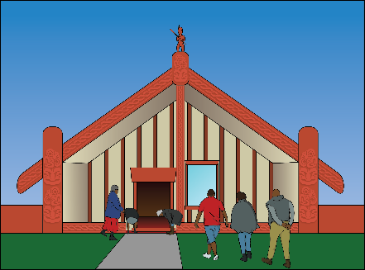
  - raranga / weaving

  - kapa haka

- Pacific arts like:
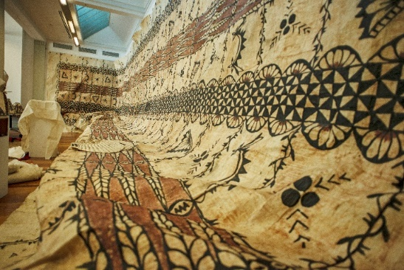
  - making tapa cloth

  - making tivaevae / quilts

  - festivals.

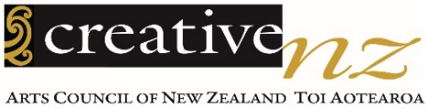
Creative New Zealand helps the arts in New Zealand with:
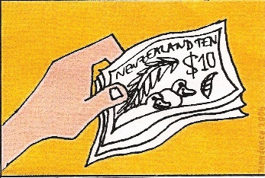
- money

- training

- research

- showing the work of New Zealand artists overseas
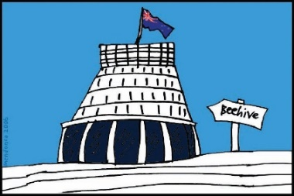
- giving advice to the Government about how to support the arts.

In this Easy Read document when we say we this means Creative New Zealand.

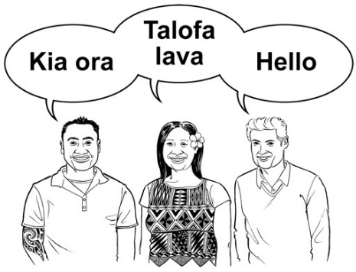
The arts are an important part of how we understand:

- our own New Zealand culture

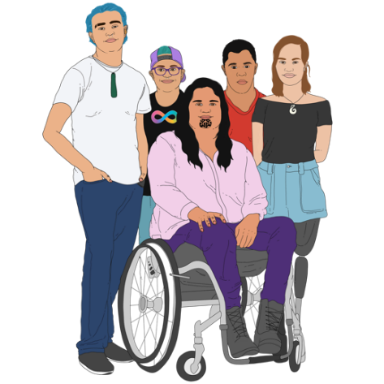
- how New Zealand is changing over time

- all the different parts of New Zealand society

- where different people fit into New Zealand culture.

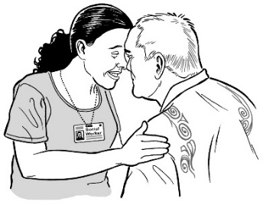
By supporting lots of different people in the arts we will support a unique New Zealand identity.

Unique means things that only happen in New Zealand.

What we mean by diversity

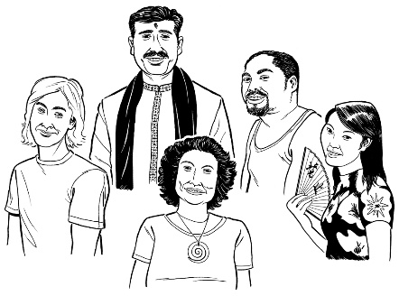
This policy is about diversity in the arts.

Diversity means including people from different backgrounds.

Aotearoa New Zealand is home to many people of different:
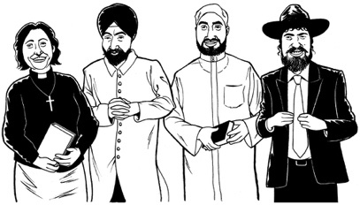
- ethnicities

- religions
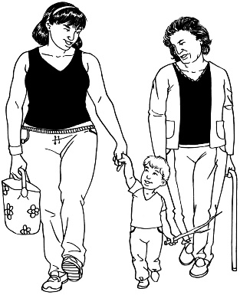
- ages

- whānau / family ways of life.

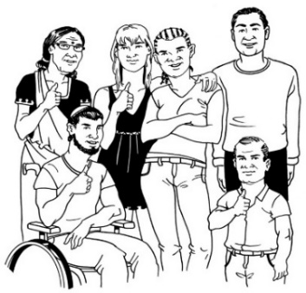
New Zealand is also home to:

- people who live in different places
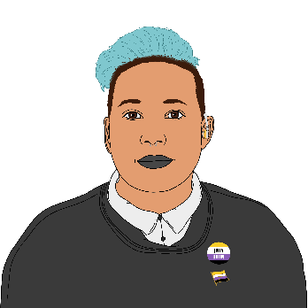
- Deaf and disabled people

- LGBTTIQ people.

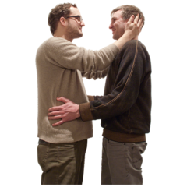
LGBTTIQ stands for people who are:

- lesbian

- gay
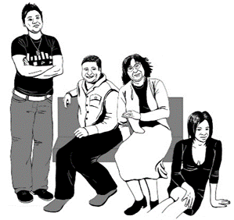
- bisexual

- transgender

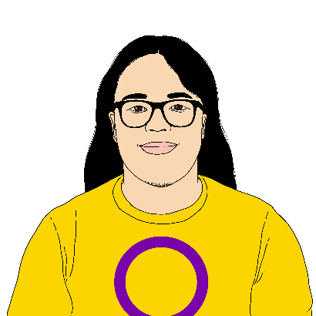
- takatāpui

- intersex

- queer.
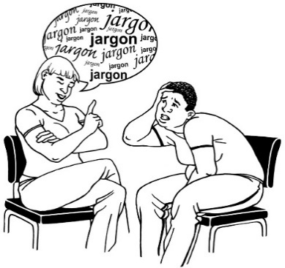
Creative New Zealand knows that some people do not like the word diversity.

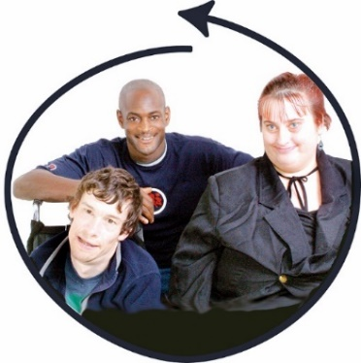
In the future we expect to put more work into:

- being fair

- including everyone.

About our diversity policy

Creative New Zealand has a Diversity in the Arts Policy that was written in 2015.

The Policy says what we will do to make sure different communities can be involved in the arts.

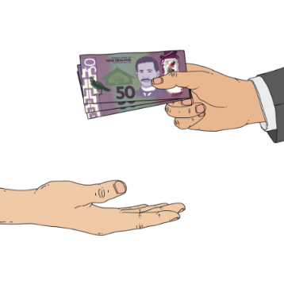
One thing the Policy tries to do is to make sure the way that Creative New Zealand gives money / funding:

- is fair to everyone
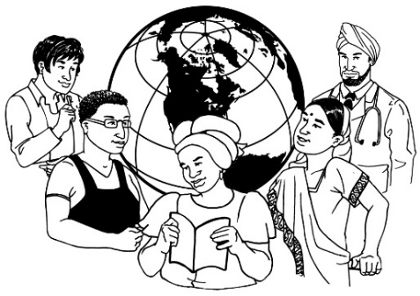
- keeps up with changes in the population like people who move to New Zealand from different countries.

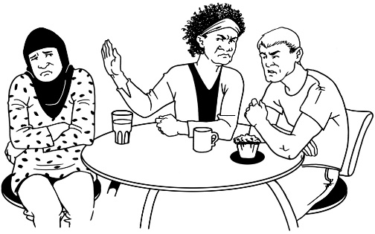
Creative New Zealand wants to make sure that we do not discriminate against anyone.

Discriminate means being unfair to a group of people because of who they are.

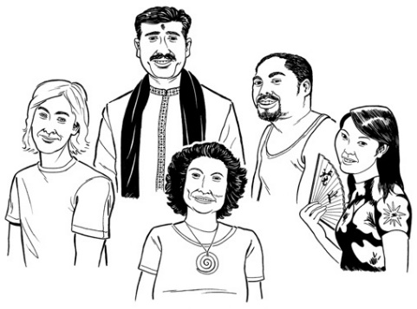
People from lots of ethnic groups live in New Zealand.

Ethnic groups are people with a special culture of their own who come from a certain place.
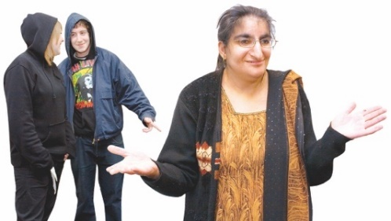

Some ethnic groups have not been treated fairly in New Zealand.

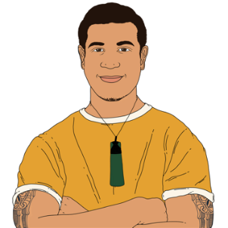
Creative New Zealand wants to make sure to support:

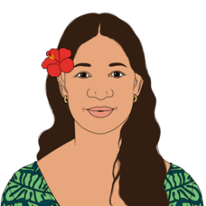
- art by Māori people

- art by Pacific people

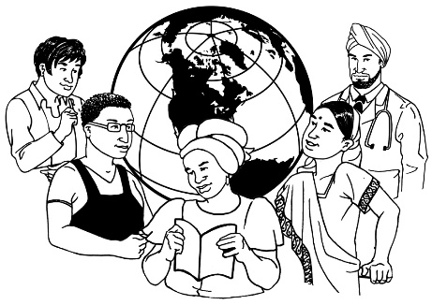
- art by groups of people who have come to live in New Zealand more recently such as Asian / Middle Eastern people

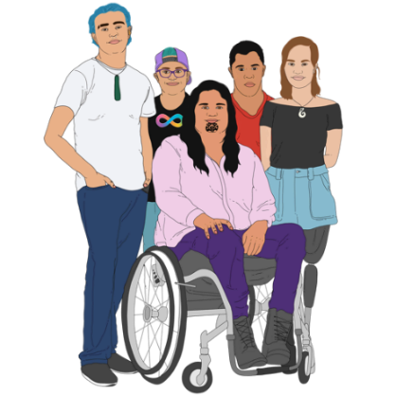
- art by people who have mixed backgrounds

- art by Deaf and disabled people

- art by LGBTTIQ people.
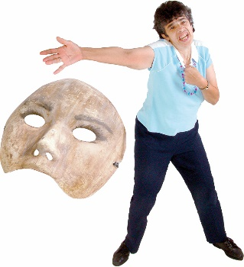

We want to make sure that all New Zealanders can enjoy the arts that we support.

Why we have a diversity policy

The Creative New Zealand Diversity in the Arts Policy says that we will:

- take notice of diversity in the arts

- promote arts by lots of different people
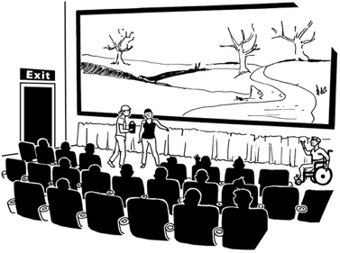
- celebrate diversity in the arts.

We have a diversity policy so we know:
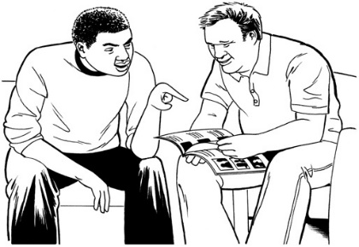
- how we are supporting diversity already

- how we can keep doing better at supporting diversity in the future.

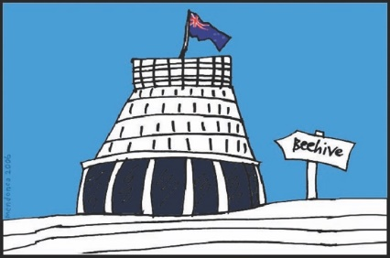
It is important to have a diversity policy because of:

- New Zealand laws
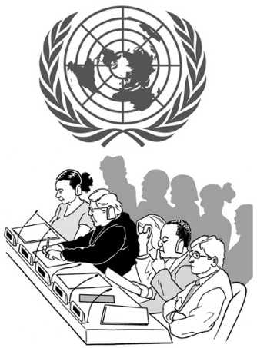
- what other countries expect us to do

- what the United Nations wants countries to do to support culture.

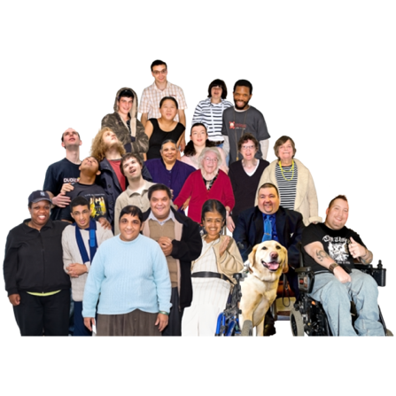
We have this diversity policy so that we can support:

- lots of different artists while they are making art
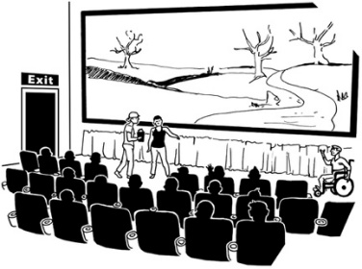
- art being shown to people

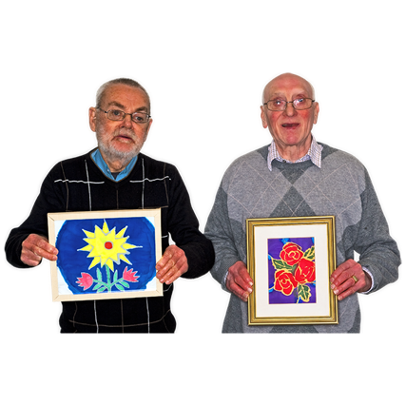
- audiences of different kinds of people seeing art

- lots of different people trying art for themselves.
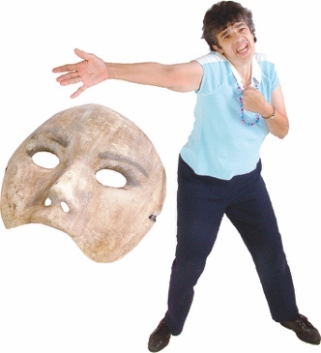
Having diverse art in New Zealand will:

- make New Zealand more creative

- assist artists to find new ideas

- assist organisations to think more widely
- give audiences more to think about

- assist whole communities to find new ideas.

What we promise to do

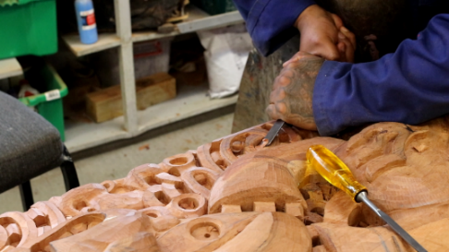
Creative New Zealand will support Māori art.

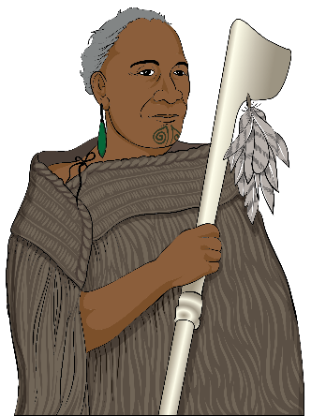
We know that Māori have a special place in New Zealand as tangata whenua.

Tangata whenua are the first people of the land / New Zealand.

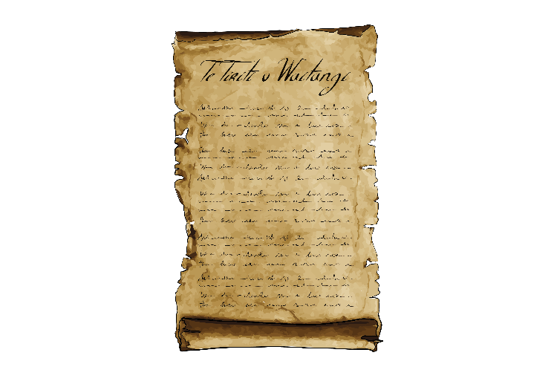
We understand that:

- New Zealand was built on an important agreement between Māori and the British Crown

- this agreement is called
Te Tiriti o Waitangi.

Te Tiriti o Waitangi / The Treaty of Waitangi is a legal document that was signed in 1840.

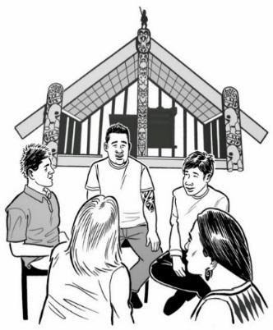
The Treaty / Te Tiriti is important to New Zealand.

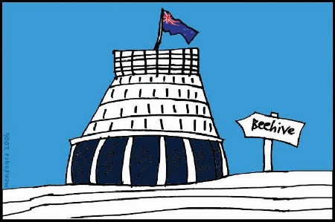
It is about Māori and the New Zealand Government:
- making decisions together
- protecting things that are important to Māori.

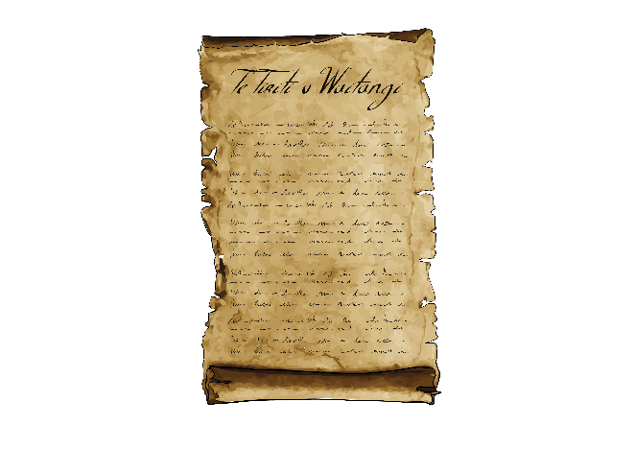
We are learning more about what Te Tiriti o Waitangi means for our work.

As we learn more about it we expect that we will need to change our policy on diversity.
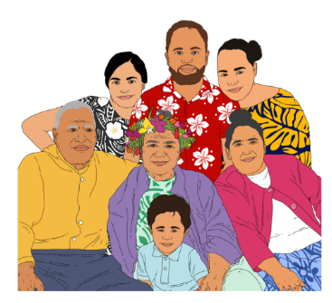
Creative New Zealand will support the art of people from the Pacific Islands.

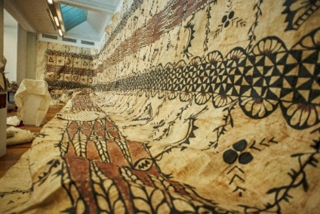
We will support the art of people from lots of different cultures in New Zealand.

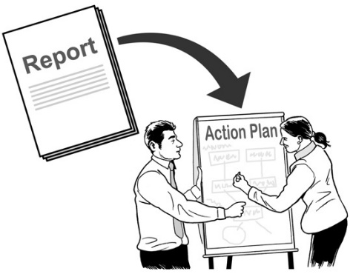
We will often look at the diversity of the arts we support.

We will write reports on the diversity of the arts we support.

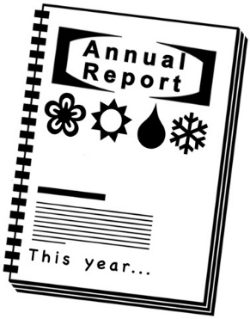
We will share these reports so that you can see how we are doing.

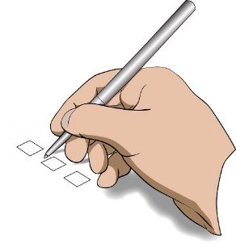
Creative New Zealand will have systems to make sure we are doing a good job of supporting diversity.

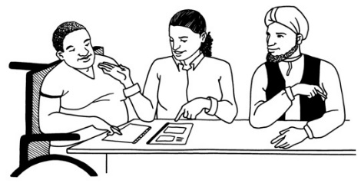
We will look at what other people are doing to make sure we do not double up on things other people are already doing well.

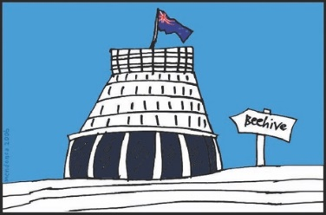
People we will look at include:

- central government
- local governments such as city councils

- private businesses.

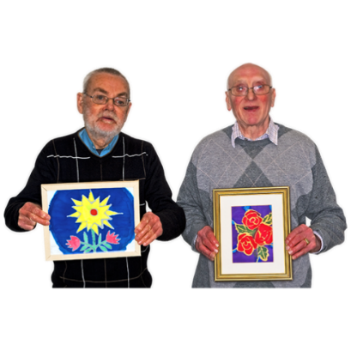
The types of things we will make sure we do not double up on are:

- pieces of art
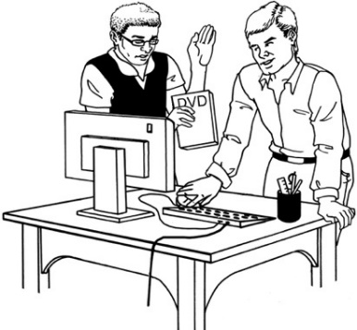
- types of art

- the things that support artists like resources.

We will support lots of different ways of experiencing art like:

- digital art
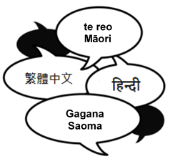
- online art

- art in different languages.

How our diversity policy supports arts
in Aotearoa New Zealand

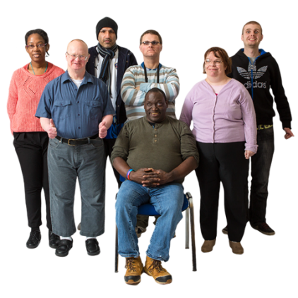
Our diversity policy makes sure that we support arts for all the different people who live in New Zealand.

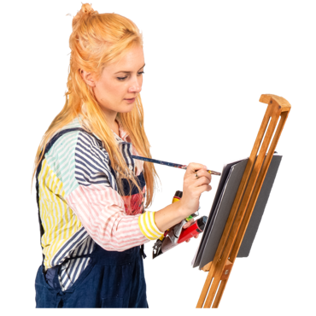
Our diversity policy is for:

- artists of all types of art

- people who enjoy all types of art

- groups that enjoy art

- whole communities that enjoy art.

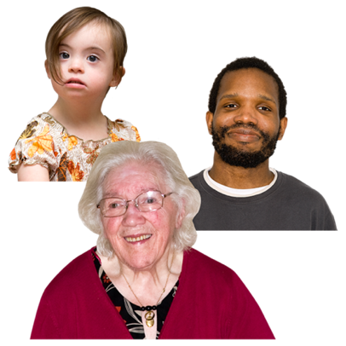
Creative New Zealand will support art for people of all:

- ages

- genders
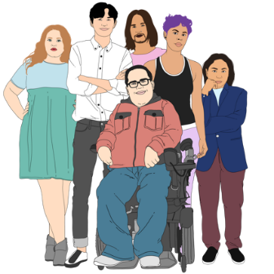
- ethnic backgrounds

- disabilities

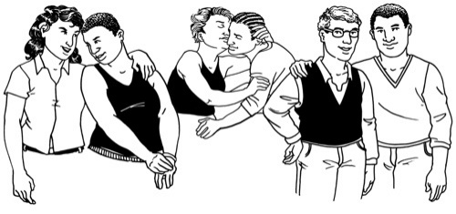
- sexual orientations

- religions.

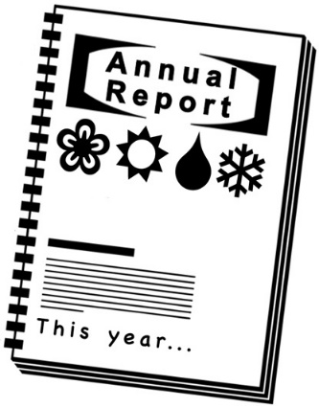
We will collect information about what types of people ask us for funding.

We will use this information to write reports about the types of people we are supporting.

We are doing our best to make it easy for people to ask us for support.

We also make it as easy as we can for people to talk to us.

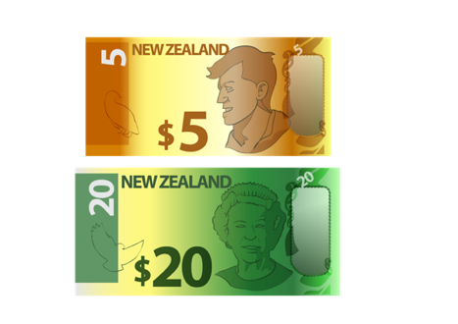
We give money to services that support diverse art in New Zealand.

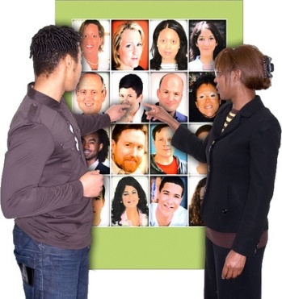
We ask other art organisations about how they support diverse communities in New Zealand.

What other things affect our
diversity policy

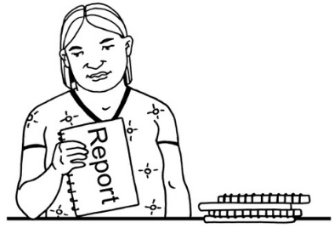
Creative New Zealand wrote our diversity policy after reading lots of other documents from many organisations.

These other documents helped us write a good diversity policy.

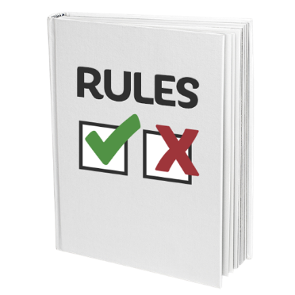
Some of these documents also gave us rules or instructions we had to follow.

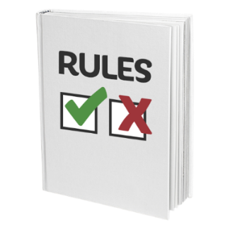
The rules we had to follow came from:

- the Arts Council of New Zealand Toi Aotearoa Act 2014
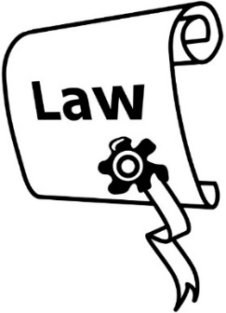
- the New Zealand Bill of Rights Act 1990

- the Human Rights Act 1993

- the New Zealand Disability Strategy 2001.

Our diversity policy helps New Zealand support:
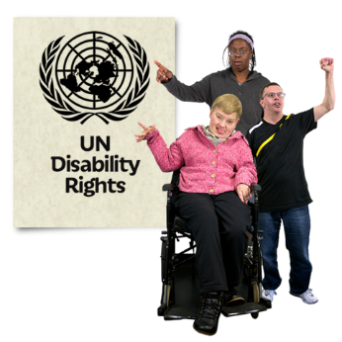
- the United Nations Convention on the Protection and Promotion of the Diversity of Cultural Expressions

- the United Nations Convention on the Rights of Persons with Disabilities.
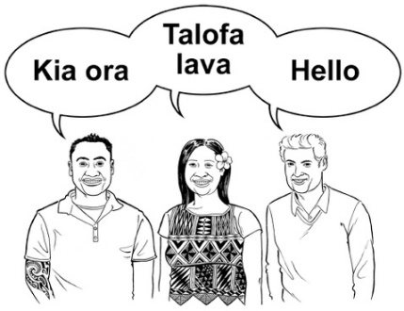
Our diversity policy follows the Cultural Sector Strategic Framework 2014–18 written by the Ministry for Culture and Heritage.

The Ministry for Culture and Heritage is a government department that gives advice about:
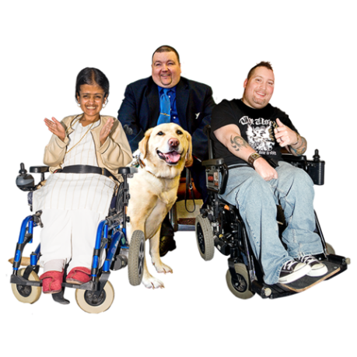
- art

- culture

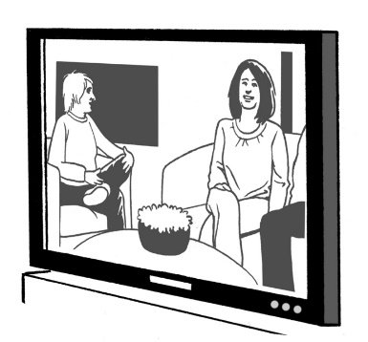
- sports

- broadcasting – like TV and radio.

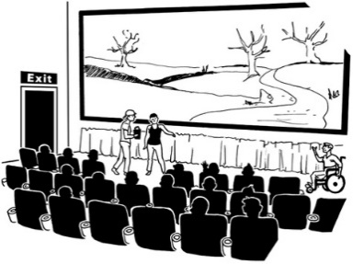
Our diversity policy supports diversity for:

- New Zealand on Air
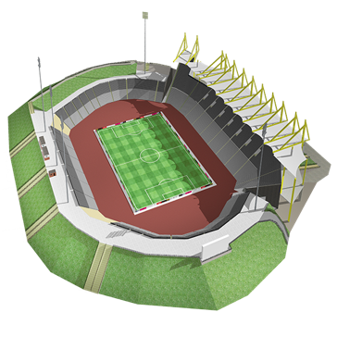
- the New Zealand Film Commission

- Sport New Zealand
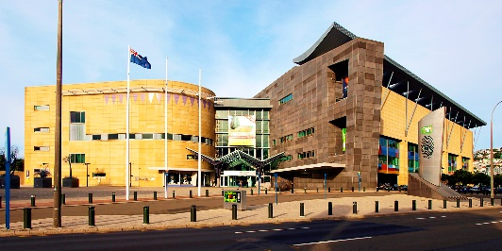
- Te Papa Tongarewa – Museum of New Zealand.

Our diversity policy uses information from Statistics New Zealand.

Statistics New Zealand is a government agency that collects information about lots of things in New Zealand.

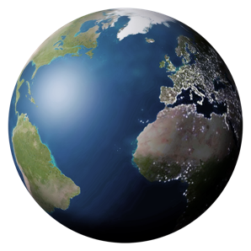
Creative New Zealand also looked at how other coutries make diversity policies for arts.

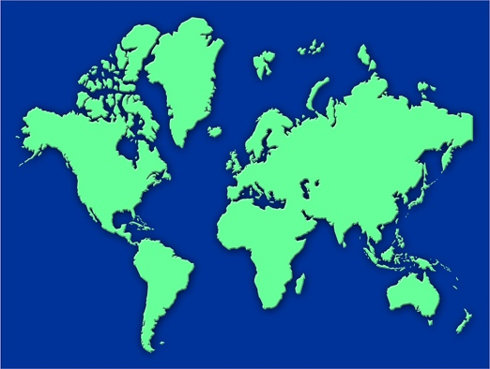
Some of the countries we looked at are:

- Australia

- UK
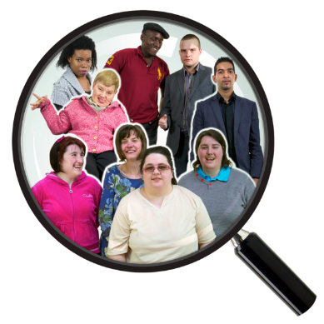
- Ireland

- Canada

- Singapore.

All of this information has helped us write our diversity policy.

For more information

You can read more about our diversity policy on the Creative New Zealand website:

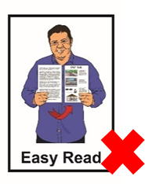
creativenz.govt.nz/diversity-in-the-arts-policy-2015

The website is not in Easy Read.

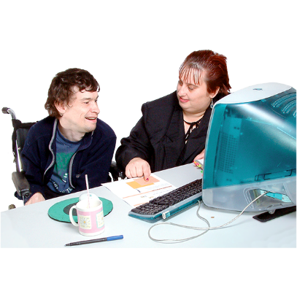
You can ask someone to read it with you.

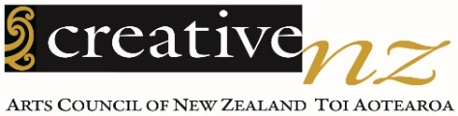
You can talk to someone at
Creative New Zealand by:
Phone:

0800 273 284
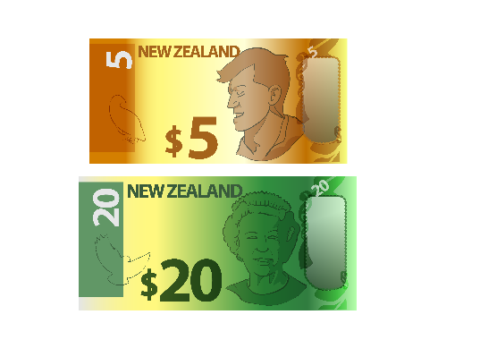

This is a free call number which means it does not cost you any money to call.

Email:

research@creativenz.govt.nz

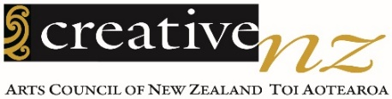
This information has been written by Creative New Zealand.
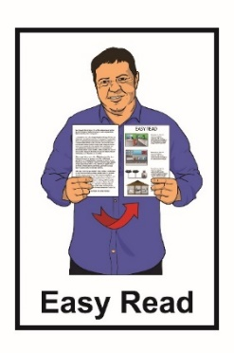
It has been translated into Easy Read by the Make It Easy service of People First New Zealand Inc. Ngā Tāngata Tuatahi.
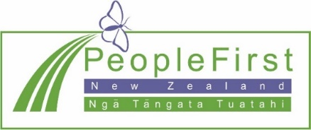
The ideas in this document are not the ideas of People First New Zealand Ngā Tāngata Tuatahi.
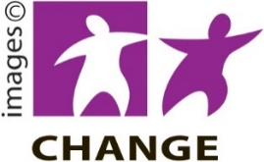
Make It Easy used images from:

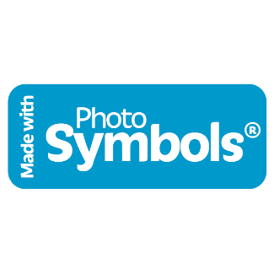
- Changepeople.org

- Photosymbols.com

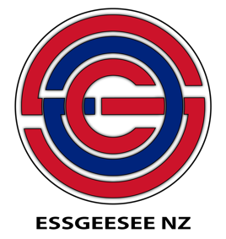
- Sam Corliss

- Huriana Kopeke-Te Aho

- Creative New Zealand
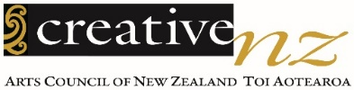
- Raymond Sagapolutele.
All images used in this Easy Read document are subject to copyright rules and cannot be used without permission.

