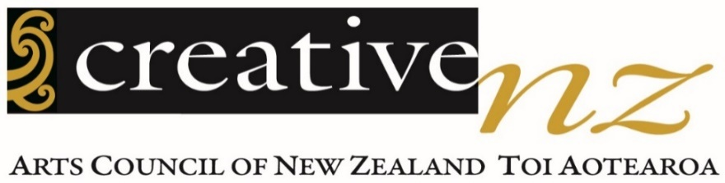

Audience Atlas Aotearoa 2020
July 2021 report

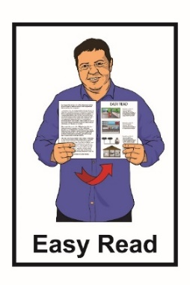
Summary of Research Report

Published in Easy Read:
June 2022

What you will find in here

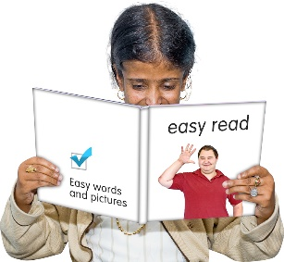
Page number:

Before you start 4

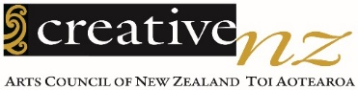
About Creative New Zealand 5

About this summary 8

What the research told us 12

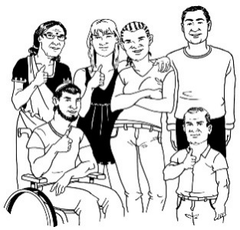
How many people are interested in the arts 13

The arts are not important to everyone 14

Page number:
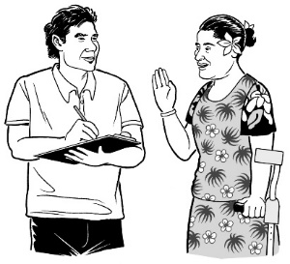
The arts can help people feel
good 16

Grouping audiences to
understand them better 17

People want more from the arts 30

What people spend on the arts 33

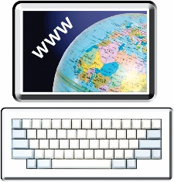
The cost of the arts is a barrier
for many people 34

How to make the arts more accessible 37

The arts most people are
interested in 41

Page number:

How to get people back
into the arts 43

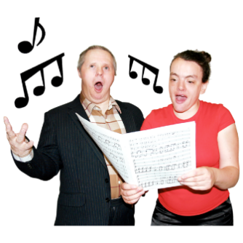
How to get new people
into the arts 46

Arts organisations need a plan
to get people to go to
the arts online 48

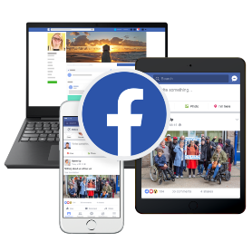
Where people get information 51

The social media most
people use 53

For more information 55

Before you start

This is a long document.

While it is written in Easy Read it can be hard for some people to read a document this long.

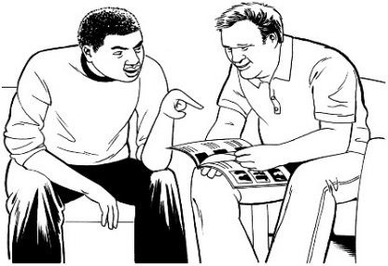
Some things you can do to make it easier are:
- read it a few pages at a time

- have someone assist you to understand it.

About Creative New Zealand

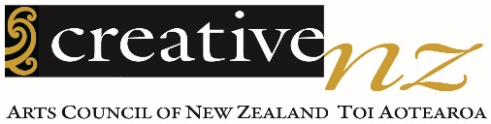
Creative New Zealand works to support the arts.

The arts means things like:
- dancing
- music / singing
- acting

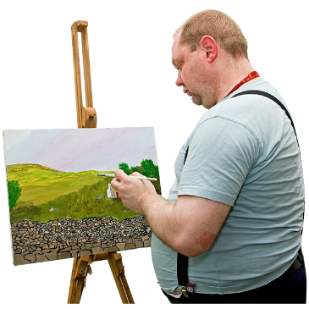
- art galleries

- paintings
- writing:
  - poems
  - stories.
The arts also means:
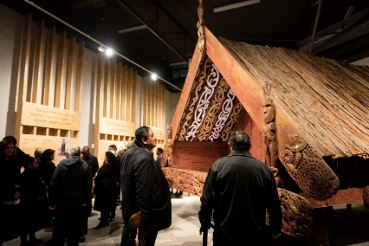
- ngā toi Māori / Māori arts like:

  - whakairo / carving

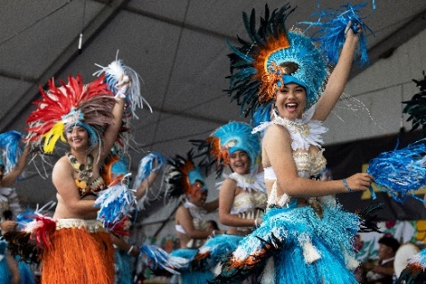
  - raranga / weaving

  - kapa haka

- Pacific arts like:

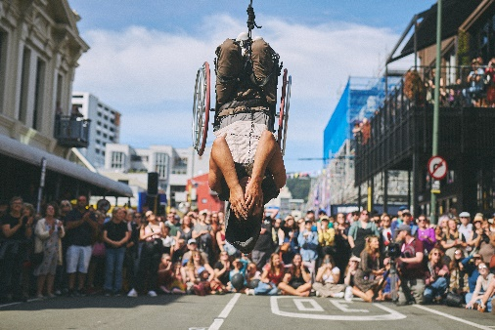
  - making tapa cloth

  - making tivaevae / quilts
  - dance like tau’olunga and siva

- festivals.

Being creative means making new things using your imagination.

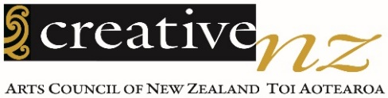
Creative New Zealand works to support the arts in New Zealand with:
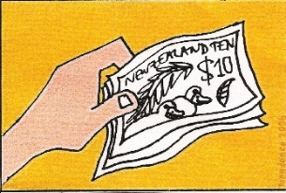
- money

- training
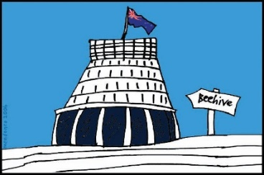
- showing the work of New Zealand artists overseas
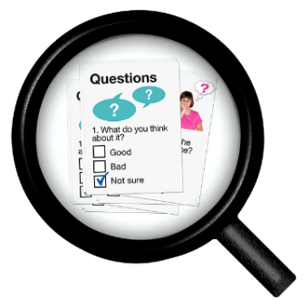
- giving advice to the government about how to support the arts

- research.

Research means looking at
something closely to get a better
understanding of it.

About this summary
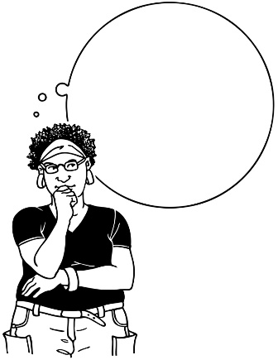
Arts

Every 3 years Creative New Zealand does research to find out how to get more people going to the arts.

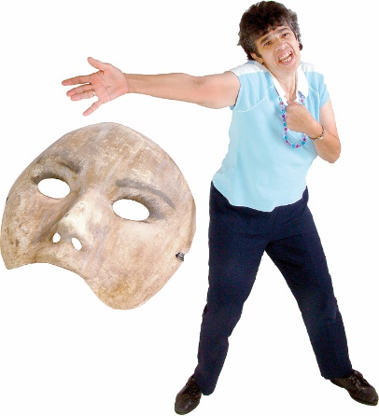
We want this information to help the arts get more people:

- interested in the arts

- going to arts events.

This research is called Audience Atlas Aotearoa 2020.

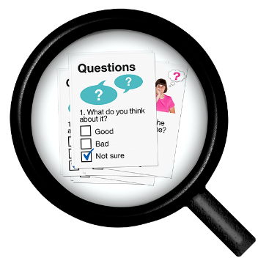
This is an Easy Read summary of some of the main things that the research found.

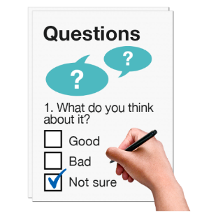
We have been asking people these questions since 2010.

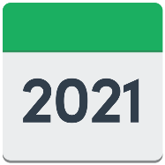
This survey was done from December 2020 to January 2021.

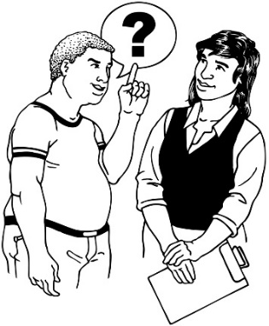
This was the 4th time we have done the research.

We asked Morris Hargreaves McIntyre to ask the questions for us.

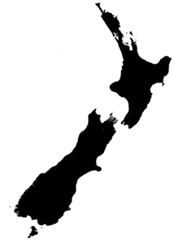
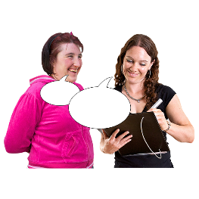

Morris Hargreaves McIntyre is an international research company with some staff in New Zealand.

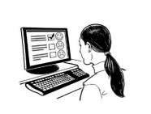
The survey questions were only online.

Online means that the survey was

on the internet for people to fill in.
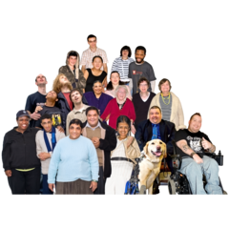

More than 6 thousand adults aged over 16 years old answered the questions.

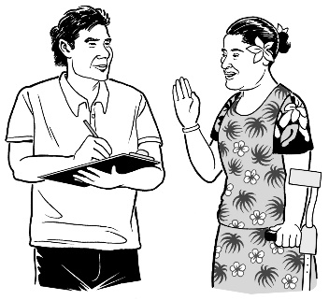

We wanted to make sure lots of different people in New Zealand told us what they thought about the arts.

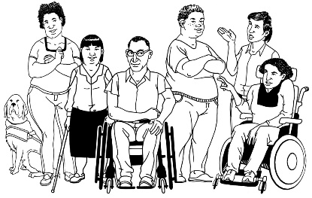

We asked people if they were Deaf or disabled.

We asked more people from some different groups of people what they thought about the arts.

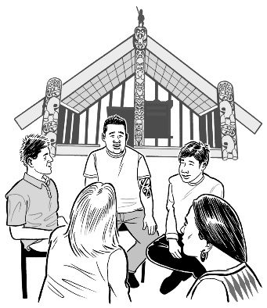

We made sure to ask more people from these groups:

- Māori
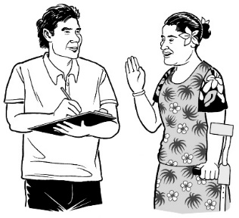
- Pasifika

- Asian.

What the research told us

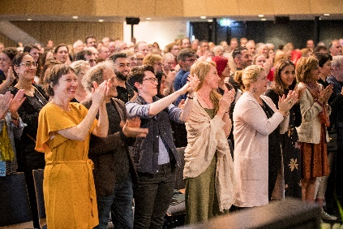
In the research we found out:

- if people are interested in the arts

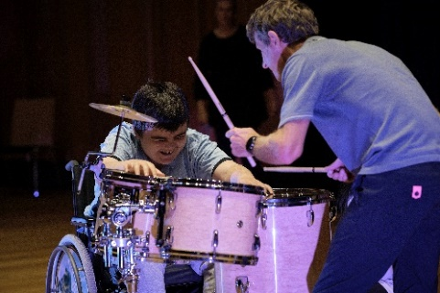
- what people want from the arts

- what people who go to the arts are interested in

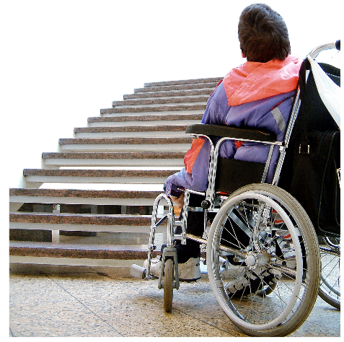
- what people who do not go to the arts are interested in

- what stops people from going to the arts

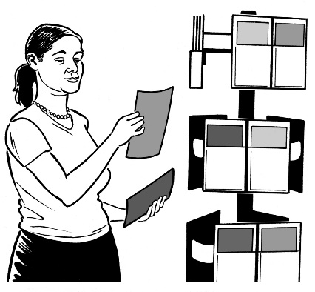
- what would make the arts more accessible

- where people find out about arts activities.

How many people are interested

in the arts

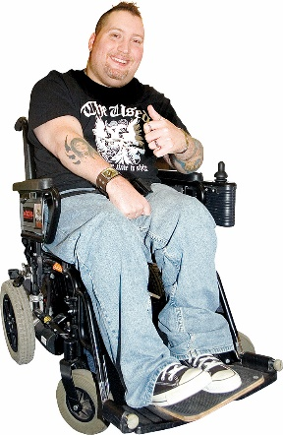
From the research, we think almost 4 million adults in New Zealand are interested in the arts.

In that group:
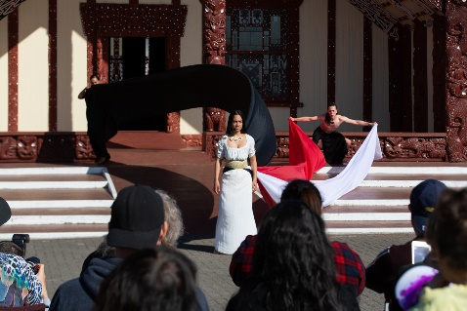
- 3.7 million adults are interested in ngā toi Māori / Māori arts

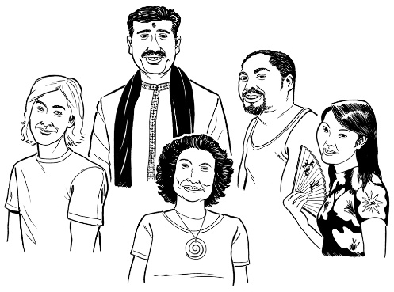
- 3.6 million adults are interested in Pacific arts

- 3.6 million adults are interested in Asian arts.

The arts are not important to everyone

4 people in every 10 people who answered the questions have strong feelings about how important arts are in their lives.

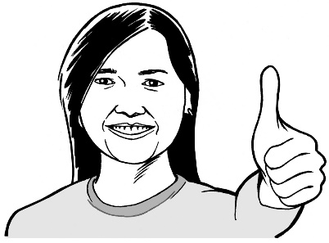

These people already know about the arts so do not need as much help understanding what they can go to.

3 people in every 10 people say the arts have some importance to them.

These people do not have strong feelings about the arts.

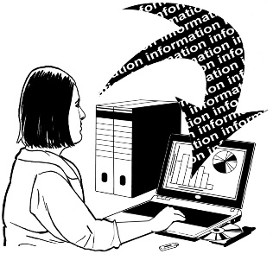
If this group had more information they might be more interested in the arts.

3 people in every 10 people do not think the arts are very important.

It will be hardest to get this group interested in the arts.

To get more people interested in the arts they need to see the value the arts can bring to their lives.
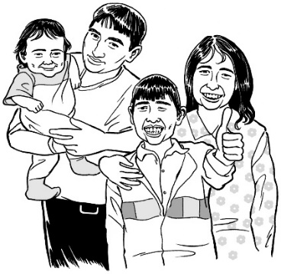

One way might be to help people understand that the arts can make them feel good.

The arts can help people feel good

About half the people who answered the questions thought the arts can help people feel good.

Only 3 in 10 people thought the arts helps them cope with their lives.

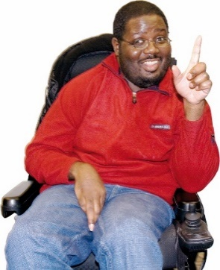

The people who already thought the arts were important in their lives also thought the arts made them feel good.

The people who did not think the arts were important in their lives also did not think the arts made them feel good.

Grouping audiences to understand

them better

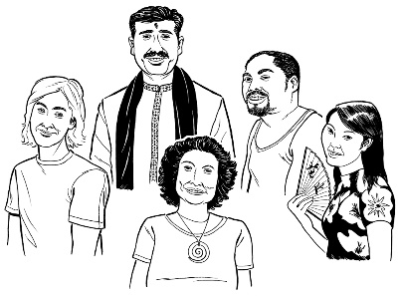

All sorts of people make up audiences for the arts.

From what people told us in the survey, we worked out how many were in each of the culture segments.

Culture segments are tools to help us understand audiences better.

They group people by what they:

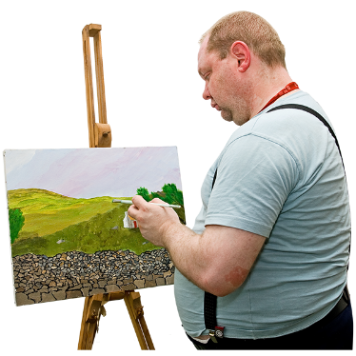
- value

- believe

- do when it comes to the arts.

The different culture segments that we looked at are called:

- Expression

- Affirmation
- Stimulation
- Release
- Essence
- Enrichment

- Perspective

- Entertaiment.

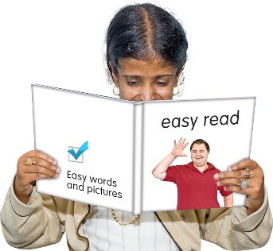

You can read more about the different groups in the next few pages.

2 in 10 people are in the Expression group.

The Expression group are very focused on:

- their community

- helping people.

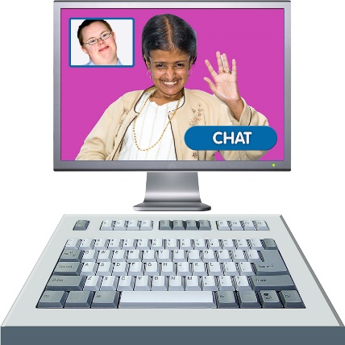
People in this group are most likely to

- go to the arts

- tell other people about their arts experience.

This group uses:

- computers

- phones.

The Expression group may be interested in online arts.

The Expression group includes lots of people who are:

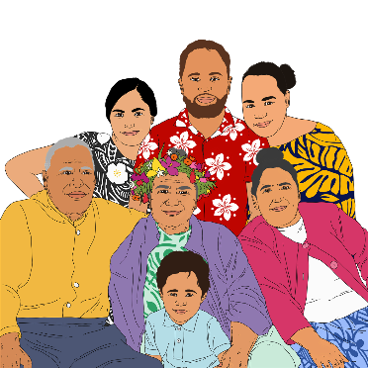
- Pasifika

- Asian

- Māori.

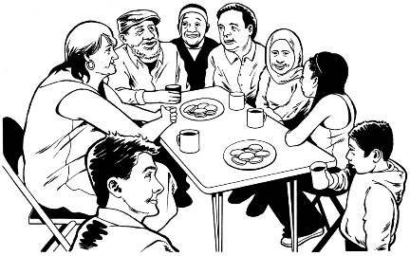
This might be because they focus on their communities.

Almost 2 in 10 people are in the Affirmation group.

The Affirmation group want to learn so they can improve themselves.

The arts are one of the ways they like to learn.

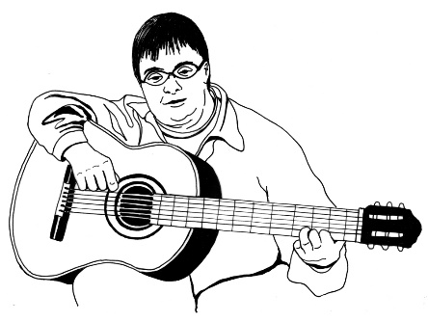
They usually choose the arts that they know.

They are less likely to choose something new.
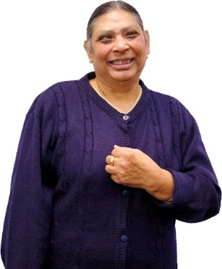

Asian audiences have lots of people in the Affirmation group.

At least 1 in 10 people are in the Stimulation group.

The Stimulation group like to:

- try new things

- find out about new ideas.

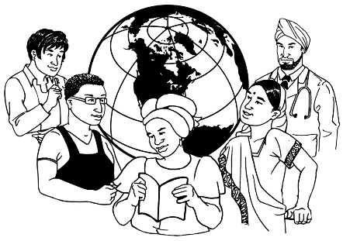
The Stimulation group also want to find out big ideas in the arts.

This group is one of the bigger users of computers and phones.
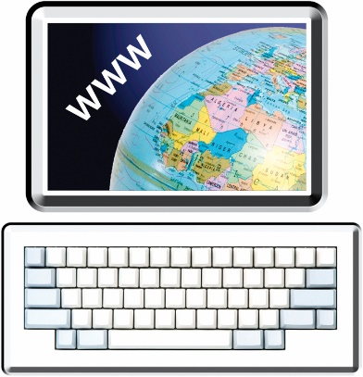

They may be interested in online arts.

1 in 10 people are in the Release group.

The Release group like to relax on their days off.

This group often feel they cannot go to the arts as much as they would like.
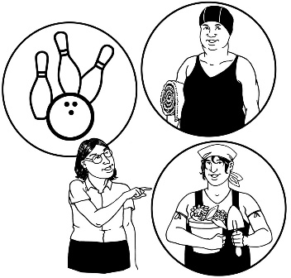

They are busy and do not have time.

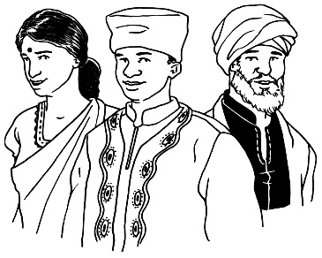
Pasifika and Asian audiences are more likely to be in the Release group.

1 in 10 people are in the Essence group.

The arts are very important to the Essence group.

They are very likely to

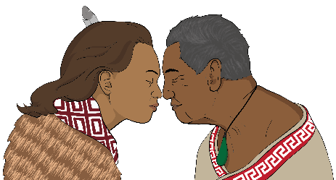
- go to the arts

- want arts that make them

  - feel deeply

  - connect deeply.
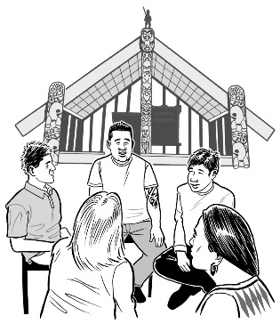

A lot of Māori are likely to be in this group.

This might be because lots of Māori feel that the arts are important.

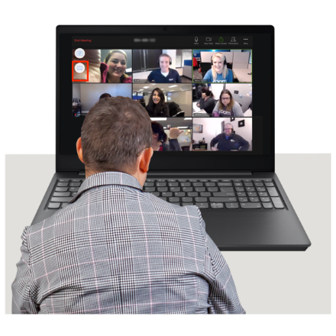
The Essence group is also the biggest user of:

- computers

- phones.

This group may be interested in online arts.

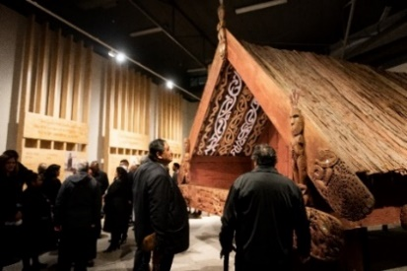

They prefer to attend the arts in person.

1 in 10 people are in the Enrichment group.

The Enrichment Group are interested in the past.

This group are less interested in new things.

They know what they will enjoy.

They are not likely to try new things.

Less than 1 in 10 people are in the Perspective group.

The Perspective group like to do things on their own.

They are often interested in just a few things.

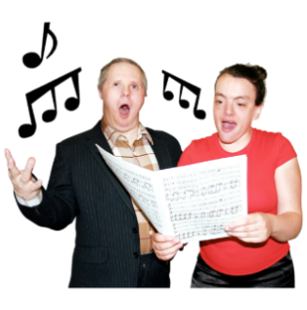

They might only be interested in one or two of the arts.

They are not likely to be interested in lots of different arts.

Less than 1 in 10 people are in the Entertainment group.

The Entertainment group are looking for fun.

They are more likely to go to fun things like:

- everyday events

- days out.

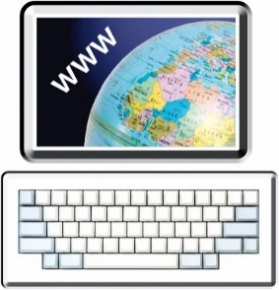
You can learn more about how people are grouped into culture segments on this website:

https://mhminsight.com/culture-segments/survey

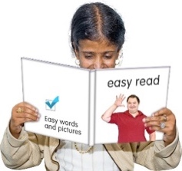

The information on the website is not in Easy Read.

People want more from the arts

The top reasons people like the arts are to:

- spend time with other people

- pass time in a nice way.

6 people in every 10 people are a little bit interested or not interested in the arts.

People want the arts to make them:

- think

- feel

- connect with the world.

People also want to go to the arts to

- spend time with other people.

- learn something
- see interesting:

  - buildings

  - places
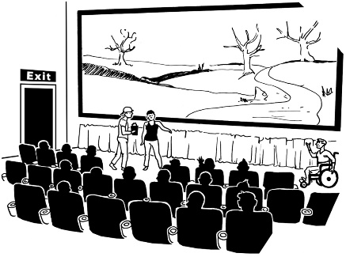
- have new experiences

- use their imagination

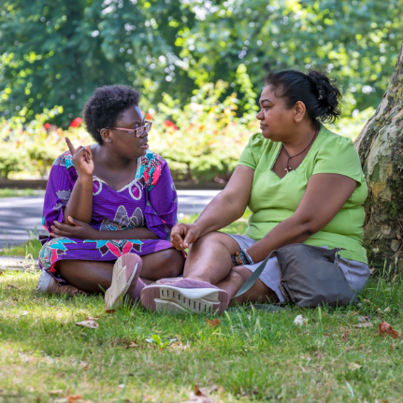
- escape

- relax.

Many Māori and Pasifika audiences want the arts to help them understand:

- themselves

- their cultural identity.
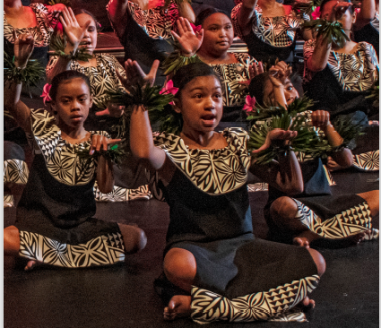

Many audiences want their children to develop an interest in the arts.

This is particularly true of people who are:

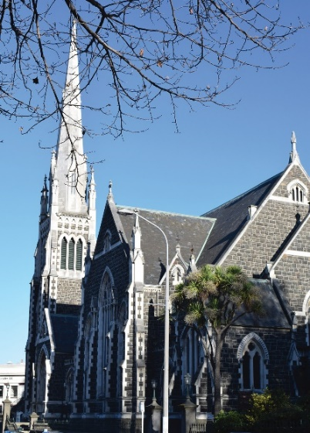
- Pasifika

- Asian

Asian audiences are also more likely to want to visit major attractions like big museums.

What people spend on the arts

Since the last survey in 2017, there has not been much change in:

- the number of people spending money on the arts

- how much people spend.
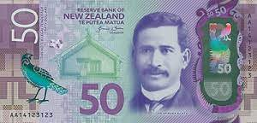
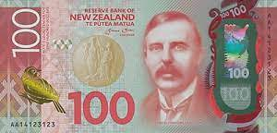

1 in 3 people we asked spend about $150 each month on the arts.

The cost of the arts is a barrier

for many people

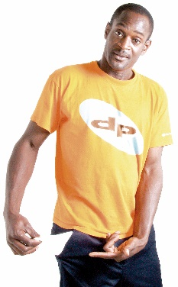
Money is the biggest barrier for all people in attending the arts.

Barriers are things that make it hard for people to be involved.

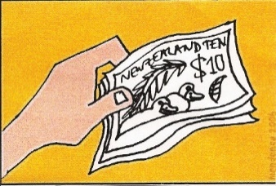
More than 1 in 3 people surveyed did not have enough money to attend an arts event in the past year.
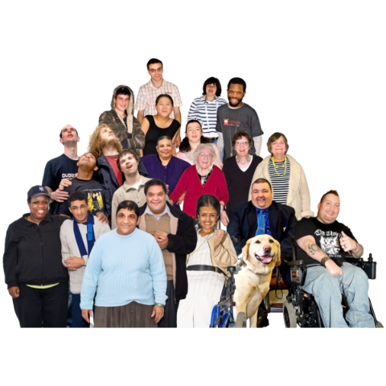

If arts organisations could make going to the arts cost less money more people could go.

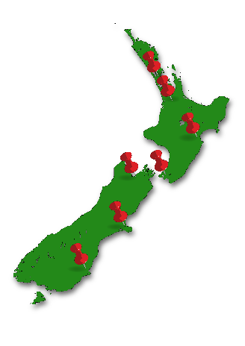
Other reasons for not going to the arts were:

- arts events not offered in their area
- it was difficult for them to travel to an arts event

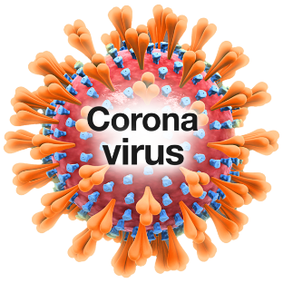
- COVID-19 restrictions
.

COVID-19 is a virus that can make people very sick.

COVID-19 meant that lots of live arts could not happen in 2020 and 2021.

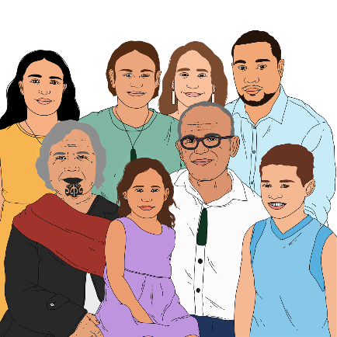
For Māori aged under 35 years, nearly 3 out of 10 people had to care for someone.

There were some barriers that stopped people who are:

- Deaf

- disabled.

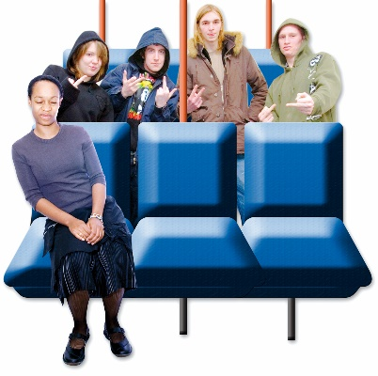
The main barriers these people told us about were:

- difficulty travelling to an event

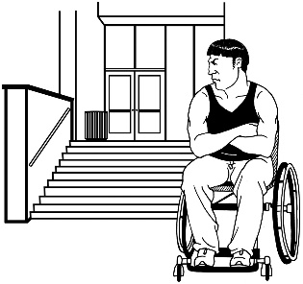
- health concerns

- not being sure they would be welcome.

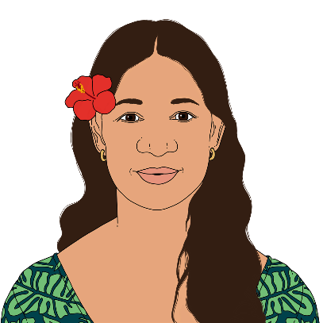
Many Pasifika do not have others to go with.

This was particularly a problem for Pasifika people aged from 16 to 24.

How to make the arts more accessible

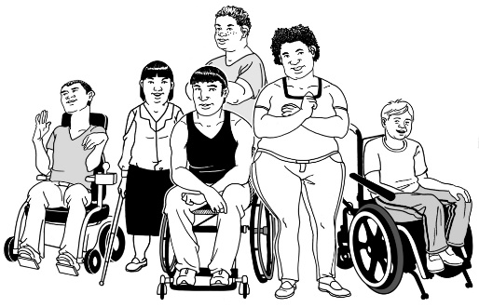
There are some things organisations can do to make arts accessible for people who are:

- Deaf

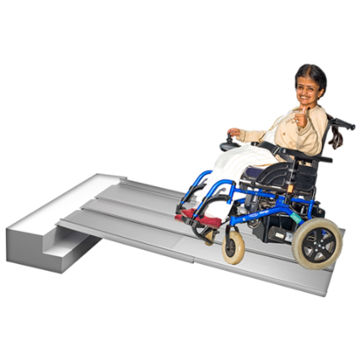
- disabled.

Accessible means making it easy for people to go to the arts like:

- making sure arts are happening in places where it is easy to get in using a wheelchair

- having a sign language interpreter so Deaf people can understand what is being said.

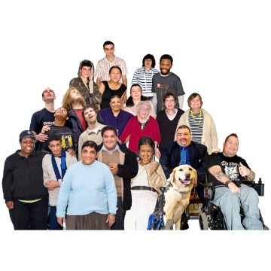
The most common answer was to make sure there are not too many people at the venue.

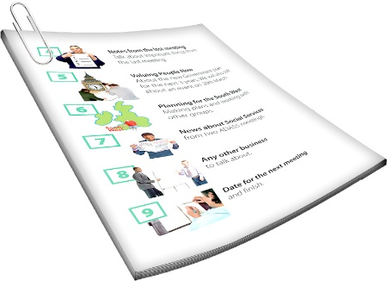
3 in 10 disabled people want more information before attending the arts.

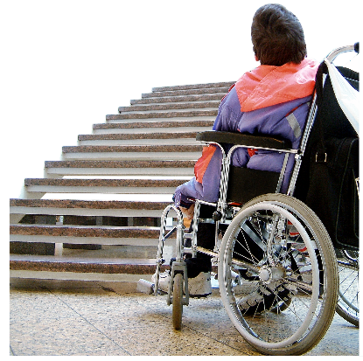
Some people want information about accessibility at the venue.

This is particularly important for people who use wheelchairs.

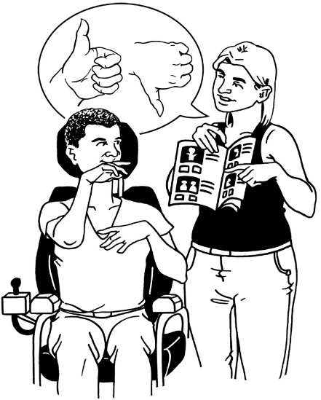
They also want to be sure that staff
are trained to understand:

- accessibility

- disability.

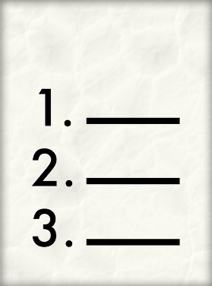
These are things organisations can do to make the arts more accessible.

They are listed in order, starting with things most people asked for:
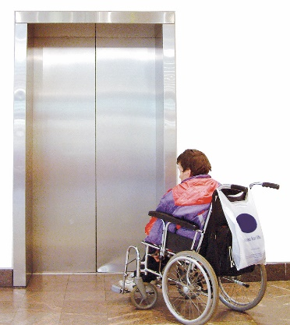
- Not too many people at the venue so there is room to move around

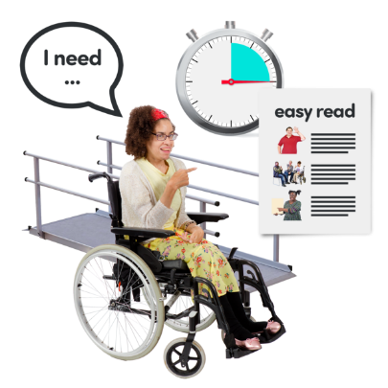
- Information about accessibility is provided before the visit

- Accessible website

- Staff understand accessibility
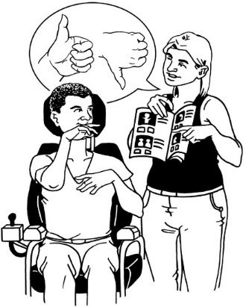
- Staff understand disability

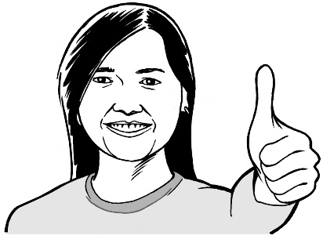
Here are some more things organisations can do to make the arts more accessible:
- have accessible transport

- make support staff available

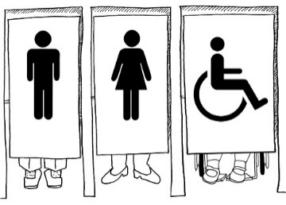
- use an accessible venue that has facilities like toilets that you can get into using a wheelchair.
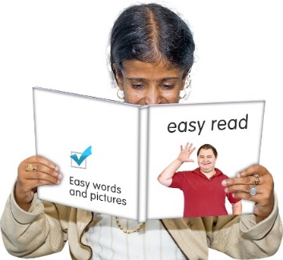
- put information in formats that everyone can read like Easy Read.
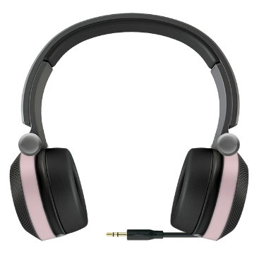
- not charge more money for a support worker / carer to attend

- have technology like headphones
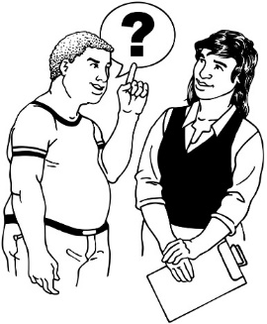
- ask people about their access needs
- have sign language interpreters.

The arts most people are interested in

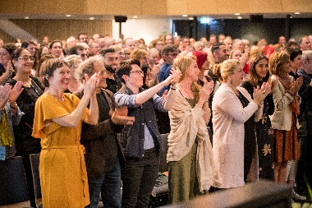
These are the different kinds of arts that the people we talked to have been most interested in since the last survey in 2017.

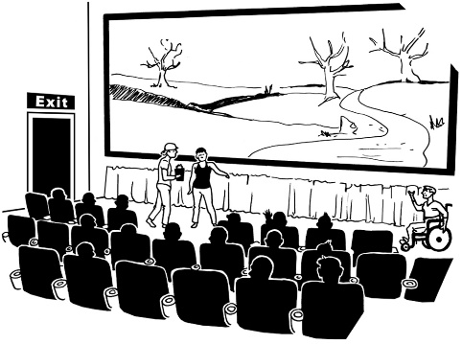
They are listed starting with the ones people were most interested in:

- films

- art exhibitions at museums.

- visual arts like painting

- festivals

- music

- theatre.

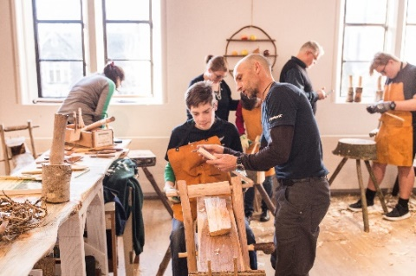
Here are more of the arts that people were interested in:

- craft and object art like:

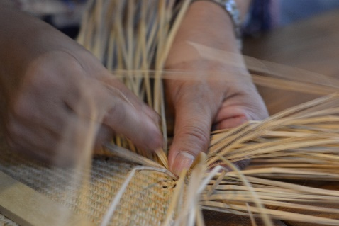
- jewellery

- tapa making

- weaving

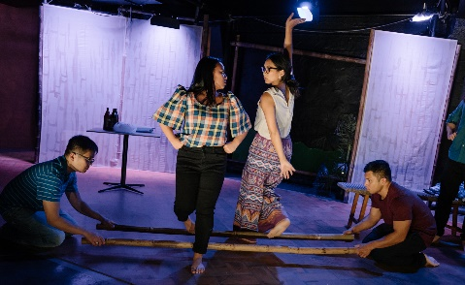
- ngā toi Māori / Māori arts

- Asian arts

- dance
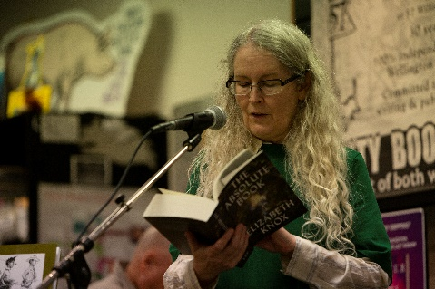
- Pacific arts

- literature including hearing a book author talk about their work.

How to get people back into the arts

Some people have not engaged with the arts for over 3 years.

When people engage with the arts it means they do things like:

- go to the theatre

- watch an event on their phone.

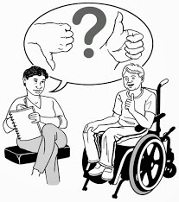
They may be interested in going again.

Film is the only art that has kept its audience numbers high.

These are the arts people engaged with in the past listed with the ones more people told us about at the top:

- dance

- pacific arts

- theatre

- ngā toi Māori / Māori arts
- music

- museums

- festivals

- Asian arts

- visual arts

- craft and object art
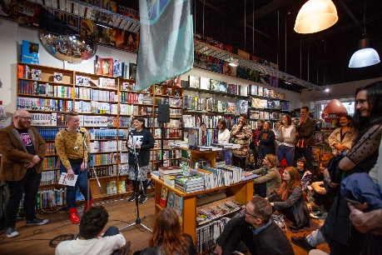
- literature like book readings.
People said they had not engaged with these arts for the past three years.

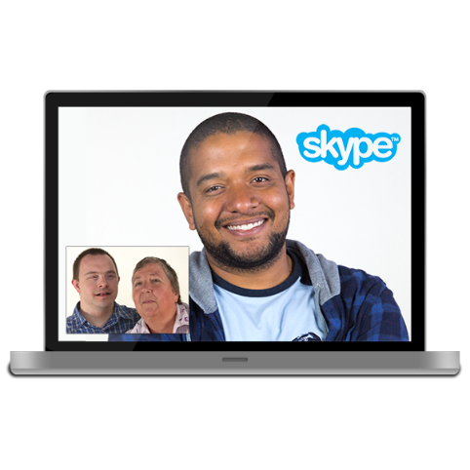
Arts organisations could try to get these people interested again.

This might be easier than trying to get new people interested in the arts.

How to get new people into the arts

A lot of people who have not yet engaged with the arts are interested in doing so.

These people might need some encouragement to engage with the arts.

These people told us what art they are interested in.

We have listed them here with the ones more people are interested in at the top:

- literature

- Asian arts
- Pacific arts

- dance

- craft and object art

- festivals

- theatre

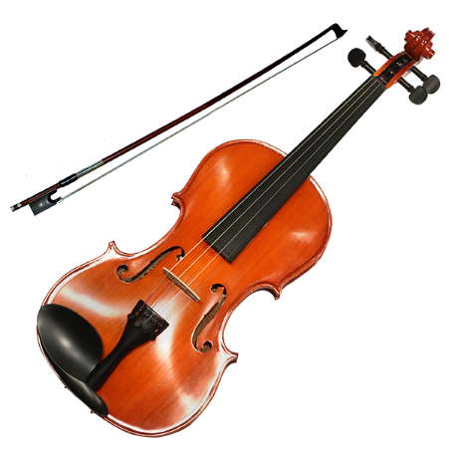
- visual arts

- music

- ngā toi Māori / Māori arts

Arts organisations need a plan to get people to go to the arts online

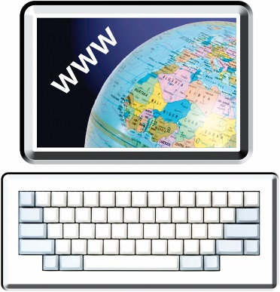
A lot of organisations are putting their arts online.

There are lots of reasons for this like:

- lots of people use

- computers

- phones

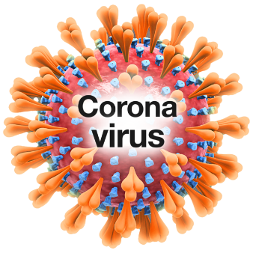
- COVID-19 restrictions made it harder for people to watch the arts live.

The research showed that fewer than 1 in 5 people looked at the arts online in the past year.

The number of people going online for the arts was the same for all age groups.

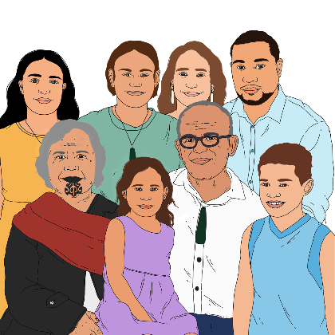
The people who were more likely to go online for the arts were:

- Māori audiences

- people who had studied at a:

- polytech

- university.

About 4 out of 10 people said they would pay to see the arts online.

Some people who have paid for arts online before said they would pay again.

Arts organisations that want to get more people going to the arts online need to plan how to interest them.

Where people get information

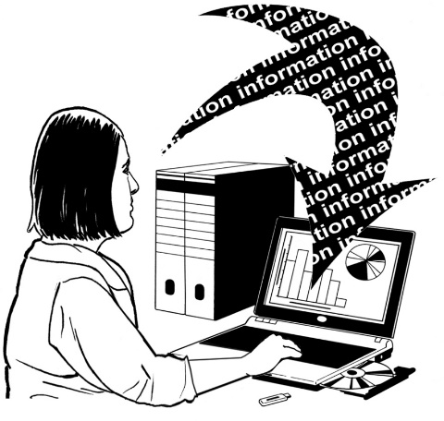
There are lots of ways to get information about what is going on.

Most people we asked find out about the arts in lots of ways.

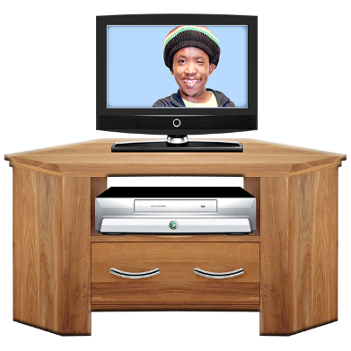
These are the ways people are getting information listed with the most common ways at the top:

- free to air television

- subscription television streaming service like Netflix

- New Zealand news website / app

- social media like Facebook.

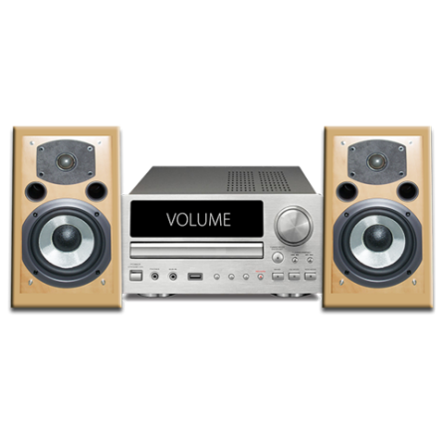
Here are more ways people get information about what is going on:

- listening to the radio

- New Zealand on demand television

- international news website / app

- local / community newspaper

- New Zealand national newspaper
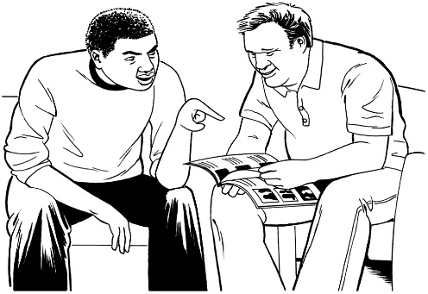
- New Zealand magazine.

- international on demand television

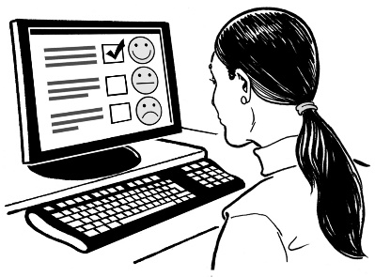
- read an online blog

- radio through a streaming platform.

The social media most people use
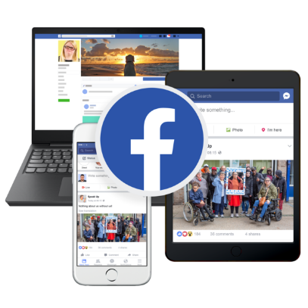

People who use social media to find out what is going on mostly use:

- Facebook
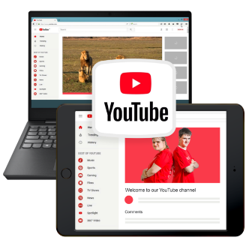
- YouTube.

More than 4 in 10 people use Facebook to find information.

People under 45 years are much more likely to use Facebook.

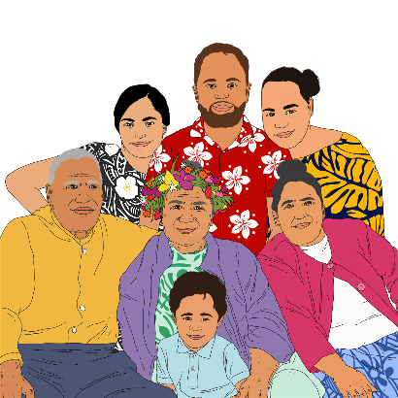
The people most like to use Facebook to learn about events are:

- Māori

- Pasifika.
The people less likely to use Facebook to learn about the arts are:

- European

- Asian.

TikTok is fairly new.

The number of people using TikTok has increased quickly.

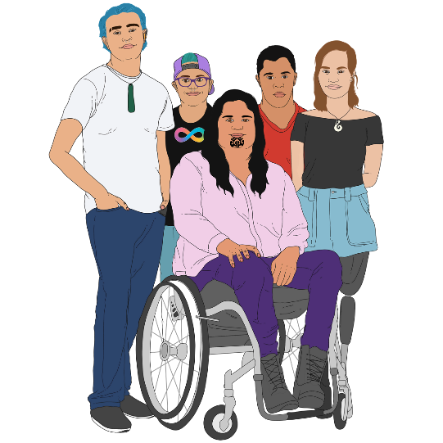
Lots of people using TikTok are:

- Māori

- Pasifika

- Asian

- young people from 16 to 24 years old.

For more information

You can find more information about arts audiences in the full report.

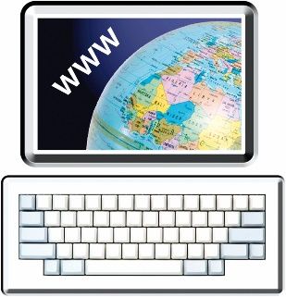
The full report is on the Creative New Zealand website: www.creativenz.govt.nz/audience-atlas-2020-report

The full report is not in Easy Read.

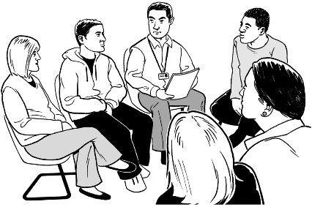
You can ask someone to read it through with you.

If you want to tell us anything about the research you can email us:

research@creativenz.govt.nz

This information has been written by Creative New Zealand.
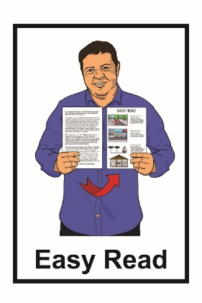
It has been translated into Easy Read by the Make it Easy service of People First New Zealand Inc. Ngā Tāngata Tuatahi.

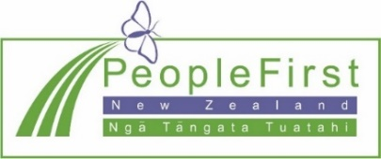
The ideas in this document are not the ideas of People First New Zealand Inc. Ngā Tāngata Tuatahi.
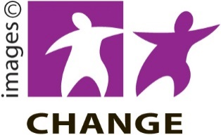
Make It Easy uses images from:

- Changepeople.org
- Photosymbols.com
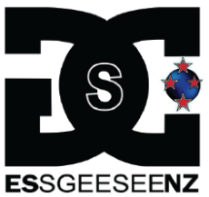
- Sam Corliss

- Huriana Kopeke-Te Aho.

All images used in this Easy Read document are subject to copyright rules and cannot be used without permission.

