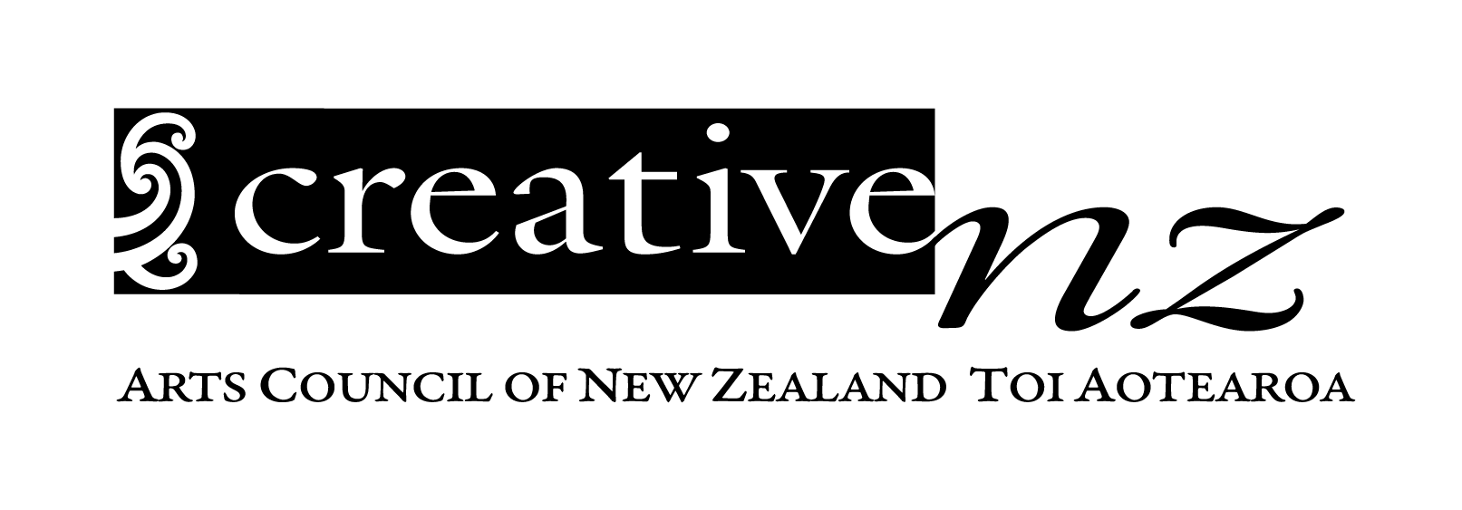 | 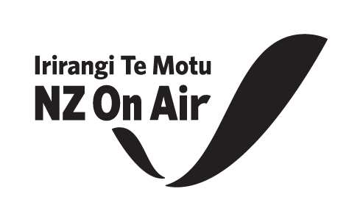

Creative New Zealand

Profile of Creative Professionals 2022 research summary

Plain Language

1. Introduction
This is a summary of the Profile of Creative Professionals 2022 research.
This research looks at the income (money people receive for their work), hours worked and wellbeing of creative professionals.
When we say ‘Creative professionals’ we mean people over 16 years old who earned some income from their creative work.
Creative work can include things like working in the craft and object art (such as jewellery and carving), community arts, visual arts (such as painting, drawing), theatre, music, ngā toi Māori (Māori arts), Pacific arts, literature or writing, dance, media production and making video games.
The 2022 research provides information on creative professionals who earned some income from their creative work in the financial year ending 31 March 2022.

2. How was the research done?
We found out what people thought mainly through an online survey.
Information about the survey was sent out in different ways, such as New Zealand Sign Language and Easy Read.
People could do the survey over the phone or on a video call with a New Zealand Sign Language (NZSL) interpreter instead of doing it on a computer or mobile phone.
People could take part in the research between 15 September – 10 October 2022. 603 surveys were completed by creative professionals.

3. Who did we speak to conduct the research?
By gender:
51% of the people who took part in the research are Men (305 men).
46% of the people are Women (280 women).
3% of the people are Non-binary (18 people).

By ethnicity:
78% are NZ European (469 people).
18% are Māori (109 people).
6% are Asian New Zealanders (38 people).
6% are Pacific Peoples (34 people).

By age:
15% of the people who took part in the research are aged between 16 to 29 years.
24% are aged between 30 to 39 years.
26% are aged between 40 to 49 years.
21% are aged between 50 to 59 years.
15% are over 60 years old.

10% of the people who took part in the research are Deaf and disabled creative professionals (63 people).

4. Background and objectives of the research
Creative New Zealand Toi Aotearoa and NZ On Air Irirangi Te Motu paid for the research. The research was done by the research company Kantar Public.
The research looked at the sustainability of careers in the arts and creative sector, and how people in creative careers could be better supported.
This research was last carried out in late 2018. This report provides information from 2022.
Creative New Zealand Toi Aotearoa, NZ On Air Irirangi Te Motu and Kantar Public would like to thank all the creative professionals who took part in the survey.
We would also like to thank Arts Access Aotearoa, Te Matatini, Te Māngai Pāho, Te Taumata Toi-a-iwi and members of The G8 including Te Tairāwhiti Arts Festival, Taki Rua, Kia Mau Festival and Te Pou that supported the research by letting a broader range of artists and creative professionals know the research was happening.

5. Key findings from the research
5.1 Income and hours of Creative Professionals

How do Creative Professionals compare to the rest of the population when it comes to income?
Creative professionals earned a median total income of $37,000 per year.
This amount is similar to self-employed New Zealanders (who earned a median total income of $39,900) but much lower than New Zealanders earning a wage or salary who got a median income of $61,800 per year.

Are there any differences in how much creative professionals earned (their personal income after expenses) depending on who they are?
Creative professionals earned a median total income of $37,000 per year.
In comparison: Creative professional men earned $43,800 per year while Creative professional women earned $30,000 per year. Māori creative professionals earned a median total income of $41,500 per year. Deaf and disabled creative professionals earned a median total income of $28,600 per year.

Have creative professionals incomes changed since COVID-19?
Creative professionals were asked how their creative income now compared to their creative income before COVID-19 entered New Zealand (February 2020).
- 38% of creative professionals said their creative income was higher (either a lot or slightly higher) than in February 2020.
- 22% said their creative income was unchanged.
- 40% of creative professionals said their creative income was lower (either a lot or slightly lower) than in Feb 2020.

Some groups that said that their income was very different now than before COVID-19 entered New Zealand:
- 79% of video game developers said that their income is higher now.
- 47% of music and sound artists said that their income is lower now.

This research is the second time the research has been done. Comparing the results from 2018 research with the 2022 research shows:
- In 2018 the median total personal income was $35,800
- In 2022 the median total personal income was $37,000.
- In 2018 the median creative income was $15,000
- In 2022 the median creative income $19,500.

The research shows that artists and creative professionals are still not earning very much per year.
There are some differences between the group of people who took the survey in 2018 and the group that took the survey in 2022 that may have affected the data.
The 2022 group were working in different artforms, some were more experienced, some were older and the group included more men. These differences could explain some of the higher amounts seen in 2022.

Do creative professionals think the amount they are paid for work is fair?
Creative professionals were asked if they thought that the income from their creative career was a fair reward for the time they spent on it?
- 68% disagreed - they thought the amount they were paid was unfair.
- 14% neither agreed or disagreed.
- 19% agreed that the amount they were paid was fair.

The groups that were more likely to think the income from their creative work was unfair were:
- Deaf and disabled creative professionals.
- Writing and literary artists.
- Performing artists (people working in theatre, music and/or dance).
- Those who work in the gig economy.
- Women.

Some creative professionals also do work outside of the creative sector
Creative professionals were asked if they did paid work outside of the creative sector or in a non-creative role?
- 56% said they only work in the creative sector.
- 44% said they also do some work outside of the creative sector.

Creative professionals who are more likely to also work outside of the creative sector include:
- Music and sound artists.
- Creative professionals who are becoming established in their career.
- People working in the performing arts.
- Those who work in the gig economy.

Household income of creative professionals
‘Household income’ means the combined income of everyone (e.g. members of a family) who live under the same roof.
The median household income for creative professionals is $87,500
The median for all New Zealand households is $104,700.

Creative professionals were asked about how they felt about their current household income?
- 10% said they were ‘Finding it very difficult’ on their present median household income of about $39,000.
- 22% said they were ‘Finding it difficult’ on their present median household income of about $67,300.
- 43% said that they were ‘Getting by’ on present median household income of about $95,400.
- 24% said they were ‘Living comfortably’ on present median household income of about$140,000.

5.2 Wellbeing and Career Satisfaction
Career satisfaction is important, because the more a person feels satisfied or happy about their career, the more they feel satisfied with their life.
Creative professionals were asked how satisfied they were with their career in the creative sector?
- 12% of creative professionals said they were dissatisfied (not happy) with their career.
- 37% said they were neither satisfied or dissatisfied with their career.
- 53% said they were satisfied (happy) with their career.

Creative professionals that were not as happy with their creative career were:
- Those people finding it difficult on their present income.
- Asian New Zealand creative professionals.
- Those beginning their creative career.
- Those also working outside of the creative sector.
- Those that considered themselves part of the gig economy.

Burnout is a type of work-related stress where you feel physically or emotionally exhausted because of the demands of your job
Creative professionals were asked if they thought that they had experienced burnout over the last year?
- 52% said yes.
- 27% said no, but that they had come close.
- 20% said no, that they had not experienced burnout.
- 1% said they ‘Didn’t know’.

Some groups of creative professionals were more likely to say they have experienced burnout in the last year. They were:
- Deaf and disabled creative professionals.
- Younger professionals, aged 16 to 39 years.
- Those finding it difficult or very difficult on their present income.
- Those becoming established in their career.
- Multi-disciplined artists.
- Those also working outside of the creative sector.
5.3 The Gig Economy
The gig economy is a way of working that is based on people having temporary jobs or doing separate pieces of work, each paid separately, rather than working for an employer in a permanent role.

71% of creative professionals said that they considered themselves part of the gig economy.

Challenges of the gig economy
Creative professionals were asked how easy or difficult they found the following features of the gig economy?
- 94% of creative professionals said it was very or quite difficult getting a loan.
- 84% said it was difficult to know how much money they would make.
- 83% said it was difficult having no holiday or sick pay.
- 62% said it was difficult securing new work.
- 61% said it was difficult promoting their own work.
- 60% said it was difficult protecting their intellectual property or copyright.
- 53% said it was difficult doing their taxes.
- 30% said it was difficult understanding contracts.

